The party in the car
Analyse visual or oral texts: English
Supports internal assessment for: English Achievement Standard 2.10
Analyse aspects of visual and/or oral texts through close viewing and/or listening, supported by evidence (AS 91107, Version 2, Credits 3)
Date of publication of this resource: September 2017. Revised July 2023.
This resource:
- clarifies the requirements of the standard
- supports good assessment practice
- should be subjected to the school’s usual quality assurance process
- should be modified to make the context relevant to students.

Guidelines for teachers
The following guidelines are to ensure that teachers can carry out valid and consistent assessment, using this internal assessment resource.
Teachers need to be very familiar with the outcome being assessed by Achievement Standard English 2.10 (91107). The achievement criteria and the explanatory notes contain information, definitions and requirements that are crucial when interpreting the standard and assessing students against it.
Curriculum values that underpin this task | Key competencies that are foregrounded | Key English understanding
Community and participation  Integrity  Respect | Participating and contributing  Making meaning from language, symbols, and text | That visual and oral texts can create meanings and effects for the audience to have an impact on how young people behave on and around roads.

Four key assessment resources
[1] The standard; [2] Conditions of assessment; [3] Assessment schedule; [4] the Sufficiency Statement and exemplars. Note: the exemplars in this unit were moderated by NZQA in 2013.

Authenticity of evidence
Teachers must manage authenticity for any assessment from a public source because students may have access to the assessment schedule or exemplar material.
Using this assessment resource without modification may mean that students’ work is not authentic. Teachers may need to change data sources or use a different context or topic or use a different text to read or perform. Teachers should be guided by the level 2 English conditions of assessment.

Assessment
Refer to Assessment Schedule and Sufficiency Statements.

Context
This activity requires students to analyse aspects of an oral or visual text that has been designed to educate young people about keeping themselves, and their peers and family, safe in cars. You will need to ensure that students are familiar with all aspects of oral and visual text analysis. The questions for exploration in the tasks use SOLO taxonomy verbs to develop ideas from a surface to a deeper engagement.
SOLO Taxonomy (Pam Hook)

Conditions
See Level 2 assessment resources for comments on developing and practising the skills required, use of modelling and scaffolded practice, managing authenticity and sufficiency for this standard.
Level 2 English assessment resources (TKI)
- Students will analyse one or more road safety videos and make developed interpretations of the ideas, language, and visual or oral features. They will do this in appropriate oral, visual or written forms. They can listen to and view texts, collect information, and develop ideas for their presentation both in and out of class time.
- Students will select the texts they use for their assessment. Teachers must pre-approve selected texts. A list of possible texts is provided as a starting point.
- Teachers may identify text conventions for consideration, but students should not have previously studied the selected texts.
- Texts must be suitable for level 7 of the curriculum, for classroom use, and for the age of the students. The visual texts selected must allow the students to achieve the standard at every level.
- Teachers must assess students’ presentations holistically.

Possible local adaptation
Where local adaptations are made, teachers and schools should ensure that they have:
- checked that the assessment validly assesses the achievement standard
- checked the copyright status of any material imported into the assessment resource
- complied with all internal and external quality assurance requirements.

Integration with other standards
Preparation for this task, which focuses the exploration of road safety issues related to young drivers, might be part of a wider thematic study, such as exploring issues and challenges facing young people today. This task could also contribute to students’ preparation for:
- AS 91099: Analyse specified aspect(s) of studied visual or oral text(s), supported by evidence
- AS 91104: Analyse significant connections across texts, supported by evidence
- AS 91105: Use information literacy skills to form developed conclusion(s).
The presentation for assessment might be integrated into other standards such as:
- AS 91101: Produce a selection of crafted and controlled writing
- AS 91102: Construct and deliver a crafted and controlled oral text
- AS 91103: Create a crafted and controlled visual and verbal text.
Students might also explore:
Pathways Awarua Pathways deliver content for driver licences and health and safety requirements for the workplace, while at the same time strengthening learners’ literacy and numeracy competencies: car licences, heavy vehicle licences, health and safety.
Literacy and numeracy standards: Practising active citizenship through safer journeys Curriculum resource. Use the official New Zealand road code to integrate learning for citizenship within broad contemporary social issues for safer journeys in New Zealand. This contextualised learning programme can help secondary students meet NZQA literacy and numeracy requirements.
Driver licence NCEA credits Students who have, or who obtain Class 1 driver licences, can be awarded unit standards that count towards NCEA and other qualifications on the NZQF framework.
Wherever such integration between different parts of the programme occurs, teachers must ensure that the work presented for assessment is developed sufficiently to meet the criteria for the other standards. In all such cases, teachers should refer closely to the relevant standard including the explanatory notes and the conditions of assessment guidelines.

A note on the context
Teachers should be aware that this unit might involve the discussion of road crashes. Students may have first-hand experience of such issues, and teachers should be discreet during discussions. Students should be forewarned before the start of the unit.
Note: The teachers’ resource guidelines have been adapted from the New Zealand Qualifications Authority (NZQA), under Creative Commons Attribution 3.0 New Zealand (CC BY 3.0).

Internal assessment resource

Student instructions
Achievement Standard: English: Analyse aspects of visual and/or oral text(s) through close viewing and/or listening, supported by evidence.
Resource reference: English 2.10 | Credits: 3 | Resource title: The party in the car

Achievement | Achievement with merit | Achievement with excellence
Analyse aspects of visual and/or oral texts through close viewing and/or listening, supported by evidence. | Analyse aspects of visual and/or oral texts convincingly, through close viewing and/or listening, supported by evidence. | Analyse aspects of visual and/or oral texts perceptively, through close viewing and/or listening, supported by evidence.

This activity requires you to analyse visual and/or oral texts through close viewing and/or listening of texts that you have selected. You will need to provide evidence to support your points.
You can present your analysis in any suitable written, oral or visual form. For example, it could be a written report, an oral and/or visual presentation to the class, or an online publication.
During class time, you will have viewed some visual texts. You will also have discussed how these texts create meaning (for example, by using a character to express an idea) and effects.
You will be assessed on your ability to analyse the way meanings and effects are created in visual and oral texts, using supporting evidence. You will need to consider how the different aspects of the texts on road safety are used by the creator or director to convey important messages to the intended audience.
You should complete the assessment individually in class. The texts you choose for assessment cannot have been studied before. Your teacher will provide further details and the due date.

Activity 1: Our parties in cars (this task is not assessed)
It is useful to consider some of the ’big ideas’ and experiences that the road safety videos might be trying to convey.
Tapping into our own experiences in and around cars is a powerful way to begin.
Review the resources below, which focus on how we might behave in and around cars:
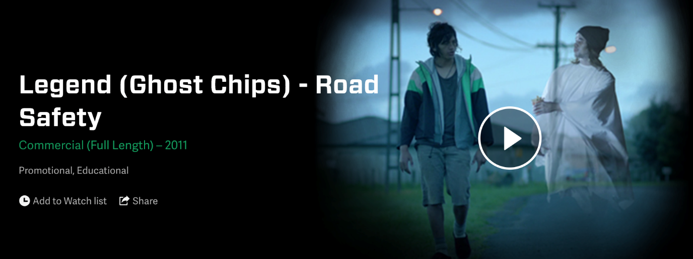
Legend ‘Ghost Chips’ (NZ on Screen)
‘The Party Planner’
The After Party interactive video (Kaitiaki o Ara SADD)
Do these resources reflect your experiences? Why or why not?
How typical are these experiences, in your view?

Activity 2: is the party always fun? (this task is not assessed)
Before you view and analyse your selected text, explore some of the ideas and messages about road safety that affect young people like you.
This task will help you understand the bigger picture around how young people behave with each other on the road and in cars.
- In class and with your peers, select, read and watch from the resources on pages 7–8.
- Use the questions below to unpack the ideas in the texts.
- Your teacher may ask you to use a Jigsaw activity or Placemat activity to organise this.
SOLO levels | Choose at least ONE prompt to answer from each row
Identify one factor that can affect the way teenagers drive.
Identify one risk that young people face.
Identify one positive action people can take to reduce risk.
Define ‘distraction’ in the contexts of behaviour in cars.
List several reasons why teenagers are more likely to be involved in crashes than older drivers.
List several reasons why road crashes are the single greatest cause of death in 15–24 year-olds.
Describe why young people get distracted and take risks.
Explain the likely causes of teenager crashes.
Explain why some people see the car as a ‘party’ place.
Compare the different approaches to reducing risk. Which are better?
Generate some ideas about how teenagers could change the way they behave in cars.
Generate ideas about what government organisations might need to do to reach young people more effectively.
Reflect on why teenagers continue to have crashes despite all the advice and advertising targeted at them.
SOLO Symbol images © Hook Education Ltd. Reproduced with permission.

Resources
Driver distraction
Read about driver distraction:
Driver distraction (Waka Kotahi)
Then check out the following resources that explore driver distraction, including:
- distraction infographic
- distraction video
- focus on driving quiz
Driver distraction resources (Waka Kotahi)
Other links:
No distractions (SADD student video – YouTube)
The Party Planner (2010). Australian competition-winning film about driver distraction.

Driving needs your full attention. Distractions can be both visual (you’re looking at it), and cognitive (you’re thinking about it). Essentially, anything that diverts a driver's attention for more than two seconds can significantly increase the likelihood of a crash or near-crash.
Dangers of distracted driving (AA)

Young drivers and other risk factors
Drivers on a restricted licence are seven times more likely to be involved in a fatal or serious injury crash than other drivers. Data also shows that young restricted drivers are more at risk of having a serious crash in the first six to 12 months of driving solo on their restricted licence than at any other time in their lives. This increased risk is partly due to driving inexperience.
Young drivers (Waka Kotahi)

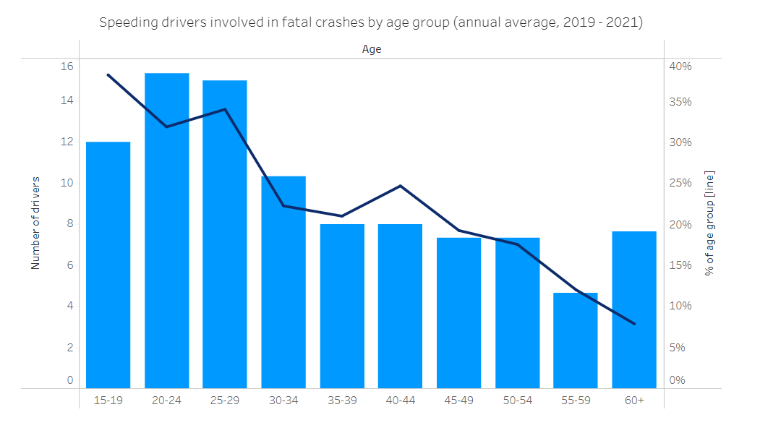
Safety annual statistics – Speed (Ministry of Transport)
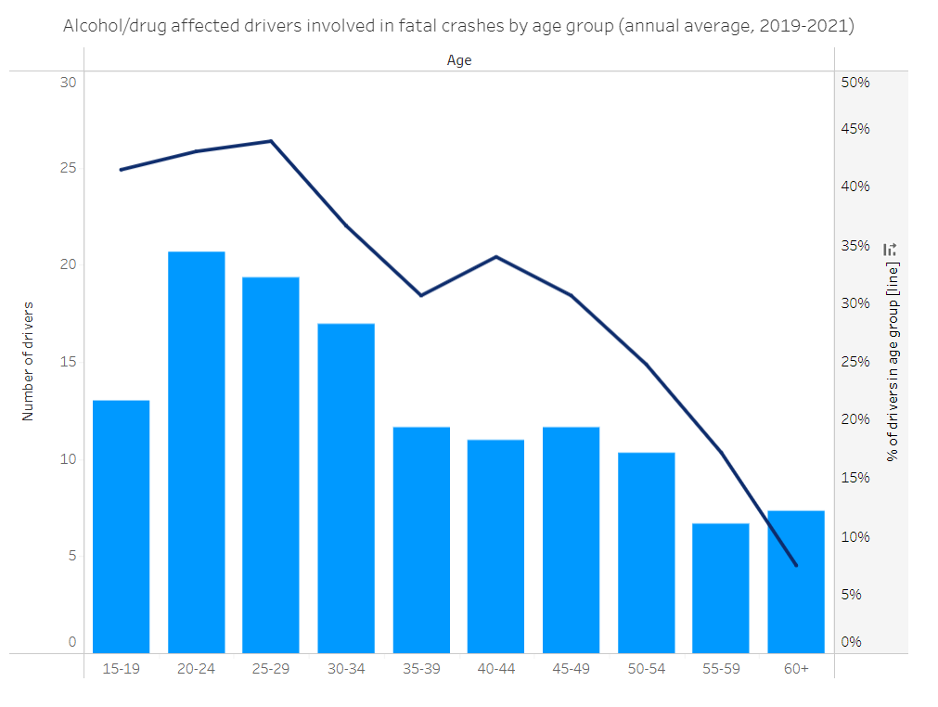
Safety annual statistics – Alcohol and drugs (Ministry of Transport)

Activity 3: choose your advertisement (this is not assessed)
Select at least one oral or visual road safety text, for example, a film or an advertisement, that you have not studied in class. Your teacher must pre-approve your selected texts. If you are choosing more than one text, you might like to choose those that have similarities or those that explore a similar idea in different ways. Consider exploring a campaign series.

Suggested resources
There are many advertising campaigns and student-developed films online, focusing on improving road safety for young people. These might provide some starting points for text selection and discussion:
Split Second Competition (Transport Accident Commission, Victoria) Scroll down for past winners.
SADD NZ video competition (YouTube)
Current marketing campaigns (Waka Kotahi)
The science of speed with Nanogirl
Think! Road Safety UK (YouTube)
TAC Campaigns
Transport for NSW marketing campaigns

First viewing
Watch your chosen texts several times. Brainstorm ideas in response to the following prompts:
- Identify the target audience.
- List the ideas or messages about road safety that are being suggested.
- List any language or visual and oral techniques or features.
- If you have chosen more than one text, compare them – what obvious similarities and differences do you notice?

Preparing to view closely
You will need to watch and listen to the texts for your close viewing. If the close viewing is to be done in class, you need to choose a way to watch or capture the texts. You will need to liaise with your teachers on the best way to do this. Possible ways to organise your text for viewing might include:
- viewing the text on your mobile phone (if the school permits and if your phone is web capable)
- viewing online (or download and viewing offline) via the school computer
- taking screen grabs for viewing offline
- sketching a series of key frames from the video.

Activity 4: close reading and analysing your oral or visual texts (this task is not assessed)
Now you have completed your brainstorm, you need to view your texts more closely.
- This task must be done under teacher supervision.
- This is where you begin to develop your understanding and interpret how the different aspects of the videos convey a message to the target audience about teenage behaviour in cars.
- Take notes about meanings, effects and specific aspects such as ideas, language features, oral language techniques and structure.
- Make sure you select specific and relevant details from the text to support your ideas.
As you watch your texts, you might like to use the following grid to help scaffold your analysis.

 | Questions to consider | Your notes | Evidence (examples from the text)
Purpose and audience | Analyse the purpose of the video.  What is the director’s intention?
Who is the intended audience?
Who is being targeted?

 | Analyse how the video makes you feel.
Ideas | Analyse the causes of any incidents in the videos.
 | Analyse the messages that the video sends about road safety in and around cars.
 | Compare the way different videos convey their message.
Analyse the different characters and points of view.
Whose view do we not hear?

 | Analyse the genre. How might this influence the text and its message?
Apply your own knowledge about road safety to the video.
Analyse the links between your own experience and the video’s messages.

Analyse the way the video relates to the ‘big ideas’ about road safety from Activity 2.
What links can you see between the video and what is known about teen behaviour in cars?

Evaluate how successfully this video would persuade its audience.
Predict how they might react and try to justify your response.

Language features | Analyse how you know who the video is for.
 | Analyse how the director uses cinematography, for example, one shot, a group of shots, camera angles, the setting, special effects, lighting.
Analyse the characters. How are techniques used to show you what they are like?
Explain what the director wants you to think of the characters and why.
Analyse how the director creates mood and feeling.
What techniques are being used?
Analyse the use of mise-en-scene in at least two shots in the video.
How is it developed to convey meaning?

Analyse the use of music in the video.
How is it used to develop character, ideas, or mood?
 | Analyse how the dialogue and sound (or absence of them) show you the key ideas.
Analyse the way similar techniques relate to each other.
Is there a recurring pattern in the way a language feature or other technique is used?
How does this convey a message?
Structure | Analyse how the video is edited, how it moves from scene to scene.  How do the transitions and editing affect the meaning?
Analyse the main events. How does the central plot develop?
How do the different events and the way they are ordered, convey the main ideas?

Analyse the beginning and ending.
Why are they the same?
Why are they different?

Ideas can include themes, attitudes, beliefs, experiences, feelings, insights, meanings, opinions, thoughts and understandings.
Language features can include dialogue, acting, costume, setting, camera angle, camera shot, lighting, editing or structural techniques, such as transitions, flashbacks or intercutting, sound effects, special effects, dialogue, intonation, pitch, pace, captions, call-out boxes, music, sound effects, use of voice-over and language techniques, or they might include the deliberate omission of any of these techniques.
Structure can include other visual or oral techniques that might involve narrative sequence, beginnings and endings.

Activity 5: present your response (assessed)
Waka Kotahi wants young people to help educate each other and their families, about the risks and factors involved when getting behind the wheel.
Schools are invited to produce a series of videos aimed at students who could make real change for that community. This assessment maps out ideas for future films.
Using the videos you have explored, develop a presentation for your school that analyses how a road safety video can engage teenagers so that they might change their behaviour in and around cars. Aim to analyse at least four significant aspects in your chosen texts.
Support your analysis with evidence from the videos.
Present your response in a way that will best support the purpose and show your understanding of how visual and oral texts can create meanings for the audience. For example, you might choose one of the following forms or a combination of them:
- Written form (for example, an essay, a report, a letter, a blog post).
- Visual form (for example, a short film, a digital essay with voice-over accompanying the images).
- Oral form (for example, a formal speech, a presentation to the board with visual support, a podcast).

Assessment schedule: English 2.10: party in the car
The examples of student responses are based on an analysis of ‘The Party Planner’ from Activity 1. Analysis is in bold, supported by evidence.
Note: the exemplars in this unit were moderated by NZQA in 2013.

Assessment schedule: evidence for achievement
These are examples of possible student responses. It is a selection of possible points, not a complete response.
Context: ‘The Party Planner’ sets out to warn young people about the dangers of travelling together at night in cars. We know that young people are the group most likely to take risks around cars, especially when they are with their friends. The film sets out to persuade young people to make better choices.

Ideas/effects – An important idea in the film is that David is the host of a party in his car and that he needs to learn a lesson about driving more safely and responsibly. When there is a close-up of him being identified as the host by the Party Planner (with a freeze-frame of her tick sheet), and a freeze frame of a pink neon sign saying ‘host’ by his head, we are being shown that he is actually hosting a party in his car, even though he doesn’t realise it. With each freeze-frame, we begin to understand, even if he doesn’t, that the car journey is full of dangerous distractions for him as the driver. The idea of him being a host, even in a car, is also shown through his dialogue. When he frowns and says, ‘I’m not having a party’ in a confused voice to the party planner, we can see he doesn’t understand that she is trying to tell him that he is in a dangerous ‘party’ situation right there in his car. This creates a feeling of tension for us as we wait to see whether he will realise what is happening and do anything to stop it. The use of close-ups of David’s face, with its embarrassed expression whenever the party planner ticks off a party item in his car, show us that he knows he’s wrong to let his friends behave wildly in the back but isn’t brave enough to stand up to them. The director is showing the audience that it is hard to resist peer pressure and make a more sensible choice when you are surrounded by your friends in a car on a night out.

Example of language/effects – the use of sound and camera work: One aspect of language that the director uses is a fast zoom, loud sound and then a freeze-frame with the special effect of a pink neon sign hanging in the air that labels the party feature in the car, such as music, beverages or decor. The neon sign looks like one you might see in a nightclub and that, plus the list of party ingredients that we all know about (music, décor and so on) emphasises that the journey is like a party. The way the film freezes with the loud sounds (whooshing, a bell ringing, a pen on paper) grabs our attention and makes us notice all the dangerous aspects of the journey. We see this aspect of language many times through the film and it shows us that there are lots of risks that come from partying in a car, and that, as the journey goes on, it gets more dangerous and much harder to resist peer pressure. It is interesting that the director uses these neon signs, freeze frames and exaggerated sound, even though the idea that the party in the car is serious. Because we don’t expect this contrast, this technique creates a fun, surprised feeling for the audience. The director is doing this to persuade teenagers through humour, rather than using shock tactics, that the music, alcohol and silly behaviour are distracting and dangerous in the car.

Example of structure/effects – the ending: One important aspect of structure is the ending. At the end of the film the director uses mid-shots of a smiling David getting out of a taxi. He is smiling and this shows that he is clearly relieved to have arrived and pleased to be there after the near-crash. It suggests that he made the right decision by not driving to the party after all. As he walks into the party, we are shown, through a high angle shot (as if we are already at the party ourselves), the fast-forward action as the guests climb the stairs and we can hear loud music which suggests that the party will be an exciting one, that they are rushing to get inside and that it was worth getting to safely. In the final moments, the director uses a close-up on the party planner’s smiling expression, and we hear her friendly dialogue ‘Hey, you made it!’ She is pleased that he made the right choice, and her dialogue also has the double meaning that he survived the journey. The director then cuts to David’s surprised but smiling face. This close-up shows that David made the right choice, that he is excited about the real party, and that he is pleased the pretty party planner is proud of him, as if he was right to listen to his conscience. The ending is designed to show us that it is better to make the choice not to drive dangerously with friends or have a ‘party’ in the car – and that the best party is the one you get to safely.

The student analyses aspects of visual or oral texts through close viewing and listening, supported by evidence. This means that the student:
- selects an appropriate visual or oral text in its original form (see En 1, 6, and 7)
- makes a detailed exploration and consideration of aspects of the text (En 4)
- makes developed interpretations of meanings and effects of the text (see En 2), such as:
  - ideas, for example, themes, attitudes, beliefs, experiences, feelings, insights, meanings, opinions, thoughts, and understandings
  - language features, for example, cinematography, editing, special effects, dialogue, narration, music, sound effects, rhetorical devices
  - other oral techniques and structures, for example, part film (extract), whole film, narrative sequence, beginnings, and endings
- supports their analysis with specific and relevant details from the text (En 5)
- presents their analysis in a form that provides opportunity to achieve the standard at this level (En 3).

Assessment schedule: evidence for merit
These are examples of possible student responses. This is a selection of possible points, not a complete response.

Context: Young people are over-represented in statistics for road crashes, with speed and the use of alcohol being the major contributing factors. ‘The Party Planner’, with its group of excited friends on their way to a night out, sets out to appeal to teenagers and persuade them that they can stand up to the peer pressure in cars without feeling embarrassed.
Example of an idea/effects – the role of David who represents all teenagers:
The director shows us, through a metaphor, that David is the host of a ‘party’, not the one they are going to, but the one in the car. We are shown this when there is a close-up of him being ticked off as the host by the party planner, combined with a freeze-frame and the superimposed pink neon sign saying ‘host’ by his head. The idea of him being a host, even in a car, is also shown through his dialogue. When he says, ‘I’m not having a party’ in a confused voice, we can see he doesn’t understand what she is trying to tell him – that the party is happening already in his car. The audience can understand the situation, however, and this creates tension. What will it take for him to learn his lesson? The director combines this with repeated freeze-frames and the exaggerated sound of her pen on paper as the party ingredients are ticked off the party planner’s list. The director is showing us that David doesn’t understand the danger he and his friends are in. The use of close-ups of David’s face, with its embarrassed expression whenever the party planner ticks off a party item, show us that he knows he’s wrong but isn’t brave enough to stand up to his friends. This emphasises that, while young people may understand the risks being run in allowing loud music, alcohol and friends in a car at night, it is hard to resist peer pressure and make a more sensible choice. Using rapid cutting, the director contrasts close-ups of David’s confused expression with close-ups of the party planner’s calm, questioning gaze. This creates the idea that she symbolises David’s conscience she knows what’s right and, really, he does too. The combination of close-ups of her attractive, warm expression and her dialogue, ‘Maybe a change of venue?’ shows that she is encouraging him – and the audience – to choose a safer option, to trust his instincts and make the brave choice. It is clear that a car journey is highly risky if the party has already started in the back seat.

Example of language/effects – the combination of sound and camera work:
One aspect of language that the director uses is repeating the use of fast zoom towards an aspect of the party (eg a disco ball in the car), exaggerated whooshing sound, and a freeze-frame on the aspect with the special effect of the superimposed disco-like pink neon sign that labels the party feature. This combines with the close-up of the party planner’s tick list and the exaggerated ringing of a bell and scratch of her pen on paper as she completes another tick box. The repetition of this combination of techniques draws our attention to the many risks that come from partying in a car, and suggests that it gets harder to resist peer pressure. In addition, even though the message that the journey is dangerous is a serious one, by contrasting this serious message with the repeated neon signs, exaggerated sound and freeze-frames, it is amusing because the audience doesn’t expect it. The repetition of the combination becomes a running joke, or motif, in the film. The director is doing this to appeal to teenagers through humour, to persuade them that the music, alcohol and rash behaviour are highly distracting and best saved for the real party itself.

Example of structure/effects – the ending:
One important aspect of structure is the ending. At the end of the film, after the near crash breaks the tension for the audience, the director uses mid-shots of a smiling David getting out of a taxi, followed by fast forward and exaggerated, loud music at the party. This shows that he is clearly relieved to have arrived and pleased to be there. We are being shown that the sensible choice, not to drive with his mates, was a good one because they arrived safely and can enjoy a great night out. The combination of loud, techno music, fast-forward action as they climb the stairs, and a high-angle shot to make us feel like we are there ourselves, all suggest that the party will be an exciting one for them all and that they are hurrying to join their friends. In addition, the final close-up on the party planner’s attractive smile, and her warm greeting – ‘Hey, you made it!’ – cutting to his smiling, relieved face emphasize that David made the right choice, as well as creating a sense of irony that he made it without a serious crash. The ending is designed to show us that it is better to make the choice not to drive recklessly with friends or have a ‘party’ in the car, and that safe driving so you arrive at the real party, is a confident, attractive choice for young people.

The student analyses aspects of the texts convincingly through close viewing and listening, supported by evidence. This means that the student:
- selects an appropriate visual/oral text in its original form (see En 1, 6, and 7)
- makes a detailed exploration and consideration of aspects of the text (En 4)
- makes developed interpretations of meanings and effects of visual/oral texts (see En 2), such as:
- ideas, for example, themes, attitudes, beliefs, experiences, feelings, insights, meanings, opinions, thoughts, and understandings within the film/s
- language features, for example, cinematography, editing, special effects, dialogue, narration, music, sound effects, rhetorical devices
- other oral techniques and structures, for example, part film (extract), whole film, narrative sequence, beginnings and endings
- demonstrates understanding of how significant aspects of visual and oral texts work together to create meaning (En 2)
- supports their analysis with specific and relevant details from the texts (En 5)
- presents their analysis in a form that provides opportunity to achieve the standard at this level (En 3).

Assessment schedule: evidence for excellence
These are examples of possible student responses. This is a selection of possible points, not a complete response.

Context: International research is emphatic in showing us that young people are over-represented in statistics for road crashes, with speed and the use of alcohol being the major contributing factors. The short film, ‘The Party Planner’, is a winning video, made in response to an annual competition for young people; it tries to influence teenagers’ risky behaviours with humour and wit.
Example of an idea/effects – the role of David as representative of an ‘everyman’ teenager who learns his lesson:
The director explores the central idea that David is the metaphorical host of a ‘party’, not the one they are going to, but the one in the car. We are shown this by the way that he is ticked off on her pad as the host by the party planner, in a freeze-frame with the special effect of the nightclub-like neon sign superimposed by his head, as well as the fact he is the ‘host’ of the car journey, as the driver. While his dialogue with confused tone shows us he doesn’t see himself as responsible for what is happening in the car – ‘I’m not having a party’ – the unrelenting freeze-frames throughout the first half of the film and exaggerated sound of the pen on paper as the party ingredients are ticked off the list contrast with this view: the party planner is showing us that, even in a car, a journey can be foolishly managed as if the party has already started. Close-ups of David’s face, with its embarrassed expression whenever the party planner ticks off a party item show us that he knows he’s wrong but isn’t brave enough to stand up to his friends. This emphasises that, while young people may understand the risks being run in allowing loud music, alcohol, and friends in a car at night, it is hard to resist peer pressure and make a more sensible choice. The party planner, shown by close-ups of her calm, questioning gaze contrasting with David’s bewildered frown, symbolises David’s conscience. With her question, ‘Maybe a change of venue?’, we can see she encourages him – and the audience - to choose a safer option, to trust his instincts and make the brave choice. The central idea here is that David represents every teenager – an everyman character – to show us that the driver must take responsibility, even in the face of peer pressure, for safety in the car, and that the car journey is not a safe place for drinking and celebrating.
Example of language/effects – the repeated motif of sound and camerawork:
The concept of the journey being an actual party, made up of all the usual party ingredients, is shown through the repeated use of the following language technique: a repeated combination of fast zoom on the feature (eg the disco ball in the car), exaggerated whooshing of the zoom, and a freezeframe with a superimposed disco pink neon sign that labels the party feature in the frame. This combines with the close-up of the party planner’s tick list, the elevated sound of the ringing of a bell and the loud scratch of her pen on paper as she completes another tick box. The repetition of the combination of techniques draws the audience’s attention towards the growing list of risks associated with partying in the car, as well as how the danger, and peer pressure on David, is mounting. However, even though the message that the journey is dangerous is central to the film, the juxtaposition of the serious theme of road safety with the neon special effects and exaggerated sound is amusing because the motif is so unexpected and surreal, and the special effects are fun and modern. This is a reflection of the director’s light, humorous approach which contrasts with the many road safety films that adopt a didactic, preaching style, which is a ‘turn off’ for a teenage audience. He wants to persuade us, through humour, that the party ingredients – music, alcohol, rash behaviour – are highly distracting (just like the audience is distracted by the technical combination of zoom, amplified sound and freeze-frame) and are best saved for the real party itself.
Example of structure/effects – the ending:
This is a road safety video with a serious message but the director resists a shock ‘crash’ ending that we might expect and which young people could easily dismiss – it is vital that young people can learn from this video. The ending focuses on the positive consequences of making the right decision. When we see mid-shots of a smiling David leaving a taxi, followed by the excitement created by the use of fast forward action, exaggerated, techno music at the party and the high-angle balcony shot as though we are there ourselves, we are being shown that the sensible choice, not to drive with his mates, was worth it because they arrived safely and can enjoy a great night out. The fast-forward creates a sense of anticipation and excitement; they are rushing to join their friends. The close-up on the party planner’s attractive smile, combined with her warm greeting – ‘Hey, you made it!’ – cutting to his smiling, relieved face emphasise that David made the right choice, as well as ironically suggesting that it’s good he didn’t haven’t a serious crash. There’s even the suggestion of an attraction between them! It’s a warm, engaging conclusion that appeals. The key message drives home for the audience that choosing not to drive recklessly with friends at night is an attractive, brave decision with positive consequences for everyone.

The student analyses aspects of visual and/or oral texts perceptively through close viewing and/or listening, supported by evidence. This means that the student:
- selects an appropriate visual/oral text in its original form (see En 1, 6, and 7)
- makes a detailed exploration and consideration of aspects of the text (En 4)
- makes developed interpretations of meanings and effects of visual/oral texts (see En 2), such as:
- ideas, for example, themes, attitudes, beliefs, experiences, feelings, insights, meanings, opinions, thoughts, and understandings within the film(s)
- language features, for example, cinematography, editing, special effects, dialogue, narration, music, sound effects, rhetorical devices
- other oral techniques and structures, for example, part film (extract), whole film, narrative sequence, beginnings, and endings
- demonstrates insightful and original understanding of significant aspects of the text(En 2)
- supports their analysis with specific and relevant details from the text (En 5)
- presents their analysis in a form that provides opportunity to achieve the standard at this level (En 3).

Assessment schedule: evidence for not achieved
Student example: this is not a complete response.

‘The Party Planner’ shows us that it is dangerous for young people to travel together at night in cars, especially when they are with their friends. (Purpose outlines but does not identify intended audience.)
In the video, the driver, David, is the host of a ‘party’, not the one they are going to, but the one in his car. He does not understand who the ‘party planner’ girl is but she is going to teach him how to travel safely. (Retelling events, rather than analysing.)
The close-up and freeze-frame on all the party details – the music, the alcohol and the photography – are used throughout the film. (Identifies language features but does not analyse; no reference to structure.)
The video shows us how to make sensible decisions when we are driving with our friends. (Refers to purpose again.)

In this example, the student:
- gives a basic outline of a key idea in the first lines
- retells the events of the video, rather than linking them to the purpose of the film
- provides specific examples of techniques but fails to analyse why they have been used
- does not interpret meanings or effects; does not show developed understanding of how the aspects of the film create meanings or effects for the audience.

Note: final grades will be decided using professional judgment based on a holistic examination of the evidence and set against the criteria in the Achievement Standard.

