Access all areas: how transport can serve all of us
English Years 9-10: create persuasive text
In this unit, students will use photovoice and design thinking as they prepare to create a persuasive text that will aim to make local transport more accessible for all.

Teacher notes

The context
Key understanding: If transport is to be effective, everyone needs to be able to access and use it. Transport receives more investment than almost any other service in our society, and we all use it. We can all play a part in pushing for better solutions to the way transport (e.g. roads, rail, buses, pathways) serves our needs.
Driving question: How could our local travel system in New Zealand be more inclusive and accessible?

Timeframe
This unit can be explored over 2-3 weeks, but classes may choose to extend the experience as part of a wider inquiry (within English or across other learning areas).

Big picture focus
Vision, values, and key competencies (NZC): This unit focuses on students being informed decision makers and effective communicators for their communities. It foregrounds the principles of inclusion and community engagement – the values of innovation, inquiry, and curiosity; diversity; equity; community and participation; and respect – and the key competencies of participation and contribution and using language, symbols, and texts.
A place we all share:
‘When the road is framed as a commons, students can develop deeper, more flexible perspectives of citizenship. All students are road users and have personal experience of why road use must be fair. They have an authentic model for citizenship embedded in their own experience; they have agency. The big idea for students is that all people using roads are precious, so we need to think and act together to create a safe system.’ – Pam Hook
Transport as a context for encouraging skilled and active citizenship (Pam Hook, Waka Kotahi)

Note on the context
Teachers should be aware that this unit might involve the discussion of transport-related challenges, disability and road crashes. Students may have first-hand experience of such issues and teachers should be discreet during discussions. Students should be advised of the issues before they start the unit.

Plan the learning intentions
This unit is aligned to the English Achievement Objectives (Levels, 4, 5 and 6): Speaking, writing and presenting.
Use the inquiry cycle to inform your planning. You might use diagnostic testing, review of previous assignments and discussion to establish the students’ needs. You will have your own process for developing learning intentions in your school.
Planning using inquiry (English Online)
The learning intentions in this unit are structured around the SOLO taxonomy verbs to develop ideas from surface to deeper engagement. Suggested learning outcomes are listed below. Select those that best match your students’ learning needs.
SOLO Taxonomy (Pam Hook)

Unistructural  (can identify a single idea; ‘on the lines’)  Define ‘persuasive’.  Define ‘purpose’ and ‘audience’.  Define the purpose of a persuasive text.  Identify one idea in a persuasive text.  Name one language feature in a persuasive text.  Name one aspect of structure in a persuasive text. | Relational  (can identify more than one idea and explain how they are related; ‘between the lines’)  Classify the different language features.  Classify the different structural features.  Compare the ideas in a persuasive text.  Explain the reasons for the use of language and structural features in a persuasive text.  Explain why one piece of persuasive text is more effective than another.  Sequence the structure of their persuasive text.
Multistructural  (can identify more than one idea but not link them; ‘on the lines’)  List several ideas in a persuasive text.  Describe the purpose of persuasive text.  Describe the language features used in a persuasive text.  Describe the structural features used in a persuasive text. | Extended abstract  (can identify and explain related ideas, and extend thinking beyond them; ‘beyond the lines’)  Create a persuasive text.  Create a set of criteria to critique a persuasive text.  Reflect on the text and evaluate its strengths and weaknesses.  Generalise the features that are typical of persuasive texts.  Integrate different sources of information to critique a persuasive text.
SOLO symbol images © Hook Education Ltd. Reproduced with permission.

Activity 1 – focus on our journeys
Students will focus on their own journeys and what it means to have access to transport options. They will engage prior knowledge, enhance the relevance of new learning, and facilitate shared learning.

Task 1: begin to ask ‘how accessible is local transport?’
Share the following ideas:
Key understanding: If transport is to be effective, everyone needs to be able to access and use it. Transport receives more investment than almost any other service in our society, and we all use it. We can all play a part in pushing for better solutions to the way transport (e.g. roads, rail, buses, streets) serves our needs.
Driving question: How could our local travel system be more inclusive and accessible?
Think about how you travel. What are your usual journeys for and why are they important?
Think-pair-share exercise or PMI: Ask the students to think about when they and other students travel around in a typical week. Discuss how easy or difficult it is to get around.
PMI (Virtual Library)
- What are the positives (pluses) that make getting around easy?
- What are the potential barriers (minuses) that get in the way of easy and accessible travel?
- What are you are still wondering about in terms of everyone being able to access transport? (interested/inquiry)
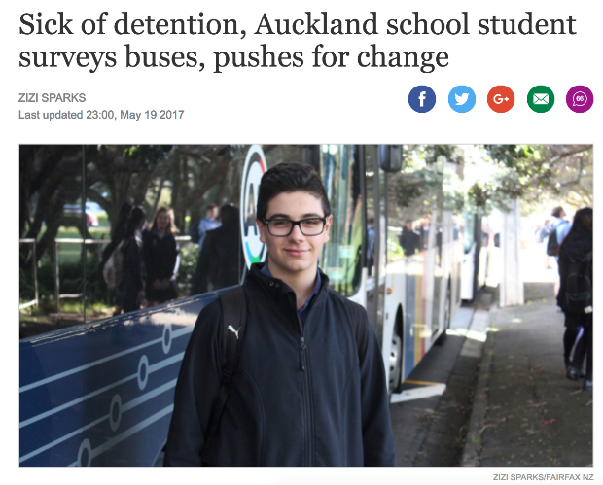
Read the story ‘Sick of detention, Auckland school student surveys buses, pushes for change (Stuff)
- Identify or list more ideas to the PMI sheet.
- Explain why transport should be accessible to everyone — and what happens when it isn’t?
- Reflect on what kinds of things young people can do to change local transport?

Task 2: what do we mean when we talk about access or inclusion?
What does accessibility or inclusion mean? Have the students work in pairs to read and explain their understanding of this quote below:

‘Accessibility is the ultimate goal of most transportation activity. Accessibility refers to people’s ability to reach services and activities, and therefore, it affects the time and money that people and businesses must spend on transport. Several general factors can affect accessibility:

- Motor vehicle travel conditions: Vehicle travel speeds, affordability, and safety.
- Quality of other ways of travelling: Walking, cycling, public transport (buses etc.), delivery services speeds, convenience, comfort, affordability, and safety.
- Transport network: How many paths and roadway connections people can access; the directness of travel between destinations; the quality of connections between types of transport, such as the ease of walking and cycling to public transport stations.
- How land is used: Development density and mix – distances between activities.’

(adapted from Evaluating Accessibility for Transportation Planning, Victoria Transport Policy)

Watch the following videos in pairs or as a whole class. They explain ‘universal design’ and how it helps designers include everyone, not only those with disabilities:
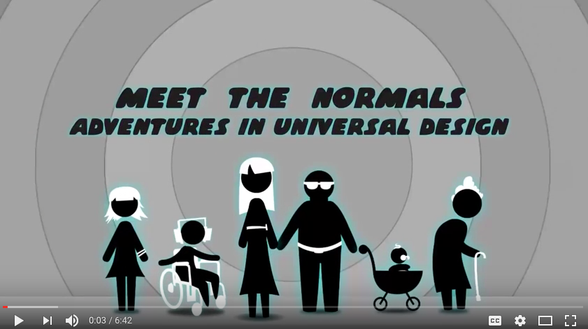
‘What is Universal Design?
‘Why We Need Universal Design’, Michael Nesmith
‘Meet The Normals – Adventures in Universal Design’

Share ideas as a class:
- Identify at least one example of transport that is easy or hard to access.
- List at least two ways in which transport can be made harder or easier to access.
- Explain why we all need to be able to access transport.
- Explain how transport can be made more accessible.
- Imagine: What if people can’t get access to transport easily?
- Reflect on how accessible your own journeys are.

Activity 2 – our lived experiences – using photovoice
Students will use photovoice to create visual stories that describe how easy or hard it is to travel around where they live. They will engage prior knowledge, enhance the relevance of new learning, and facilitate shared learning.

Task 1: capture the stories to find empathy — photovoice
‘The mission of design thinking is to translate observation into insights and insights into products and services that will improve lives.’ – Tim Brown, IDEO.
This task involves students capturing a photo of a journey that tells a local story about accessibility. It could be positive (for example, ramps for wheelchairs) or negative (for example, broken kerbs, no pavement). They can focus on their own journeys, take on the role of someone they know, or focus on a person from the video ‘Meet the Normals’.
Prepare the students:
- Check they have access to a camera (mobile phone, sharing cameras with another, using a school device etc.)
- Give students the question: What gives people access to transport or prevents them from accessing transport on your journey to school?
- Make sure you have a shared space to show the images, for example, you could upload to a collaborative Google Slide deck (one per student), email to a Flickr group or blog (send via automatic email), or upload to a shared folder.
- Share examples of a photovoice project (see below). Students need to capture a photo and be ready to tell the story behind it (see Task 2).

Examples and more information on the use of photo-voice:
A practical guide to photovoice
Photovoice students use photography to advocate for safety
Projects (PhotoVoice organization)

Task 2: tell the stories – photovoice
‘Photos (or videos) are meaningless without the story that goes with it.’
– Aimee Ward, University of Otago

Once everyone has uploaded their images, share stories and look for meanings.
Students share in small groups or with the whole class. Students can have five to ten minutes to explain the story behind their photo. Each person talks about:
- why they took the photo
- what they captured
- what the photo shows about access to travel
- what other story is shown in the photo
- how the photo relates to the big question.

Keep everyone participating: assign roles in groups (photographer; scribe; synthesiser; challenger, etc.)
As a class, look across the collection of images and pull ideas together:
- What examples show positive aspects to local transport?
- What examples show barriers to our local journeys?
- How do all our images relate to the big question?
- How might some of these images change the minds of those who design our transport systems?
- What can we change ourselves?

Activity 3 – widen the net
Students will view video stories to research wider issues related to how easy it is for people to access travel options. You will be introducing new knowledge and reading for meaning.

Task 1: what else is happening out there for other people?
The students will now find out more about the kinds of barriers transport systems can present – and how we can design for universal access.
Different sites could be set up via a Google doc or Livebinders, and the research activity could be done as a jigsaw activity.
Jigsaw learning (TKI)
Select resources (see below) at the appropriate literacy and interest level for your students. The resources should help them understand their own journeys in more detail.
Clarify the purpose for reading, and revisit the following questions:
- Identify at least one example of transport that is easy or hard to access.
- List at least two ways in which transport can be made harder or easier to access.
- Explain why we all need to be able to access transport.
- Explain how transport can be made more accessible.
- Imagine: What if people can’t get access to transport easily?
- How accessible are your own journeys.

Stories from New Zealand
Christchurch: Transport plan for ‘an accessible city’ (2013)
Auckland: Boy misses school due to disability taxi shortage (2017)
Hamilton: Arms open for accessibility in the Tron (2016)
One in ten elderly Kiwis could be ‘socially isolated’, Age Concern says
Timaru couple upset ten-year-old son has been blocked from school bus (2017)
Young people can tell us how to provide the transport they need to find work (UK, 2013)
Waikato/Bay of Plenty: Community programme removes barriers for young drivers (2015)

Stories from overseas: How do these compare with NZ?
How easy is public transport access for disabled users? (UK, 2014)
No Go Britain: disabled public transport access (2016)
Disability and access: Rap artist 2JHarmonix assesses public transport in South Africa (2016)
Inclusive Design: Making Metrolink accessible for all (UK)
Fukuoka City Subway case study

Activity 4 – problem finding – define your point of view
Students identify problems and generate solutions to improve access to local travel and transport for themselves or others. They might develop the skeleton of their persuasive text here. You will be encouraging reflective thought and action.

Task 1: find your point of view
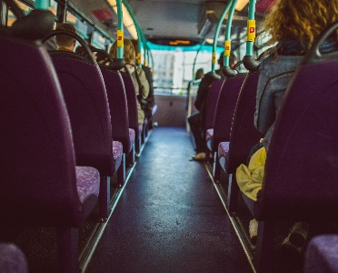
An example: You are a student, travelling to school every day. You notice that you regularly have issues with buses arriving on time. You can see that some people find it much harder to get around. Perhaps, if you think like a designer, you can identify a problem – and then solve it!
This task focuses on defining a problem worth addressing in their persuasive text.
Steps to take
Look across the findings from the previous activity – note the barriers to accessing transport.
Ask students to think about their needs – or the needs of other people.
Ask them to reframe the problem into a worthwhile action statement. Focus on the user, the need, and their own understanding. Have them write it as a sentence as follows:
User (describe) … needs (verb) … because (compelling ideas) …For example, ‘The students at our school need to be able to arrive at school on time because learning can get underway for everyone.’
Sharpen the focus by having the students ‘test’ the statement with others.

Task 2: develop possible solutions – ideate!
Now it’s time to innovate! The aim of this task is to find the best solutions for the local transport ideas they have captured in their statements in Task 1 above. Students can work in pairs or small groups to generate ideas for solving their problems or pitching their point of view more persuasively in their text.
One way to do this is the ‘100 Ideas Challenge’ (adapted from NoTosh).
- Gather students around the different problem statements.
- Make sure everyone has sticky notes and pens.
- Set the timer for 10 minutes. Generate as many ideas to solve the problems as possible in ten minutes.
- After 10 minutes, invite other students to the group and rank the ideas from ‘best’ to ‘not today’.

Activity 5 – take action through persuasion
In this task, students will plan, develop, draft, and refine a persuasive text for immediate friends and family, or their peers, to show how our journeys are part of other people’s journeys – and how we can be safer.

Task 1: understand persuasion
Define what a persuasive text is for the whole class. Discuss why you might want to persuade people of a viewpoint.
Brainstorm examples of who you can set out to persuade in order to make local transport more accessible. Examples could include:
Waka Kotahi, your school, local businesses, families who live nearby, other students, your local council or mayor, online communities or audiences (e.g. Facebook groups), local advocacy groups, charities, Campaign for Better Transport
Compare some examples of persuasive text. Identify and describe the audience, purpose, language features (surface and deep), and the structure.
As they read, use the following actions to work towards success criteria for creating a persuasive text:
- Describe the features of persuasive text.
- Explain the reasons for the surface and deep features of persuasive text.
- Explain why one piece of persuasive text is more effective than another.
- Show the structure of the persuasive texts.
- Compare the persuasive texts to see which is more effective and why.
As a class, identify the success criteria for successful persuasive texts to help students self-assess as they create. See resources below – and refer to the SOLO taxonomy questions on page 2.

Task 2: developing their texts
It’s time for students to develop their texts. Identify authentic contexts. Provide a choice of topics and genres, or they can develop their own. (Possible genres that might include a short film, an oral presentation, a digital essay, a blog post, a letter, a podcast, a montage with voiceover, an advertisement.)
Have students develop a plan. They can do this by using a mind map, planning grid or similar graphic organiser to sequence and structure their ideas. Model this with the class first as appropriate.
Students could develop, draft, review and revise their texts.
Students should swap their texts and self or peer evaluate them against the success criteria.
Students could publish their texts online and request feedback, particularly from their target audience if possible.

Task 3: take action!

This unit could be the basis for further study. They could:
- submit their text to the intended audience, for example, through a letter or video to the local council
- combine the ideas in their writing with images in a digital essay or advertisement which they could upload to YouTube
- present their ideas at an assembly in a speech, video or dramatic presentation
- use what they have found out to prepare for a debate, for example, they could use the topic ‘Young people don’t do enough to keep themselves safe on the roads’
- participate in the international Decade of Action on Road Safety movement
Decade of Action on Road Safety (WHO)
- develop a whole-school action to improve road safety and share their story with Waka Kotahi.
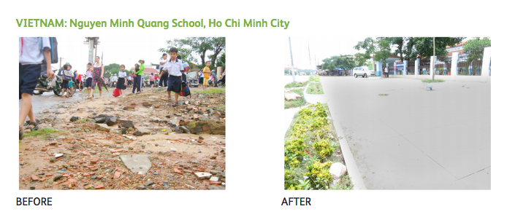
Example: Before and after from photovoice project – SafeKids

Resources to support the text development process
Learning about persuasive texts
Features of persuasive writing (English Online)
Creating texts (Literacy Online)
Supporting the writing process
Persuasive online video strategies that prompt action
Top tips for filming with a phone
Develop a persuasive speech
Examples: Oral and Visual
Waka Kotahi marketing campaigns
Students Against Dangerous Driving
Split Second Competition (Transport Accident Commission Victoria)
Examples: Written
Accessible and inclusive transport: can we achieve it?
Our campaigns (Brake, the Road Safety Charity)

