A place we all share
English Years 9-10: read persuasive adverts for meaning
In this unit, students will undertake critical reading of advertisements in the context of their own actions around road safety.

Teacher notes

The context
Key understanding: Advertisements often try to change how we behave. New Zealand road safety advertisements encourage us to think of the roads as a ‘commons’, a place we all need and share.
Driving question: If we see the roads as a place we all need and share, can we make it a safer and fairer place for everyone?

Timeframe
This unit can be explored over 2-3 weeks, but it can be adjusted to be part of a wider inquiry. Students do not need to complete every task.

Big picture focus
Vision, values, and key competencies (NZC): This unit focuses on students being informed decision makers and effective communicators for the benefit of their community. It foregrounds the values of community and participation, integrity and respect, and the key competencies of participation and contribution and using language, symbols, and texts.
A place we all share:
‘When the road is framed as a commons, students can develop deeper, more flexible perspectives of citizenship. All students are road users and have personal experience of why road use must be fair. They have an authentic model for citizenship embedded in their own experience; they have agency. The big idea for students is that all people using roads are precious, so we need to think and act together to create a safe system.’ – Pam Hook
Transport as a context for encouraging skilled and active citizenship (Pam Hook, Waka Kotahi)

Note on the context
Teachers should be aware that this unit might involve the discussion of road crashes. Students may have first-hand experience of such issues, and teachers should be discreet during discussions. Students should be advised of the topic before they start the unit.

Plan the learning intentions
This unit is aligned to English Achievement Objectives (Levels, 4, 5, and 6): Listening, reading, and viewing.
Use the inquiry cycle to inform your planning. You might use the following methods to establish your students’ strengths and needs.
Planning using inquiry (English Online)

You may choose to use diagnostic testing. Use ‘What next’ to identify next steps for your students.
What next
And for assessment, you could use:
Assessment Resource Banks (NZCER)
Review previous assignments and learning completed by your learners. Have discussions with your students and their family or whānau. Ask yourself how you can integrate culturally responsive content and processes so the learning has direct relevance and meaning for them.
The learning intentions in this unit are structured around the SOLO taxonomy verbs to develop ideas from surface to deeper engagement. Select those that best match your students’ learning needs. Different students may have different learning intentions.
SOLO Taxonomy (Pam Hook)

SOLO symbol images © Hook Education Ltd. Reproduced with permission.
Unistructural  (can identify a single idea; ‘on the lines’)  Define ‘persuasive’.  Define ‘purpose’ and ‘audience’.  Define the purpose of a persuasive text.  Identify one idea in a persuasive text.  Name one language feature in a persuasive text.  Name one aspect of structure in a persuasive text. | Relational  (can identify more than one idea, and explain how they are related; ‘between the lines’)  Classify the different language features.  Classify the different structural features.  Compare the ideas in a persuasive text.  Explain the reasons for the use of language and structural features in a persuasive text.  Explain why one piece of persuasive text is more effective than another.  Sequence the structure of their persuasive text.
Multistructural  (can identify more than one idea but not link them; ‘on the lines’)  List several ideas in a persuasive text.  Describe the purpose of persuasive text.  Describe the language features used in a persuasive text.  Describe the structural features used in a persuasive text | 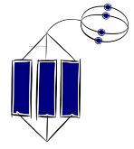  Extended abstract  (can identify and explain related ideas and extend thinking beyond them; ‘beyond the lines’)  Create a persuasive text.  Create a set of criteria to critique a persuasive text.  Reflect on the text and evaluate its strengths and weaknesses.  Generalise the typical features of a persuasive text.  Integrate different sources of information to critique a persuasive text.

Activity 1 – who shares our journeys?
Students use their prior knowledge to explore how we are all part of a system of road users. They will build a shared picture of the people in their community by exploring the journeys they make at similar times and places.

Task 1: our fellow travellers
Watch these Waka Kotahi advertisements:
Thank you for your speed
Hello
Explain the concept of a ‘commons’ and ask the students for any other examples (for example, Wikipedia, Creative Commons, shared parks, DoC huts)
Commons (Wikipedia)
Ask the students to share their impressions of the idea that ‘When I travel to school, I am part of a commons because …’.
Capture their initial ideas in the first two columns of a KWL chart.
Interactive K-W-L creator
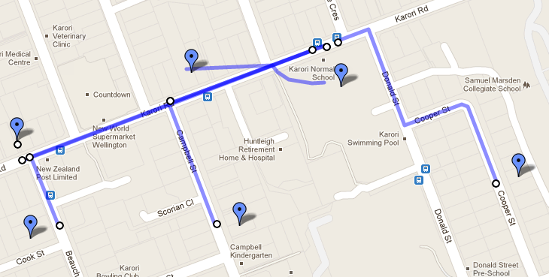
Ask the students to think about the journeys they and their families make at a similar time each day, for example, the journey they make to school.
Map their journeys so the class builds a shared picture of their journeys. You could map their journeys in ways that suit the class and your resources. You could choose from:
Idea 1 – physical map
Using Google Maps, print off a local area map and display it. Students could use pins, labels, string or highlighters to mark their journeys.
Idea 2 – digital map
Collaborative map making using Google maps
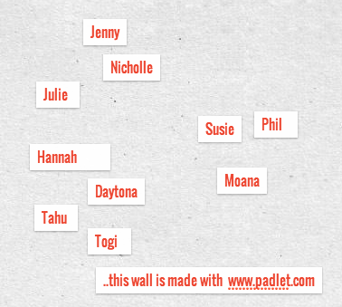
Label the journeys by time, name of person and type of transport – and aspects of the journey that they find interesting or frustrating.
Identify which members of the class share journey times and routes. The task could be extended to include members of family or whānau who may be travelling at similar times.
Help students to see themselves as part of a group who have things in common. Have them do an activity to show this.

They could choose from the following:

Idea 1 – physical network
They can write their fellow travellers’ names on sticky notes.
Have them move around the room to stand with different people with whom they have something in common.

Idea 2 – digital network
Use a tool like Padlet and group the students according to their similarities.
Use a graphic organiser to manipulate groups and label them with different people’s names. They could use online graphic organisers:
Mindmeister
Bubbl.us

Task 2: how are we all part of the same ‘commons’?
This task aims to synthesise what students have learned in the previous task and focus on the concept of the road as a commons that we are all part of and are responsible for.
Have them complete this sentence: ‘When I travel to school, my journey is part of a commons because … this means that I should …’

Activity 2 – what if …?
Students, using their knowledge from activity 1, come to understand why seeing journeys as being part of a commons or shared space means that we can think like active citizens as we travel.

Task 1: identify at least one decision that people take during their journeys
Ask the students to brainstorm decisions that people have to make when travelling in the mornings. For example, we drive the car, rather than walk; in the car, we decide whether to put on seatbelts; we cross the road; we decide whether to look for cars …’
Have them describe what happens before, during and after they make their decision.

Idea 1 – Physical story
Storyboarding their decision. They could use:
Miro storyboarding template
Act out the decision, with friends or as a monologue.
Write it out as a first-person narrative.

Idea 2 – Digital story
Using a story-creation app or comic-creation app:
14 apps for story creation (iOS)
Pixton

Task 2: let’s think about ‘individuals’ and ‘commons’
Now the students understand the details of the decision that they make, they are going to look at it from two different points of view.
They should generate at least two ‘What if …?’ questions: one from the point of view of ‘my journey’ and another based on ‘our journey’ as part of the commons.
For example, if the decision involved crossing the road:
My journey | Our journey as part of the road ‘commons’
What if … I ran across the road so I can get to school faster? | What if … I thought about the people who are driving along the road?

They may be able to think of several ‘what if …?’ questions for each point of view.

Ask students to predict the consequences for each of their ‘What if …?’ scenarios.

Idea 1 – dramatic
Performing, freeze-framing and thought-tracking two versions of the decision.
See:
thought-tracking

Idea 2 – mapping
Using a futures wheel for one point of view, then for the other – a futures wheel is a way of mapping out future consequences of an action. Examples:
Futures Wheel Diagram (Mindtools)

Task 3: create a general statement about what it means to ‘travel social’
This task invites students to synthesise ideas from the previous tasks to understand the implications of thinking about journeys in terms of others, rather than ourselves. The aim is to introduce the idea of everyone being an active citizen in a safer road system.
Discuss the statement: If we all saw our journeys as part of a shared ‘commons’ where everyone has a responsibility to everyone else, the road system would be safer.
You could do this through:
- a classroom discussion or classic debate
- a walking debate
- a groups discussion using the placemat activity
- a digital collection of ideas using VoiceThread or Google Slides.
What other questions do they still have? Share their questions.
For example:
- Would this even be possible?
- What if a minority of people didn’t think that way, or wouldn’t?

Activity 3 – the big issues
Students explore background material on travel and road issues. They should begin to integrate different sources to understand the key ideas, purpose, and audiences that they might see in persuasive texts aimed at the way people use our roads.

Task 1: identify and list the opportunities and issues on our roads
Students will explore the different parts of the ‘commons’ (eg behaviour, structures) that influence how people use the roads in New Zealand, especially young people.
Read a selection of the background material to identify at least one issue (or list more than one) that impacts the way we travel.
Students could read alone, in pairs or use:
Jigsaw activity

Suggested resources from Waka Kotahi
Perhaps begin with your own mode of transport!
Walking
Scooter safety tips
Cycling in New Zealand
Skateboard and bike tips
Keeping children safe
Vehicle safety
Safety around railway lines
How we behave:
Driving safely – speed, young drivers, driver distraction, alcohol and drugs, motorcycles etc.
Speed
Current marketing campaigns
Film (20 mins): ‘The difference between life and death’ (discretion advised)

Task 2: make connections to see the ‘commons’ big picture
This task pulls together the different issues students have discovered from their reading.
Two ways to identify connections between issues:

Use hexagonal thinking
Provide each student with a pile of hexagons.
Have them write the issues from their reading in Task 1 on a hexagon.
Ask:
- What different groups of people are involved in the road system?
- What are the key issues? How are they related?
They can share their hexagons and make connections to others, explaining why they are connected.
Here are some examples of how hexagons can be used in class:
SOLO Hexagons (Pam Hook)
Hexagon thinking

Use a connections circle
Have the students plot the issues from the Task 1 reading by using a connections circle (systems thinking chart).
Ask:
- What different groups of people are involved in the road system?
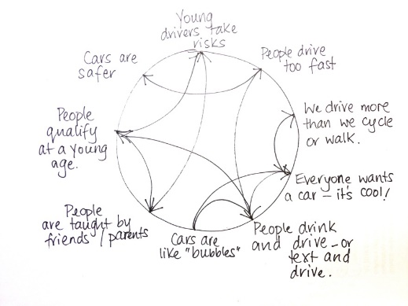
- What are the key issues? How are they related?
Here are some examples of how it works:
Systems thinking
A systemic approach to strategy
A connections circle can help students see the big picture, understand how different issues impact on each other, and help them explore problems where solutions are not obvious.
The aim is to highlight the way the roads are part of a wider system that we all share.

Task 3: generate questions or criteria for a successful advert
Ask the students to look at the connections they have made. List the key ideas that might be in a successful advert that aims to persuade people to think of others when using the road system. Create a series of criteria or questions that should define a successful advert.

Activity 4 – persuasion
Students integrate sources of information and prior knowledge (from activities 1, 2, and 3) to understand the ideas, language, and structure in a Waka Kotahi advertisement.
The mission! Time to road test an advert and figure out if it could make a difference to how people behave.
Think about why and how persuasive advertisements can make a difference – and whether this advertisement is likely to be successful.

Task 1: identify and describe the features in a persuasive text
Have the students watch at least ONE of the persuasive texts from:
Current marketing campaigns (Waka Kotahi)
Other example:
‘Legend (Ghost Chips)’
After they have watched one advertisement, have them explore some of these questions:
- What is a persuasive text?
- What features make a text persuasive?
- What is the purpose and the audience of the advert?
- What point is the advertisement trying to make?
- What features are used in the advert to try to get the ideas across?
They could do this individually or in small groups, using a graphic organiser, post-it notes, brainstorm, or a class collaborative discussion or document.

Task 2: organise features of persuasive texts
As a class, list the students’ ideas about the advertisement’s features and organise them under different headings, such as ideas, language (vocabulary, phrases, visual effects, point of view, connotation) and structure (beginnings, endings, sequence).
They could do this around the room, using an online collaborative space, for example, they may group all their ideas related to words and phrases and put it under the heading ‘language’.

Task 3: generate criteria
Look across the notes and create a set of criteria for a successful persuasive text. For example, if an advertisement is going to persuade its audience, what should it do well? Resources on persuasive texts include:
ARBS: Making meaning in persuasive texts (Levels 4 and 5)
English Online – features of text forms (persuasion)

Task 4: critique the advertisements
Explore the first advertisement again. You might want to adapt the following chart to capture the students’ ideas:

 | Questions | Your notes | Evidence (examples from the text)
Purpose and  audience | Describe the purpose of the text – what is the director trying to tell us?
 | Who is the audience? Who is being targeted?
 | How does the text make you feel?
Ideas | What are the causes of the incidents in the text?
 | What is the message?
 | Examine two different texts. What different ways do they convey their messages?
 | Who are the characters? What are their points of view? Whose view do we not hear?
 | What do you know now about road safety? How does this text compare with your own experience?
 | How does the text relate to the ‘big ideas’ we have discussed about road safety?
 | How well would it persuade its audience?
Language  features | Who is the text for? How do you know?
 | How does the director use different shots, groups of shots, camera angles, setting, special effects and lighting?
 | How does the director show you what the characters are like?
 | How does the director create mood and feeling?
 | Describe the kind of music in the text. How is it used to develop character, ideas or mood?
 | How does dialogue and sound (or absence of them) show you the key ideas?
 | Identify/describe the main events. How do the different events and the way they are ordered, tell you about the main ideas?
 | Describe the beginning and ending. Are they the same? Are they different?

Have students complete ‘magic sentences’ after they have watched the advertisement.
They can do this individually or in groups and on paper or in a collaborative document.
For ideas about creating magic sentences:
DIY magic sentence
(This is a literature version of this activity by Ian McGilchrist, via English Online.)
They could use this framework to help them write their sentences.

Author/creator | Verb* | Aspect of persuasive text (language/structure) | Purpose* | Idea
Waka Kotahi | uses | a close-up shot of smiling faces | to show us | it’s a good idea to think of others as we drive.

* You could provide verbs and purpose phrases, or they could generate their own.
Explore a second text, and repeat the process.
Compare the two texts, using the criteria developed by the class.
Discuss which one is most successful and why.
Return to the KWL activity from the first activity and complete the final column about what they have learned.

Activity 5 – take action!
This task could be used as a formal assessment of critical understanding of persuasive texts. Consider: How are your students using English to make a positive contribution to their community’s road commons? Are they:
- making active decisions and taking the initiative?
- making links to ideas and contexts beyond their immediate contexts and thinking about the future?
- engaging in challenge, critique, and inquiry?
Review their understandings through:
Key competencies self-audit framework
Discuss:
- How and why are road safety advertisements trying to change what people do on the roads?
- What impact do the advertisements have on me and people around me?
- How can I turn what I have learned into actions that make a difference to the way my community and I travel?
Assessment through ‘participation’: English
Students can choose how they show their understanding about how persuasive texts work. Base your assessment on the SOLO Taxonomy statements from page 2.
These could be part of a cross-curricular initiative on road safety in school, it could be a presentation of students’ ideas at an assembly, or they could take action in their local community.
Examples of students taking action locally:
Case studies of teaching and learning (Waka Kotahi)
You could develop a student-driven whole school action to improve road safety and share the story with Waka Kotahi. Ideas for assessments:
- An essay or extended piece of writing that explains how one or more of the advertisements is constructed.
- A multi-media presentation to the school community, unpacking how well the advert might impact young people.
- A blog post that explores how a text works – and how it could be improved.
- A multi-media presentation, for example, a video of the advert with commentary from the student accompanying it or a VoiceThread.
- A dramatic re-enactment of the advert, paused, with commentary from the student.

