Safe speeds around schools

Unit plan outline
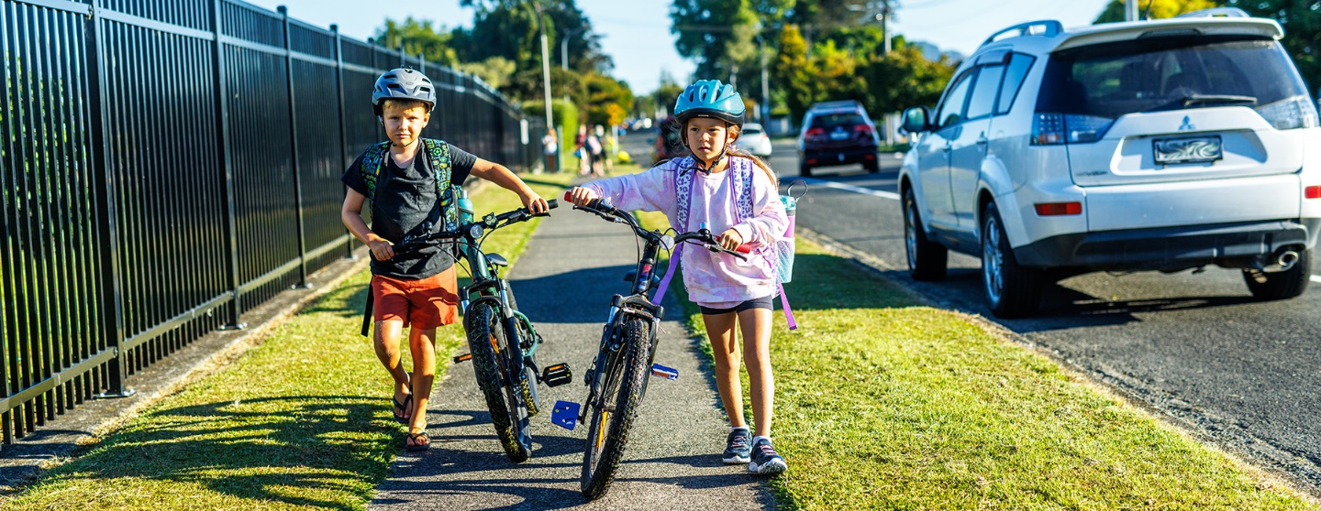

Purpose
Speed limits are changing on the roads around school and kura. Your students will see new speed signs and other features, prompting a real-world opportunity to understand how they themselves contribute to a safer, thriving community.
Safe speeds enable more kids to get around safely in ways that are good for their health and the environment. Plus, there’s reduced risk to tamariki and whānau of being killed or seriously injured on the way to and from school.
The Safe speeds around schools lesson plans bring this to your classroom.
Students will:
- identify hazards on our roads
- know the science of how lower speeds make school travel safer
- investigate and present their findings about safe local routes, learning through doing that it will take all of us working together to make our roads safe.

Curriculum connections (refreshed NZ Curriculum)
Understand, Know, Do format used. This can be adapted to fit the exact content of the refreshed curriculum as it is released.
Years 0-3, 4-6 and 7-8 replace current curriculum levels. These are used here for the 3 lessons.

Three lessons per age group
This unit can be taught in its entirety while each lesson is also designed to work as a stand-alone activity.
Understand: Our travel behaviours
Students will:
- identify hazards of travelling on our roads
- identify safety features that are currently in place
- Understand everyone has a part to play to make our roads safe.

Know: Speed and safety
- speed limits will be set lower around schools
- slower = safer
- science experiments demonstrate force, and reaction time.
Do: Travelling around our school
- hazards
- how best to go
- construct a safety map or plan
- Possible digital presentation option linked to digital technology curriculum.

Each lesson includes:
- adaptations for each age group
- resources for the lesson
- links to additional resources from Waka Kotahi
- suggested steps
- tikanga and te reo Māori connections
- suggested extensions for learners who require a challenge
- suggested accommodations for learners with additional needs.

Overview of lesson 1
- Students brainstorm hazards of road travel in groups and present them to the class.
- Students brainstorm road safety features that are in place. Video or walk around to spot road safety features (signs, crossings, etc)
Students identify something they do or can do to improve road safety and produce a piece of persuasive writing to convince others to do the same.

Overview of lesson 2
- Videos shown and idea of speed limits discussed.
- Students discuss why there are speed limits.
- Safe Speeds Around Schools campaign introduced.
- Science experiments conducted to identify why lowering speed limits increases safety.
- Force with which something hits. Marble investigation.
- Reaction time – how quickly can we suddenly stop at various speeds?
Students write or otherwise present their conclusions and explain using the evidence from the experiments what the effect of lower speeds can be.

Overview of lesson 3
- Walking around school grounds or using Google Maps, students explore the area around school and their personal route to school.
- Students construct a map of the area around school which identifies hazards.
- Each hazard is annotated with a suggested action.
- Depending on age, ability, and teacher commitment this could take the form of a digital interactive map, a series of videos shot at each location or a collective slideshow with slides for each hazard area.
The focus and theme is ‘it takes everyone to get to no one’. We all have a part to play in road safety and thinking about our personal responsibility.

Curriculum Connections (current NZC)

Key Competencies
Thinking
Thinking is about using creative, critical, and metacognitive processes to make sense of information, experiences, and ideas.
These processes can be applied to purposes such as developing understanding, making decisions, shaping actions, or constructing knowledge.
Managing self
Students who manage themselves are enterprising, resourceful, reliable, and resilient.
They establish personal goals, make plans, manage projects, and set high standards.
Participating and contributing
Students who participate and contribute in communities have a sense of belonging and the confidence to participate within new contexts.
They understand the importance of balancing rights, roles, and responsibilities and of contributing to the quality and sustainability of social, cultural, physical, and economic environments.

Social Sciences
Level 1
- Understand that people have different roles and responsibilities as part of their participation in groups.
Level 2
- Understand that people have social, cultural, and economic roles, rights, and responsibilities.
Level 3
- Understand how groups make and implement rules and laws.
- Understand how people view and use places differently.
Level 4
- Understand that events have causes and effects.
- Understand how people participate individually and collectively in response to community challenges.

Science
Levels 1&2
Investigating in science
- Extend their experiences and personal explanations of the natural world through exploration, play, asking questions, and discussing simple models.
Participating and contributing
- Explore and act on issues and questions that link their science learning to their daily living.
Physical inquiry and physics concepts
- Explore everyday examples of physical phenomena, such as movement, forces, electricity and magnetism, light, sound, waves, and heat.
- Seek and describe simple patterns in physical phenomena.
Level 3
Investigating in science
- Ask questions, find evidence, explore simple models, and carry out appropriate investigations to develop simple explanations.
Participating and contributing
- Use their growing science knowledge when considering issues of concern to them.
- Explore various aspects of an issue and make decisions about possible actions.
Physical inquiry and physics concepts
- Explore, describe, and represent patterns and trends for everyday examples of physical phenomena, such as movement, forces, electricity and magnetism, light, sound, waves, and heat. For example, identify and describe the effect of forces (contact and non-contact) on the motion of objects; identify and describe everyday examples of sources of energy, forms of energy, and energy transformations.

Level 4
Investigating in science
- Ask questions, find evidence, explore simple models, and carry out appropriate investigations to develop simple explanations.
Participating and contributing
- Use their growing science knowledge when considering issues of concern to them.
- Explore various aspects of an issue and make decisions about possible actions.
Physical world, Physical inquiry and physics concepts
- Explore, describe, and represent patterns and trends for everyday examples of physical phenomena, such as movement, forces, electricity and magnetism, light, sound, waves, and heat. For example, identify and describe the effect of forces (contact and non-contact) on the motion of objects; identify and describe everyday examples of sources of energy, forms of energy, and energy transformations.

Health & Physical Education
Level 1: D2 Community resources
- Identify and discuss obvious hazards in their home, school, and local environment and adopt simple safety practices.
Level 2: D3 Rights, responsibilities, and laws, D4 People and the environment
- Contribute to and use simple guidelines and practices that promote physically and socially healthy classrooms, schools, and local environments.
Level 3: D3 Rights, responsibilities, and laws
- Research and describe current health and safety guidelines and practices in their school and take action to enhance their effectiveness.
Level 4: D3 Rights, responsibilities, and laws, D4 People and the environment
- Specify individual responsibilities and take collective action for the care and safety of other people in their school and in the wider community.

