Safe speeds around schools

Lesson 2: Knowing how speed affects safety
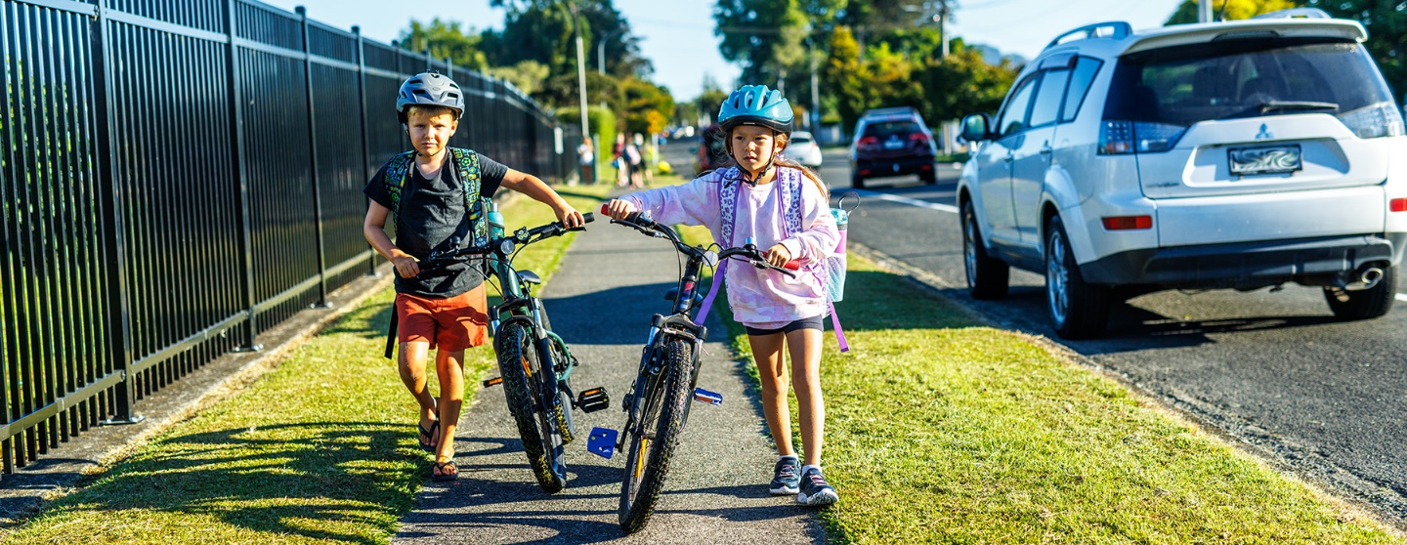

Purpose
Students will:
- learn that speed limits around schools will be set lower
- understand why slower = safer
- come to know, through scientific investigation, how lower speeds result in increased reaction time to avoid crashes, and that speed determines the outcome of a crash.

Resources
- Time: 1-2 class sessions. Approx 45min - 1.5 hours or more
- The Sign of a Safe Speed Video (Waka Kotahi, YouTube)
- paper and pens or pencils
- paper cups
- marbles or other small spheres
- rubber bands
- rulers
- measuring tape
- chalk
- stopwatches.

Matauranga Māori
Kaitiakitanga: guardianship, stewardship.
This unit of work is strongly connected to the Māori concept of kaitiakitanga, that we are seeking to protect our people, our community and ourselves. How the designers of the roads are acting as kaitiaki, and how we can be kaitiaki are great ways to frame conversations around these lessons.
Te reo Māori vocabulary:
- Waka: vehicle
- Ara: road or path
- Hīkoi: to walk
- Tangata hīkoi: walker, pedestrian
- Tohu: sign
- Kaitaraiwa: driver
- Marutau: safety, to be safe
- Pahikara: bicycle
- Kaieke pahikara: cyclist
- Kutarere: scooter
- Mapi: map
- Tere: speed
- Tepenga: limit
- Tuki: to bump or crash
- Tōpana: force

Steps | Adaptations for different levels
Discussion and hypothesis about why we have speed limits.  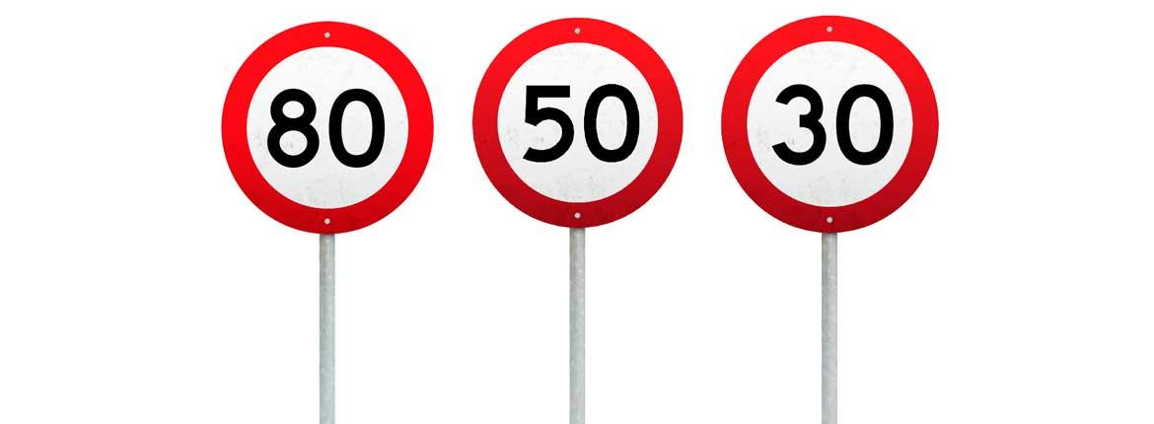  - Show students the image above (also pasted larger below) and ask why we have speed limits. Discuss.  - Discuss why different places have different speed limits. | Years 1-3  For students of this age, the discussion will be more about ‘fast’ and ‘slow’ than about the numbers.  Ask where we drive fast and where we drive slow. Why? Give some examples (e.g. Would we drive fast or slow on a motorway? Would we drive fast or slow near a hospital?).  Years 4-6  For students of this age, discussion can include different speed limits they have noticed in different areas, and why they may be different.  Years 7-8  For students of this age, discussion can include different speed limits they have noticed in different areas, and why they may be different.  They can also discuss why they think slower speeds may be safer in some places. What is it about slower speeds that makes it safer for drivers or other road users?
Science Investigation 1 – speed and force  - Students are put in groups of 3 and given a marble or other small ball, a paper cup, a pencil, two rubber bands, two pieces of paper and a ruler.  - Students first create a marble launcher according to these instructions:  How to make a marble launcher  - Mark the inner tube with measurements so that students can quickly determine how far back they have pulled the launcher.  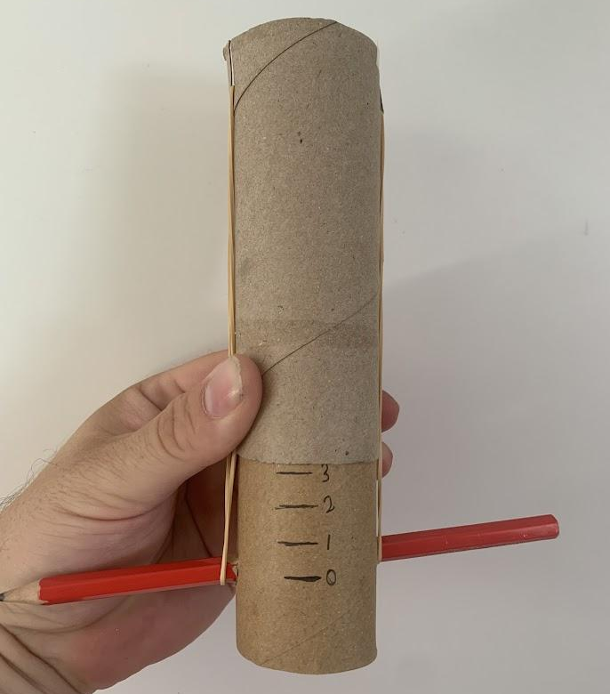  - Students set up their workspace as shown in the photo, with a clear start line for the cup, a clear start line for the front of the launcher, and a way of measuring the distance the cup moves (a ruler alongside works well, or graph paper could be used).  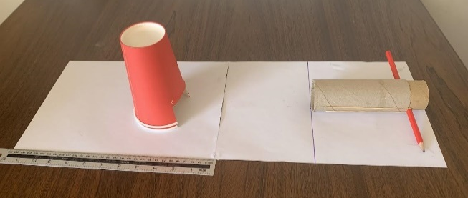  - Students take turns being the ‘shooter’, the ‘measurer’ and the ‘recorder’.  - The ‘shooter’ places the cup on its start line and the launcher on its start line. They insert the marble so that it rests against the pencil and pull back the launcher by the amount required. They then let go, firing the marble into the cup.  - The ‘measurer’ records how far back the launcher was pulled, and measures how far the cup has moved, from the line to the closest edge of the cup.  - The ‘recorder’ writes down this information on the recording sheet.  - This process is repeated with the launcher pulled back by different distances.  - Students seek to find a pattern that increased force and speed of the marble results in a greater distance the cup moves.  - Discuss with the class how this relates to cars and travelling at different speeds. Basically, faster speed = harder crash and so is more likely to lead to injury. | This video demonstrates the investigation: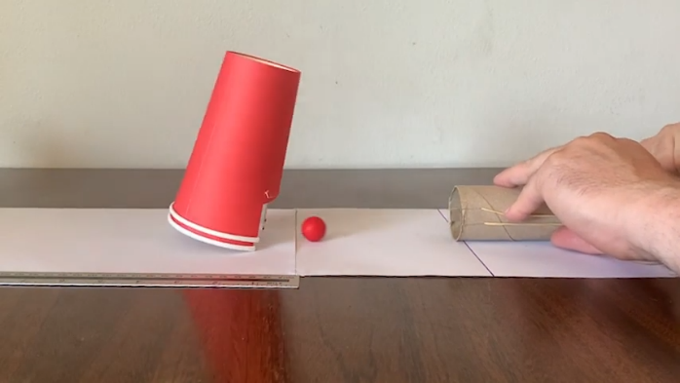  Marble investigation demonstration (Waka Kotahi, YouTube)  Years 1-3  You may wish to team up with an older buddy class to assist in building the marble launchers before the lesson.  Rather than take specific measurements, students can estimate how far the launcher was pulled back and how far the cup travelled. ‘A little, a lot’, or ‘least, middle, most’ is fine. The important thing is that they recognise the pattern.  Years 4-6  Students can measure the distance the cup moves, from the furthest point forward before it is hit, to the furthest point forward afterwards. This could involve a discussion of ‘controlling variables’, making sure that we do the same things each time and only change one thing - in this case the distance the launcher is pulled back. This ensures we know the difference in the cup’s movement is only because of what we change about the rubber band.  Years 7-8  Students can measure the distance the cup moves, from the furthest point forward before it is hit, to the furthest point forward afterwards.  This could involve a discussion of ‘controlling variables’. Students could graph their results for a visual representation of the pattern that emerges.  Students could also do a second round of the experiment with a different kind of ball. For instance, a pom pom could be used for one experiment, a marble for another. This would allow them to compare how different masses affect the force of the track and discuss how a truck colliding with another vehicle has a greater impact than a small car.
Science Investigation 2 - Stopping Distance  - Students are put in groups of 3 and given a measuring tape, a piece of chalk, a recording sheet, a pencil, and a stopwatch if you are using this variation (see age group variations in the right-hand column).  - As a preliminary activity, have each of the 3 students take a turn standing in place, while the other 2 run past them. One runs as fast as they can and the other jogs slowly. Students can discuss the difference in how this felt for the stationary student, and how this relates to the feelings of safety that different speeds may cause for other road users. (e.g. a cyclist being passed by a fast car vs a slower one).  - For the remainder of the investigation, students take turns being the ‘driver’, the ‘measurer’ and the ‘recorder’.  - A line is drawn on the ground, which will be the ‘stopping line’. This is best done on a hard surface such as tarmac or concrete which can be easily marked with chalk. Alternatively, line marking spray can be used on grass. 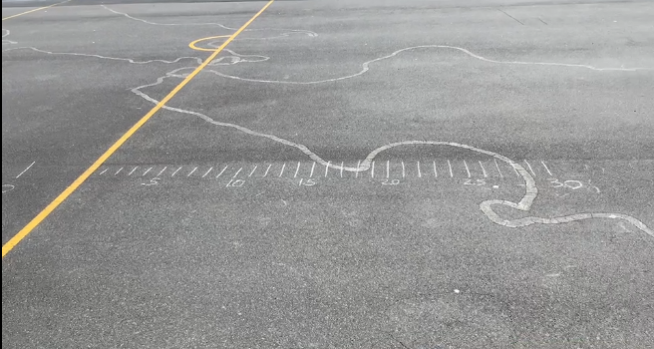  - The ‘driver’ runs towards the stopping line. They try to travel at a constant speed, and then slow to a stop safely when they get to the line. Fully stopped means they are able to stop all forward momentum and bring their back foot up to stand next to their forward foot. Emphasise that it’s expected to take a few steps of slowing down before they are able to fully stop, so to do so safely and avoiding falling over.  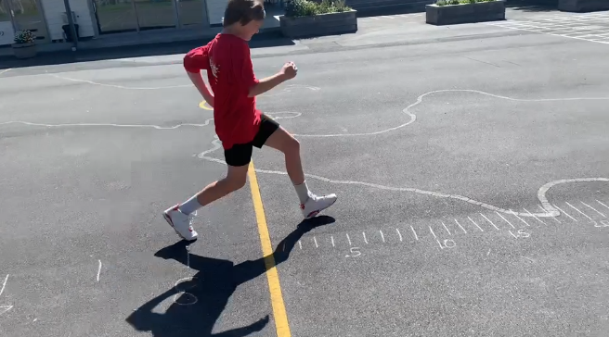  - The ‘measurer’ measures the distance between the stopping line and the heels of the ‘driver’ when they have come to a complete stop.  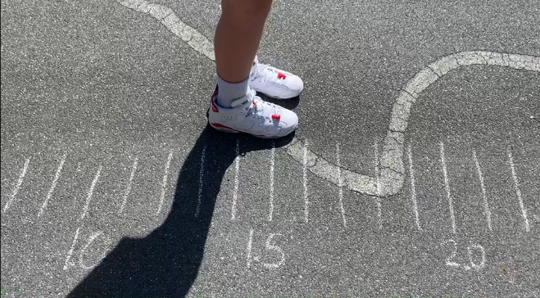  - The ‘recorder’ writes this down on the recording sheet.  - This process is repeated with ‘drivers’ travelling at a variety of speeds.  - Students seek to find a pattern that faster speeds result in longer stopping distances.  - Discuss with the class how this relates to cars travelling at different speeds. Basically, faster speed = the car travelling further before it stops. Crashes become more likely because vehicles can’t stop as quickly. | This video demonstrates the investigation:  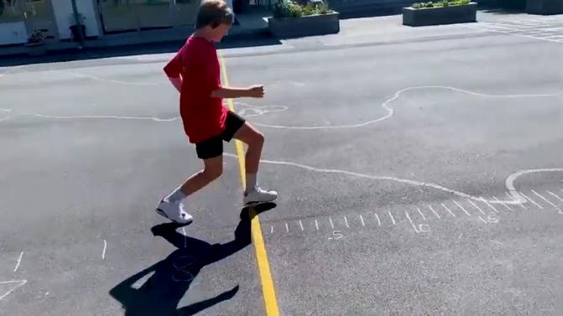  Stopping distance demonstration (Waka Kotahi, YouTube)  Years 1-3  Rather than take specific measurements, students can deliberately choose a speed (slow, medium, fast). Evenly spaced lines can be drawn on the ground by the teacher after the ‘stopping line’, and students can record how many the ‘driver’ crossed. Results would be ‘slow, 1 line’ etc.  The important thing is that they recognise the pattern.  Years 4-6  Students of this age can measure the distance the ‘driver’ travels after the ‘stopping line’ in centimetres. They may wish to do 3 trials each as the ‘driver’ and compare their personal slow, medium and fast speeds.  This can be discussed as controlling variables, because we don’t know if one person’s fast is the same as someone else’s medium. This way we compare 3 speeds for each person and can see the pattern.  Years 7-8  With a bit of extra setup and observation, nearly exact speeds can be recorded in metres per second. On the track leading up to the ‘stopping line’, a line can be drawn every 0.5 metres for about 5-10 metres.  As the ‘driver’ travels towards the ‘stopping line’, the ‘measurer’ can hit the stopwatch when the driver enters the track and observe how far they got in 1 second. If they travelled 3.5 metres, they are travelling 3.5 metres per second, etc.  This gives us much more accurate speeds to compare when seeking a pattern. Students could graph their results for a visual representation of the pattern that emerges.
Safe speeds around schools plan introduced and videos shown.  - Play The Sign of a Safe Speed Video and discuss with the class how this relates to our investigations.  - Share and discuss:  “Setting safe speed limits around all schools improves actual and perceived safety to encourage and enable more active travel to and from school which is important for healthy communities. It also reduces the risk to tamariki and whānau of being killed or seriously injured while travelling to or from school.” From:  Safe speeds around schools (Waka Kotahi)  - Discuss each of the student investigations and how it relates, guiding their thinking to drawing a conclusion from evidence. What did the marbles show us is different at a lower speed? (hits less hard). What did the stopping distances of the runners show us about lower speed? (We can stop quicker). Why would lower speed limits around our school be a good idea? | Years 1-3  Students may draw a picture of cars driving past their school. A writing prompt may be ‘Driving slower near our school is safer because ____’ giving one reason from our investigations.  Years 4-6  Students may write a paragraph explaining one of the investigations, and why it shows that slower speeds near our school would be safer.  Years 7-8  Students write 2+ paragraphs describing what each of our investigations shows and adding a persuasive message about why we should have lower speeds near our school.
Student writing to present their conclusions, based on the evidence from the investigations, in support of safe speeds around schools.
- Students write a short piece describing their findings and how they relate to speed limits.

Extra support

Extension ideas for learners who need additional challenge
Younger students who need additional challenge could do the activities suggested for older levels. They will be working on the same themes and key messages.
More detailed conclusions can be drawn by students both during the investigations and during the writing piece.
Students can graph their data for each investigation, visually representing the pattern they have found.

Accommodation ideas for learners with additional needs
Older students with additional needs could do the activities suggested for younger levels. They will be working on the same themes and key messages.
The important message is that faster speeds increase the force of a crash and the distance it takes to stop. This can be explained to students and demonstrated once or twice in each investigation, rather than having them seek to find the patterns themselves.

Investigation 1 recording sheet

Investigation 1 – speed and force
Marble launcher  How far back was it pulled? | Cup  How far did it move?
What patterns do we notice?

As the marble launcher is pulled back farther, the cup moves __________.
How does this relate to vehicles on the road?

As cars move faster, a crash would be __________.

Investigation 2 recording sheet

Investigation 2 – stopping distance
‘Driver’  How fast were they going? | Stopping Distance  How far did it take to stop?
What patterns do we notice?

As the ‘driver’ travels faster, the stopping distance __________.
How does this relate to vehicles on the road?

As cars move faster, how fast they can stop __________.

