Safe speeds around schools

Lesson 1: Understand hazards and find solutions

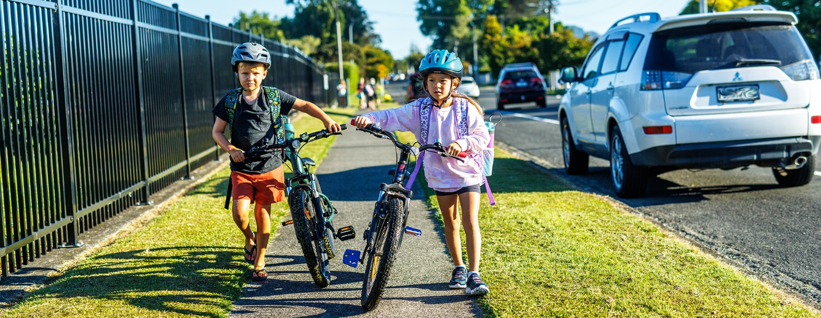

Purpose
Students will:
- identify hazards of travelling on our roads
- identify safety features that are currently in place
- understand everyone has a part to play to make our roads safe.

Resources
- Time: 1-2 class sessions. Approx 45 min - 1.5 hours or more.
- Brainstorming resources. These may include paper and pencils, post-it notes, devices for using Padlet
- Padlet

Matauranga Māori
Kaitiakitanga: guardianship, stewardship.
This unit of work is strongly connected to the Māori concept of kaitiakitanga, that we are seeking to protect our people, our community and ourselves. How the designers of the roads are acting as kaitiaki, and how we can be kaitiaki are great ways to frame conversations around these lessons.
Te reo Māori vocabulary:
- Waka: vehicle
- Ara: road or path
- Hīkoi: to walk
- Tangata hīkoi: walker, pedestrian
- Tohu: sign
- Kaitaraiwa: driver
- Marutau: safety, to be safe
- Pahikara: bicycle
- Kaieke pahikara: cyclist
- Kutarere: scooter
- Mapi: map
- Matepā: hazard

Steps | Adaptations for different levels
Brainstorm hazards and solutions in small groups  - Put students into groups of 2-3.  - Ask students to think about the hazards when we walk, bike, scooter or drive to get from one place to another.  - Ask them to identify some of the things that road designers do to identify hazards and make them safer.  - This brainstorm can be done through a variety of media (pencil and paper, post-its, Padlet).  - Groups share back some of what they brainstormed. | Years 1-3  This may be very simple and related to things they know well. Some prompting may be required. Things like car seats, seat belts, and pedestrian crossings are well known by children and related to their daily experience.  Years 4-6  Students will have a wider understanding of road safety and are more likely to have done some travelling independently. Things like bike lanes, traffic lights, light-controlled pedestrian crossings, roundabouts may be mentioned.  Years 7-8  Students may have some understanding of road safety as related to driving. Things like road rules, speed limits, car safety features may be mentioned.
Walk around school, physically or virtually, observing and recording road signs, crossings and other safety features that are in place.  - By walking around school or using Google Maps and its Street View, students observe the roads around their school and the road safety features that are in place.  - Students should record what they see.  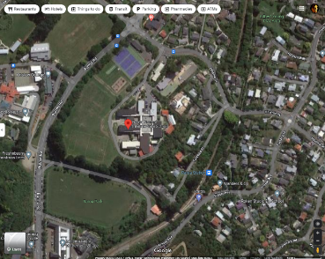  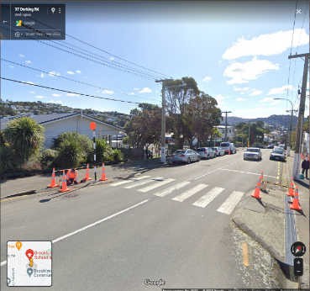 | Years 1-3  This can be done by walking a simple circuit of the school grounds and stopping to write or draw in a notebook the signs that we see, pedestrian crossings and other features.  Years 4-6  This can be done via Google Maps if necessary. Or it may include a walk offsite to somewhere close by, such as the library or the dairy. Students should record the features they see and a note about the location (e.g. traffic lights on a busy intersection, pedestrian crossing between the park and the school).  Years 7-8  This can be done via Google Maps if necessary. Or it may include a walk offsite to somewhere close by, such as the library or the dairy. Students should record the features they see and the possible reasons for this (the traffic lights are because this is such a busy road, the pedestrian crossing has lights because it is so busy that cars might not see people crossing and they could get hit).
Writing - encouraging others to be safe.  - From their observations, students will identify one road safety message to share.  - This will take the form of a piece of writing. The format can be chosen by the teacher or left to students to decide. Suggestions based on age groups are given in the right-hand column, but this can be at the teacher’s discretion. Any format could be used by any age group with appropriate support.  - The piece of writing can be shared back to the class or displayed in the classroom. This will be a great way for students to share road safety messages with each other. | Years 1-3  Students can refer back to their notes and choose one of the road signs they saw during their walk. They can draw the sign and write from the road sign’s perspective (e.g. “I am a Stop sign. When you see me, you need to stop your car or bike and look both ways to make sure it is safe”).  Years 4-6  Students can choose one important road safety message identified from their observations. They can write a narrative story about someone correctly following the safety rules (e.g. a few paragraphs with descriptive language about a student coming to a busy intersection, waiting by the crossing to make sure cars stop, then crossing the road).  Years 7-8  Students choose one important road safety message from their observations and write a persuasive piece which identifies the hazard and the safety feature which addresses it and persuades their peers to follow the rule (e.g. a few paragraphs which discuss why it is safer to ride bikes in a bike lane).

Extra support

Extension ideas for learners who need additional challenge
Younger students who need additional challenge could do the activities suggested for older levels. They will be working on the same themes and key messages.
For the oldest students who need additional challenge, their notes during the walk-around can be much more extensive or they may map out the area.
Writing can be extended in length and detail or may include more than one key message.

Accommodation ideas for learners with additional needs
Older students with additional needs could do the activities suggested for younger levels. They will be working on the same themes and key messages.
The teacher may identify for the student which signs or road features they should record, and the safety message which they will write about.
Writing may be scaffolded with key points or sentence starters (e.g. “The hazard is… The sign says… You should…).

