Everyone is a road user – maths and statistics activities
Updated 2022

Section 1: What are the “wicked problems” (problems and opportunities) for local road users wanting safer travel?

Bringing in ideas
These activities provide opportunities for students to bring in ideas about the challenges and opportunities of keeping safe on our roads.

Young people share the road as pedestrians, cyclists and passengers. They use the road for travel – to get from A to B, and as a space for socialisation – for making connections, for conversation with others, for fostering friendships.
The road gives them access to goods and services – to shops, supermarkets, schools, churches, sports facilities, takeaway bars and hospitals.
Young people use the roads for independence, for belonging, for ownership and for community.
For example, read the following presentation by Daniel Sauter, Urban Mobility Research, Switzerland. See how the mode of transport we use can affect children’s imaginings and our feelings of belonging and happiness.
Is Walking Transport? Perceptions and policies of walking

The activities in this section help students bring in ideas and information about safer travel, road users and roads. You’ll find them across the English, Mathematics and Science resources:
Activity 1.1. Wonder about a local road in the real world and in poetry [English – Making and Creating Meaning]
Activity 1.2. Describe the use of visual text to tell stories about the roads and road users. [English – Making and Creating Meaning – Visual Texts]
Activity 1.3. Calculate the area that parked cars cover. [Maths and Statistics – Measurement and Shape]
Activity 1.4. What do road users ask about a local road? [Maths and Statistics – Statistics – Statistical Investigation]
Activity 1.5. How do road users move? [Science – Physical World | Nature of Science]
Activity 1.6. What do road users see? [Science – Living World]

Learning intention: Describe the challenges (problems and opportunities) that a local road presents for local road users wanting safer travel.

Differentiated self-assessment rubric. Insert your own marking guide on the left-hand side.
My description identifies challenges (problems and opportunities) for local road users wanting safer travel.

AND explains why these challenges (problems and opportunities) cause issues for local road users wanting safer travel.

AND makes a generalisation about the importance of these challenges (problems and opportunities) for local road users wanting safer travel.

Activity 1.3. Calculate the area that parked cars cover [Maths and Statistics – Measurement Shape]

“They've paved paradise and put up a parking lot.” Joni Mitchell

1.3.1. What are the hazards for people, places and the planet when we create parking spaces for cars?
Parked cars take up a lot of space which creates problems for people, places and the planet.
Just as schools spend the majority of the time empty, vehicles spend the majority of the time parked. The demand for parking space has increased along with the increase in car ownership.
How parking spaces are eating our cities alive (video- CityLab)
The case for tearing down park and ride lots (City Lab)

List ways in which parking vehicles creates challenges (problems and opportunities).
For example:
- Parking areas bring pedestrians and cars together in small spaces.
- The restricted space in a parking lot leaves no room for evasive action if a pedestrian steps into the path of a car.
- Parking areas on the side of the road or in parking lots are “shape-shifter” zones. Drivers become pedestrians and pedestrians become drivers. Problems arise when people continue to act as if they were a driver when they are now on foot, and vice versa.
- Drivers are distracted when cruising around looking for a space.
- Distracted pedestrians (cell phone use when get out of cars and leave parking lot).
- Lack of affordable parking increases use of public transport, car pooling etc.
- The creation of parking spaces harms the environment.
- Lack of parking is bad for retail businesses.
- Non-drivers subsidise the cost of providing parking for drivers.
- Providing more spaces simply creates more demand.
Create an official code of practice for a parking lot in your local community.
What are the skills and responsibilities needed when using a parking lot? For an example, look at the skills and responsibilities outlined in The New Zealand code for cycling:
Code for cycling

Discussion prompts
[think-pair-share, or small group or whole class discussion only]

Look at official code of practice for a parking lot in your local community.
What do you notice?
Why do you think it is like that?
What does it make you wonder?
If you are a citizen using the local roads as a cyclist, pedestrian or passenger, what is worth sharing about keeping safe when parking?

1.3.2. How much space is used for car parking?

Work in groups to come up with three different strategies for determining the surface area needed by a parked car. Use card and model cars to help with thinking.
Students should record their three strategies using annotated diagrams or photographs.

Strategies for determining the surface area that a parked car needs
Strategy 1 | Strategy 2 | Strategy 3

Groups select their best strategy using a decision-making grid like the one below and success criteria constructed by the class.
The criteria:
- simple
- addresses only one concern
- uses superlatives (best, least, most, greatest)
- indicates a desired direction
- based on what you have identified as important when determining the surface area covered by a parked car.
Examples are suggested below but the class should identify the final criteria for a successful strategy.
Each group uses the established criteria to assess their strategies. Give each strategy a score out of 3 for each criterion (from 3 best to 1 worst).
Total the scores for each strategy and circle the “best strategy”. Explain why your group thinks it is the best strategy.
Decision-making grid to determine the best strategy
Criteria | Score (from 1 worst to 3 best)
 | Strategy 1 | Strategy 2 | Strategy 3
Which strategy will be the easiest to implement with existing resources?
Which strategy will give the most accurate results?
Which strategy requires the least preparation?
Which strategy is least likely to damage the car?
Which strategy will be the most fun to use?

Total

Share your strategies with the class. Students are now ready to use area-finding strategies with real cars.
Have these resources available: chalk, road cones, bean bags, string, tape measures, calculators, print maps, Google Maps.
Arrange for several cars to be parked in an open space in the school grounds.
With the students, mark an outline around the perimeter of each car on the ground using string, cones, chalk etc.
Carefully move the cars back onto the road.
Ask students to:
- Use the outline to calculate the area of ground covered by each car.
- Calculate the total area taken up by the cars.
- Calculate the average area taken up by one car.
- Explain why the area marked out in a parking area is liable to be greater than the area calculated.

Discussion prompts
[think-pair-share, or small group or whole class discussion only]

Look at the strategies used for parking vehicles on local roads.
What is common to all the strategies?
Why do you think it is like that?
What does it make you wonder?
If you are a citizen using the local roads as a cyclist, pedestrian or passenger, what is worth sharing about parking – the challenges (problems and opportunities)?

Extension
Count the number of parked cars in the school parking area.
Use your previous parking bay calculations to estimate the “footprint” of cars in the school grounds.
Explain why the actual area needed for the school car park is greater than this.
Go for a walk around the school and estimate the number of cars associated with the school that are parked on the street.
Use this figure to calculate the area needed for school-related parking.
How does this figure relate to the number of people on the school campus?
How could you reduce the area needed for school-related parking?
What effect might this have on road users on local roads?

Activity 1.4. What do road users ask about a local road? [Maths and Statistics – Statistics – Statistical Investigation]

1.4.1. Questions for the local road
What do road users want to know about safer travel on local roads?
Sometimes it is useful to imagine what a non-living object sees across a day, a week, a year. If roads were able to think and talk, they might tell us where the unsafe places are and what might be done to fix them.
Data collection
Ask road users in your class, school or local community about the questions they would like to ask the road. Keep a record of all the questions asked.
Display the road users’ questions on sticky notes or hexagons on a classroom wall.
Sort the questions in terms of purpose:
- open and closed questions
- questions about feeling unsafe/anxious
- questions about rules
- questions from cyclists
- questions from drivers
- questions from pedestrians.
Make a bar chart (number of questions versus type of question) to show the distribution of road users’ questions across your chosen categories. If you have enough questions, it may also be useful to code the questions against the type of road user.
Can you see any pattern in the type of questions road users most commonly ask about roads?
Use a SOLO Hexagons activity to re-sort the questions and find other patterns.
List each road user question on a separate blank hexagon. Either use the HookED SOLO Hexagon Generator or on, using the HookED Hexagon template.
Make connections between individual hexagons by looking for reasons to make straight-edge connections (tessellating the hexagons). Students should explain orally or by annotation why these ideas are related.
Explore the node where three hexagons share a corner (or simply look at a cluster of hexagons) and make a generalisation about the nature of the connected ideas.
Step back from the resulting tessellation (clusters of hexagons) and make a group/class claim: “Overall we think the questions road users ask are … because [give a reason] … because [give evidence].”
SOLO Hexagons:
Hexagon generator (HookED)
Hexagon template (HookED)

Discussion prompts
[think-pair-share, or small group or whole class discussion only]

Look at the clusters (tessellations) of hexagons showing connections between road user questions.
What do you notice about the question clusters?
Why do you think it is like that?
What does it make you wonder?
If you are a citizen using the local roads as a cyclist, pedestrian or passenger, what questions are worth sharing with other road users?

1.4.2. Finding out what people think about a local road

What do road users see as problems and opportunities on local roads?
Data collection
Choose road users in your class and look at the road from their perspective as a passenger, cyclist or pedestrian.
You could:
- survey road users about their feelings when using the road
- interview road users, asking them to describe their point of view and explain why they hold this view, and then finding out what they wonder about the road.

1.4.2.1. Surveying road users

Create an online survey to collect data from road users in your community about their feelings when using the road.
Suitable online surveys and poll makers include:
Google Forms – how to use
SurveyMonkey
Crowdsignal
Refer to the sample survey below. This sample is made with images and is not actual editable text.

Sample survey
Tell us about the section of a local road that frustrates you or makes you feel unsafe.
Click on the relevant area of the map, then click on the flag and drag to pinpoint the exact location. Or jump to the exact location by entering a postcode or street name and suburb in the box below. Then move the flag as required.
At any time you can zoom in or out using the controls on the map.
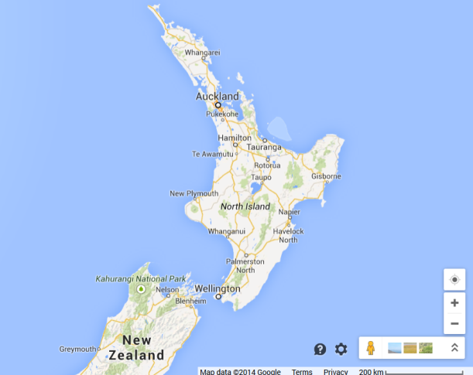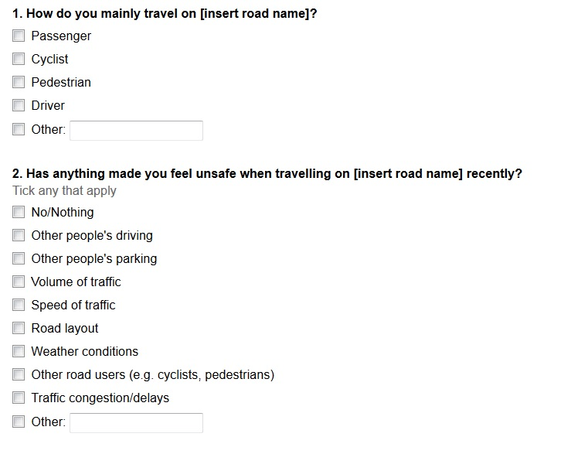
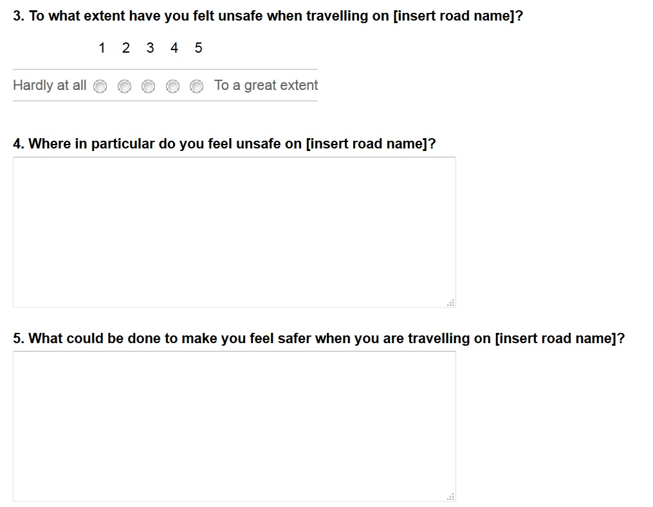

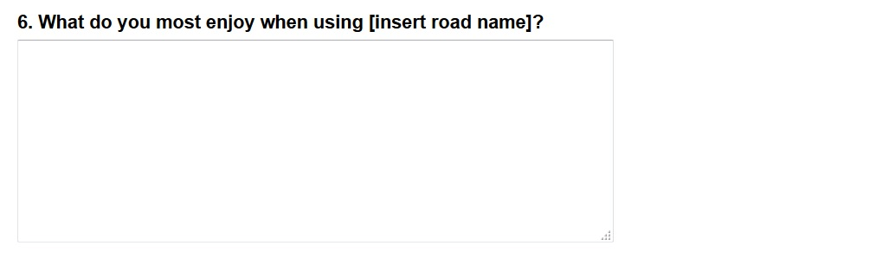

1.4.2.2. Interviewing road users

Interview road users asking them to describe their point of view and explain why they hold this view, and then finding out what they wonder about the road.

Interview record sheet
Road user  (passenger, cyclist or pedestrian) | Describe their point of view on the road.  For example, what problems and opportunities does the road provide for road users?  [Code the point of view as positive, negative or neither positive nor negative.] | Explain why they think this. | What do they wonder about the road?

Next make a list of different road users in your community.
Examples: Young people, teenagers, pre-schoolers, drivers, passengers, pedestrians, cyclists. People new to the area, long-time residents, short-term visitors, new immigrants and tourists. Primary students, secondary students, university students, employed, unemployed and retired people. Artists, town planners, local politicians, dog walkers, parents with pre-schoolers, bus drivers, bus passengers, sign writers, road markers, teachers, café owners, construction workers, courier drivers, truck drivers, taxi drivers, hairdressers, pizza delivery drivers, geologists, Māori whānau, kaumatua, scientists, joggers, power walkers, cartographers, garage mechanics, tyre bay workers, small business operators, dairy owners, petrol station operators, local GPs, accident and emergency nurses, parking meter wardens, police officers.
Make contact with different road users in your local community. Invite them to visit your class to answer questions about the road from their perspective.
Interview each road user to find out their perspective on the road.
What is their point of view? What interests them about the road? Why does this interest them? What are the advantages of using the road? What are the disadvantages? What challenges (problems and opportunities) does the road offer?
What do they know they don’t know about the road? What do they dislike about the road? What makes them grumpy about the road? What do they like about the road? What makes them smile about the road?
If they could change the road in any way, what would they change? Why would they change it? What does this make them wonder?
The following link provide information to help you design suitable questions:
BBC Schools – Bitesize – developing questionnaires

For each interview, you will need to seek the road user’s permission to keep a record of their answers. Do not record information in a way that links it to an identifiable individual.
Before the interview, give road users a written statement detailing the purpose of the questions and the use to which the information obtained will be put.
Work in groups to collect and collate this information. You can use collaborative online software such as Google Docs to make this data available to all group members. Use the following prompts to guide your thinking.

Interview record sheet
Road user | Describe their point of view on the road. What challenges (problems and opportunities) does the road provide?  [Code the point of view as positive, negative or neither positive or negative.] | Explain why they think this. | What do they wonder about the road?

Ask students to think like a statistician about the data they have collected.
What is the story in the data? What do they think the data is telling them?
Look for patterns in the data.
For example, is it helpful to know that some road users see more problems than opportunities for the road while others see only opportunity for the road and road user?
Is it helpful to know if the type of road user is related to a particular viewpoint?
Is it helpful to know about any differences between the wonderings of students in your school and the wonderings of people in your local community?
Perhaps the important story is about the commonality of views held about the road. Is there one viewpoint about the road that seems more commonly held than any other?
Use different strategies to think about the data you have collected and the stories it can tell.
For example:
- use data squares to sort the data
- make tally charts
- create simple frequency tables
- plot scatter graphs
- determine the mean
- find new categories by grouping data
- look for correlations.
In short, think like a statistician.

Discussion prompts
[think-pair-share, or small group or whole class discussion only]

Look at the survey data and how it has been sorted to show the problems and opportunities for road users on local roads.
What do you notice?
Why do you think it is like that?
What does it make you wonder?
If you are a citizen using the local roads as a cyclist, pedestrian or passenger, what is worth sharing with other road users?

Extension
Provide opportunities for students to reflect on how well their survey questions and interviews gathered the road users’ perspectives.
To what extent was the survey a more effective or less effective way of gathering information about a local road, compared with interviewing face to face?
Ask students to think about the design of the questions or questionnaire:
- how many people you included in the sample
- any bias in the questions
- the logic of the question order
- and how truthful you think people were in their responses.

Section 2: Explain the “wicked problems” (problems and opportunities) for local road users wanting safer travel

Relating ideas
These activities provide opportunities for students to connect ideas about the problems and opportunities for citizens/road users wanting safer travel on local roads.

Local roads provide both opportunities and problems for young people who use them as cyclists, pedestrians and passengers.
After identifying some of the challenges (problems and opportunities) in section 1, students are ready to make connections, to compare, to classify and to explain in order to build a deeper appreciation of the complexities involved in safer travel for road users.

The activities in this section help students connect ideas and information about safer travel, road users and roads. You’ll find them across the English, Mathematics and Science resources:
Activity 2.1. Compare road users: using local roads and as represented in poetry. [English – Making and Creating Meaning]
Activity 2.2. Compare road users: using visual text. [English – Making and Creating Meaning]
Activity 2.3. Compare the area covered by a parked vehicle with the total area needed to park. [Maths and Statistics – Measurement and Shape]
Activity 2.4. Connect the questions that road users ask about a local road. [Maths and Statistics – Statistics]
Activity 2.5: What types of forces do road users experience? [Science – Physical World]
Activity 2.6: Explain how road users see other road users. [Science – Living World]

Learning intention: Explain the challenges (problems and opportunities) that a local road presents to road users.

Differentiated self-assessment rubric. Insert your own marking guide on the left-hand side.
My explanation gives reasons for the challenges (problems or opportunities) for road users on a local road.
AND explains why these reasons are relevant for local road users.
AND makes a generalisation about the importance of these reasons for road users on local roads.

Activity 2.3. Compare the area covered by a parked vehicle with the total area needed to park [Maths and Statistics – Measurement and Shape]

Watch YouTube videos showing amazing parallel parking stunts by professional drivers in an off-road setting. Then ask students why measuring the area covered by a vehicle like they did in Activity 1.3 underestimates the space that drivers need to park on your local roads.
Tightest parallel park – Guinness World Records (YouTube)
Ask students to compare their findings in Activity 1.3 with the minimal parking space requirements for a standard-type vehicle as detailed in the table below.
Information is taken front Standards AS/NZS 2890.1:2004 or AS 2890.5.2020. These standards specify the required quality and safety criteria for off-street and on-street car parking areas.
When we measured how much space a parked car covered in Activity 1.3, we underestimated the amount of space required as outlined in the New Zealand Standards.
Ask students to use the data below to calculate the area taken up by a roadside parking bay that meets the standards.

Parking requirements for standard vehicles (car/van)
Type of on-street parking |  | Dimensions of space  (Preferred length) | Dimensions of space  (Preferred width)
Parallel parking – adjacent to the kerbside in the direction of the traffic flow |  | 5.4m (end of bay parking)  6.0m (middle bay parking) | 2.5m
Angle parking – on wider roadways | 30° | 5.4m | 2.5m
 | 45° | 5.4m | 2.5m
 | 60° | 5.4m | 2.5m
 | 90° | 5.4m | 2.5m

See also:
Traffic control devices manual part 13: parking controls (Waka Kotahi)

Parking spaces (bays) reserved for use by the disabled or “parent and child” vehicles are larger than the minimum dimensions for “standard vehicle” spaces, as shown in the table below.

Parking requirements for use by the disabled
Type of on-street parking |  | Dimensions of space  (Preferred length) | Dimensions of space  (Preferred width)
Parallel parking – adjacent to the kerbside in the direction of the traffic flow |  | 6.0m | 2.5m
Angle parking – on wider roadways | 30° | 5.4m | 3.0m
 | 45° | 5.4m | 3.0m
 | 60° | 5.4m | 3.0m
 | 90° | 5.4m | 3.0m

Use chalk or string to mark out the dimensions of a parking bay on an open area in the playground. List the reasons why the actual area of a kerbside parking bay differs from your previous calculations.
Count the number of parked cars in the school parking area.
Use your parking bay calculations to estimate the total “footprint” of cars in the school grounds.
Measure the area required to park a bike in the school grounds.
Determine how much space is needed to park the same number of bikes as the number of cars your school currently allows to park in the school grounds.
Compare and contrast parking for cars with parking for bikes.
Calculate the area available for learning if the current school parking area was replaced with a bike park area.
Estimate how much car parking space would be saved if parents and teachers used public transport or bicycles to get to school.

Discussion prompts
[think-pair-share, or small group or whole class discussion only]

Compare the area needed to park a car with the area needed to park a bike.
What do you notice?
Why do you think it is like that?
What does it make you wonder?
If you are a citizen using the local roads as a cyclist, pedestrian or passenger, what is worth sharing about the challenges (problems and opportunities) when parking in the school grounds and on local roads?

Extension
Discuss the following question:
“If we could remove all car parking areas in and around the school, should we?”
Hold a class debate on the claim that students would learn better at your school if all car parking was banned within the school and on the surrounding streets (with the exception of resident parking).

Activity 2.4. Connect the questions that road users ask about a local road. [Maths and Statistics – Statistics]

2.4.1. Classifying (sorting and grouping) the questions about a local road

What do people want to know about a local road? Use the questions collected in Activity 1.4. Place each of the questions people would like to ask the road on an individual hexagon.
Give the hexagons to groups of students. Ask them to find connections between the ideas by tessellating the hexagons and to explain orally or by annotation why these ideas are related.
Step back from the resulting tessellation (clusters of hexagons) and make a group/class claim: “Overall we think ‘the questions people would like to ask the road’ suggest [make a claim] … because [give a reason] … because [give evidence].”
Enter all the questions into a word cloud generator. For example, Wordle will generate a word cloud giving prominence to words that appear more frequently. Use the word cloud to formulate a message about the words that best capture people’s attention when they think about safer travel on our roads.
Suitable word cloud generators:
Wordle
Tagul
WordSift

Discussion prompts
[think-pair-share, or small group or whole class discussion only]

Look at the most frequently used words in road users’ questions.
What do you see?
Why do you think it is like that?
What does it make you wonder?
If you are a citizen using the local roads as a cyclist, pedestrian or passenger, what is worth sharing about local road users’ concerns?

2.4.2. Analysing what people think about a local road

What do road users see as the problems and opportunities on local roads?
Depending on the nature of the data collected in Activity 1.4 and their level of statistical understanding, students could:
- Sort road users or whole-number data about their different perspectives into groups and talk about the results.
- Count road users in the groups to compare the groups.
- Group and organise category data about road users and present it in an organised way, for example, as a tally chart, a pictogram or a bar graph.
- Choose and use an appropriate format for displaying discrete data about road users. Among the possible choices are bar graphs and stem-and-leaf graphs.
- Present statistical data about road users and their perspectives in a variety of ways, for example, simple comparative data in back-to-back stem-and-leaf graphs.
- Present comparative data about road users and their perspectives in appropriate statistical displays, for example, back-to-back stem-and-leaf graphs and box-and-whisker plots.
Ask students to classify and reclassify the data collected in Activity 1.4 so they can use multiple representations (statistical displays) to represent the raw data and thus better understand what the data is saying about road users’ perspectives on local roads.

Discussion prompts
[think-pair-share, or small group or whole class discussion only]

Look at the different ways data has been represented.
What are the strengths and weaknesses of each representation?
Why do you think it is like that?
What does it make you wonder?
If you are a citizen using the local roads as a cyclist, pedestrian or passenger, what is worth sharing about representing data to show the perspectives of local road users?

Extension

Evaluate the strengths and weaknesses of the different data representations used to analyse road users’ perspectives on one or more local roads.
Use the results of the evaluation to make predictions and find mathematical insight about road users’ perspectives.

Section 3: Extend ideas about the “wicked problems” (challenges and opportunities) for local road users wanting safer travel

Extending ideas
These activities provide opportunities for students to extend their thinking and experiment with ideas and information about safer travel for road users on local roads.

The activities in this section prompt students to think about (and act on) tentative solutions to the problems and opportunities for citizens/road users wanting safer travel on local roads. You’ll find them across the English, Mathematics and Science resources:
Activity 3.1. Write to an author/poet about safer travel for road users. [English – Making and Creating Meaning]
Activity 3.2. Create a visual text for road engineers, architects and builders.[English | Maths and Statistics – Measurement and Shape]
Activity 3.3. Is parking an issue? [Maths and Statistics – Measurement and Shape]
Activity 3.4. What are the challenges (problems and opportunities) for road users on a local road? [Maths and Statistics – Statistics | English]
Activity 3.5. Consider road users and local roads as wild life and waterholes. [Science – Physical World]
Activity 3.6. Does “I can see you” mean “you can see me”? [Science – Living World]

Learning intention: Draw conclusions about the challenges (problems and opportunities) presented by a local road.

Differentiated self-assessment rubric. Insert your own marking guide on the left-hand side.
I can draw a conclusion BUT I am not sure whether it is a key conclusion.
I can draw a conclusion AND I can explain why it is a key conclusion.
AND I can seek feedback from other road users on my conclusion.
AND I can act on the feedback to improve the effectiveness of my conclusion.

Activity 3.3. Is parking an issue? [Maths and Statistics – Measurement and Shape]

How much land is used for parking? How much land is used for learning?
Is parking an issue for your school community?
Cars parking on (and around) the school grounds are a hazard for other road users – pedestrians, cyclists and passengers.
Ask students to work in groups to:
Come up with several strategies for measuring the total land area used for cars in the school grounds – the parks, turning areas, access driveways etc. Use these strategies to calculate the area of the school car park.
For example, your group could find the total area used for parking cars on the school grounds, based on any or all of the following:
- unconventional measures
- conventional measures
- scale measurements from a printed map of the area
- line and shape tools in Google Maps

Then find the total area of your school based on the shape of the site and the side lengths or perimeter using similar measures.
Determine how much (what proportion) of the school’s land area is taken up by car parking using each measure.
Discuss any differences in the percentage coverage calculated that have resulted from using the different measures.
Use this data to create a 3-D model of the school, using any easily accessible modelling materials or software of your choice. Suitable software includes:
SketchUp
Minecraft
Clearly differentiate areas of the school site used for car parking.
Use the HookED Describe Plus Plus map to describe a local school car park from a mathematical perspective – using measurement, position and orientation and shape.
- What can you see or measure?
- Why do you think it is like that?
- What does it make you wonder?

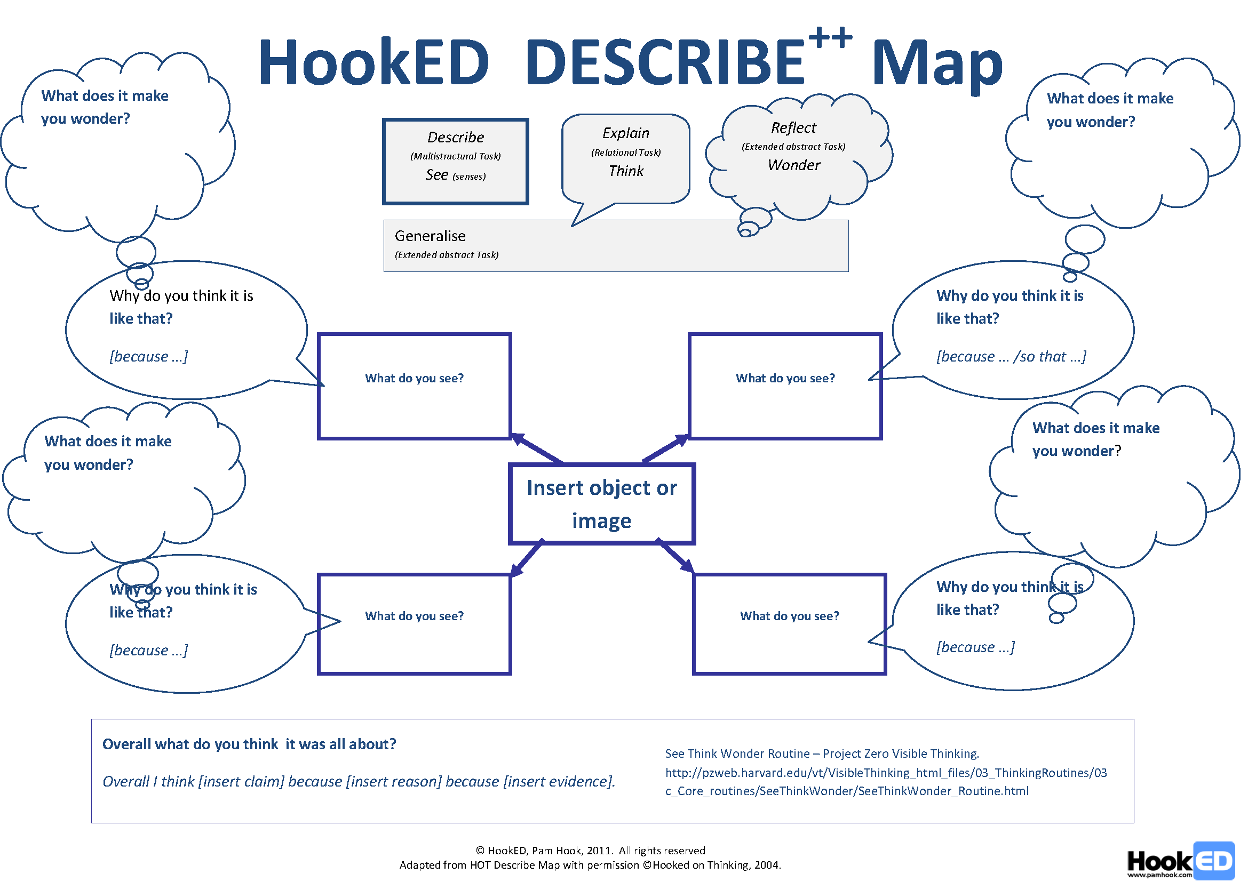

Discussion prompts
[think-pair-share, or small group or whole class discussion only]

Look at the area taken up by car parking on the school grounds or on the streets surrounding the school.
What do you notice?
Why do you think it is like that?
What does it make you wonder?
If you are a citizen using the local roads as a cyclist, pedestrian or passenger, what is worth sharing about the way we set aside land for car parking?
Discuss your wonderings about the area taken up for car parking on the school grounds using the following questions:
“Is car parking for teachers’ cars at school the best use of space in a modern learning environment?”
“How much car parking space should schools provide to teachers or people like parents who want regular access to a school?”
“Why is ‘provide more parking’ not the answer?”

Activity 3.4. What are the challenges (problems and opportunities) for road users on a local road? [Maths and Statistics – Statistics | English]

Brainstorm local road challenges (problems and opportunities).
For example,
Opportunities from local roads: free to use, flexible route choice, door-to-door transport, anyone can use the road, parking, and easily accessible pedestrian crossings.
Problems with local roads: road congestion, no parking, unsafe surfaces, speeding motorists, rush hour traffic.

Posing questions
Pose questions to investigate the challenges (problems and opportunities) presented by one or more local roads.
Identify the sample population, e.g. “road users” – the families, relatives and friends of students at the school who walk, cycle, drive or travel as passengers on local roads.
Identify the sample size.
Identify the variables to be measured based on your investigation question.
Examples of variables:
- numbers of road users (pedestrians, cyclists, passengers, drivers etc.) who have been challenged or advantaged on a local road in the past six months (discrete data)
- age of road users who have felt challenged or advantaged on a local road in the past six months (discrete data)
- type of road users who have felt challenged or advantaged on a local road in the past six months (discrete data)
- location where the road users felt unsafe or pleased on a local road (discrete data)
- type of challenge or advantage involved (discrete data), level of importance of the challenge or advantage (discrete data).
Design a method for collecting data. For example, use surveys, observations, questionnaires or interviews.

Collecting data
Ask students to:
Collect data, e.g. record this survey data in a tally chart.
Sort, organise and arrange the data.
Summarise the data.

Displaying data
Ask students to present the data, choosing the most appropriate method, e.g. bar charts, histograms, frequency tables, tally charts, pictograph, strip graph, pie chart, table, dot plots, time series.

Discussing results
Ask students to:
Discuss features of the data display. Use terms like middle, spread, outliers, average, mean, mode.
Draw a conclusion from the data analysis about the known challenges (problems and opportunities) when using a local road.
Make a generalisation from your data (a statement that makes a claim, explains why and offers evidence from the data) about how you can best manage the problems and take advantage of the opportunities offered by a local road.

Using infographics to tell a story with the data
Ask students to:
Present your data in a way that will inform road users about the local road.
Use the data representation in an infographic to tell a story about the different perspectives that road users hold about a local road. What do people think about our local road?
Your infographic should include powerful visual images, compelling statistics and data, and use scientific terms and technical language.
Research the different ways infographics are used to tell stories with data before you plan your own infographic.
Suitable sites include
Infographics by Mashable (Pinterest)
Daily Infographic

Ask students to:
- Take screenshots of the Google Maps street views of the road (or take your own photos of the road.
- Use these as backgrounds when making posters or add these images to a slideshow like PowerPoint, Canva or Apple Keynote.
- Add images you create of road users along with oral or text questions.

Discussion prompts
[think-pair-share, or small group or whole class discussion only]

Look at the infographics and think about the stories they tell about local roads and road users.
What stories do they tell?
Why do you think it is like that?
What does it make you wonder?
If you are a citizen using the local roads as a cyclist, pedestrian or passenger, what is worth sharing from your infographic stories? Think about the questions a road might like to ask pedestrians, cyclists and passengers. Think about the infographic a road might use to tell a story.

Online graphic programs suitable for infographic poster design
Tux Paint
Draw.To
ABCya Paint
One Motion
Alternatively use:
VoiceThread to add student voice, video or text to each background.
Comic Life or Marq
Visualise your data on a custom map using Google My Maps
Add the images and questions directly and embed the student-annotated map in a class blog or wiki.

