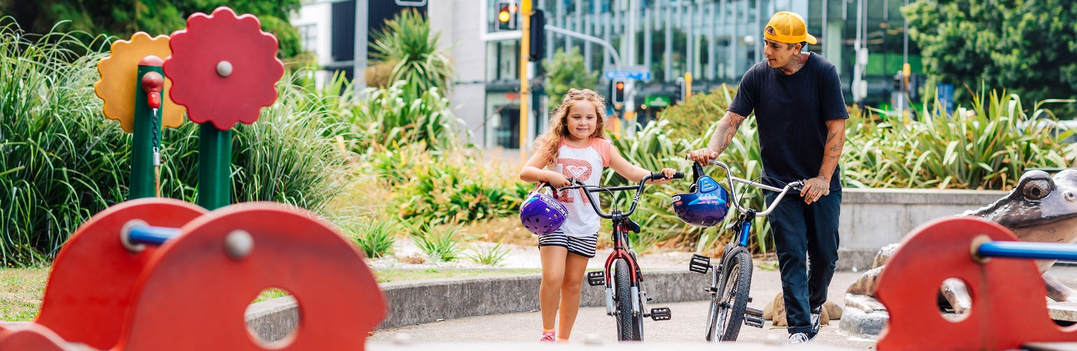Everyone is a road user – introduction
Updated 2022
Note: Be aware these resources may involve the discussion of incidents on the roads that cause serious injury or death. It’s likely some students have first-hand experience of such issues. Discretion is advised.

Overview
Wicked problems for pedestrians, cyclists and passengers and the roads they use
Everyone is a road user. Think of the road as a commons – a shared place where users understand and follow the rules and respond to ensure all citizens who use the roads enjoy safer travel and richer lives.
This Waka Kotahi NZ Transport Agency resource encourages primary and intermediate school students to act as citizens. They can find the “wicked problems” around safer journeys for road users in their local community and actively listen to different perspectives on how these problems might be fixed.
The resource prompts students and schools to work with others, to see the “wicked problems” in road safety as community challenges (problems and opportunities), and to seek community-based “clumsy solutions” that increase the likelihood of safer travel for all.
Finally, the resource encourages schools to become knowledge producers for their local communities – collecting, creating and curating stories about how they and others ensure safer travel on their local roads for pedestrians, cyclists and passengers.
The resources take a strength-based approach to road safety. Every student has resources to help manage safe outcomes for themselves and others on our roads.

What is a wicked problem?
It’s a term used to describe complicated societal problems where a simple, easy solution is not available. The word wicked is used to mean tricky or difficult. Wicked problems like road safety or climate change involve many social factors and complex interaction between systems. Solutions may be incomplete or may uncover further problems.

Structure of the resources
The main resources are arranged by learning area: English, Mathematics and Statistics, and Science. Within each of these resources, activities are arranged in three sections:
- bringing in new ideas (section 1)
- relating these ideas (section 2)
- extending these ideas in ways that make a difference for others (section 3).
They integrate into the existing school curriculum and provide additional materials that:
- identify prior knowledge
- provide feedback on learning through self‐assessment rubrics.
All activities are numbered for teacher reference.

Teacher notes
School‐based road safety education needs to scaffold deep understanding.
This resource deploys differentiated learning experiences set to New Zealand Curriculum key competencies and learning areas in English, Mathematics and Statistics, and Science (Levels 1 to 5). Teachers can use them as a “pick and mix” selection for their own curriculum planning.
There is a “wicked problem” investigation and 18 differentiated learning activities to meet curriculum expectations for Year 1 to Year 8. Student reflection is built in.
Editing is fine – teachers may adapt activities to suit the learning needs of students.
This resource is the copyright of Waka Kotahi and licensed under the Creative Commons Attribution-Noncommercial 3.0 New Zealand licence. Creative Commons Attribution-Noncommercial 3.0 New Zealand licence
Teachers are encouraged to select learning experiences to create learning pathways based on student prior knowledge. Aim to challenge and extend student thinking, and where possible provide opportunities for active citizenship through student action. One‐off lessons, providing information alone or using scare tactics are for the most part ineffective. These approaches do not affect young people’s long‐term attitudes and behaviours.
The resource design is based on how students learn and effective pedagogies in teaching and learning. More background in this article by Mary Chamberlain and Pam Hook:
Changing mental models: How recent developments in teaching and learning can be applied to road safety education in schools (PDF)

Introductory activity

You are a citizen. You belong, you matter and you make a difference. As a citizen, you have the right to safe journeys on our roads.
The type of transport we use and how we use it affects people, places and the planet. Our physical and mental health and wellbeing, our ability to make friends and our ability to imagine can be influenced by how we use the roads.
Young people belong, they matter and they make a difference. They have a right to safe journeys. However, too many young people are killed or suffer serious injury when using our roads as cyclists, passengers and pedestrians.
Ask students to consider:
- To what extent do transport issues affect your ability and the ability of your family and friends to participate in life?
- To what extent do your local roads enable you to get on with your life?
- To what extent do your local roads let you and your family and friends experience safer travel?
Study the transport overview concept map below (you can download a PDF version). The map is also available as a transport hexagons activity. Refer appendix 3.

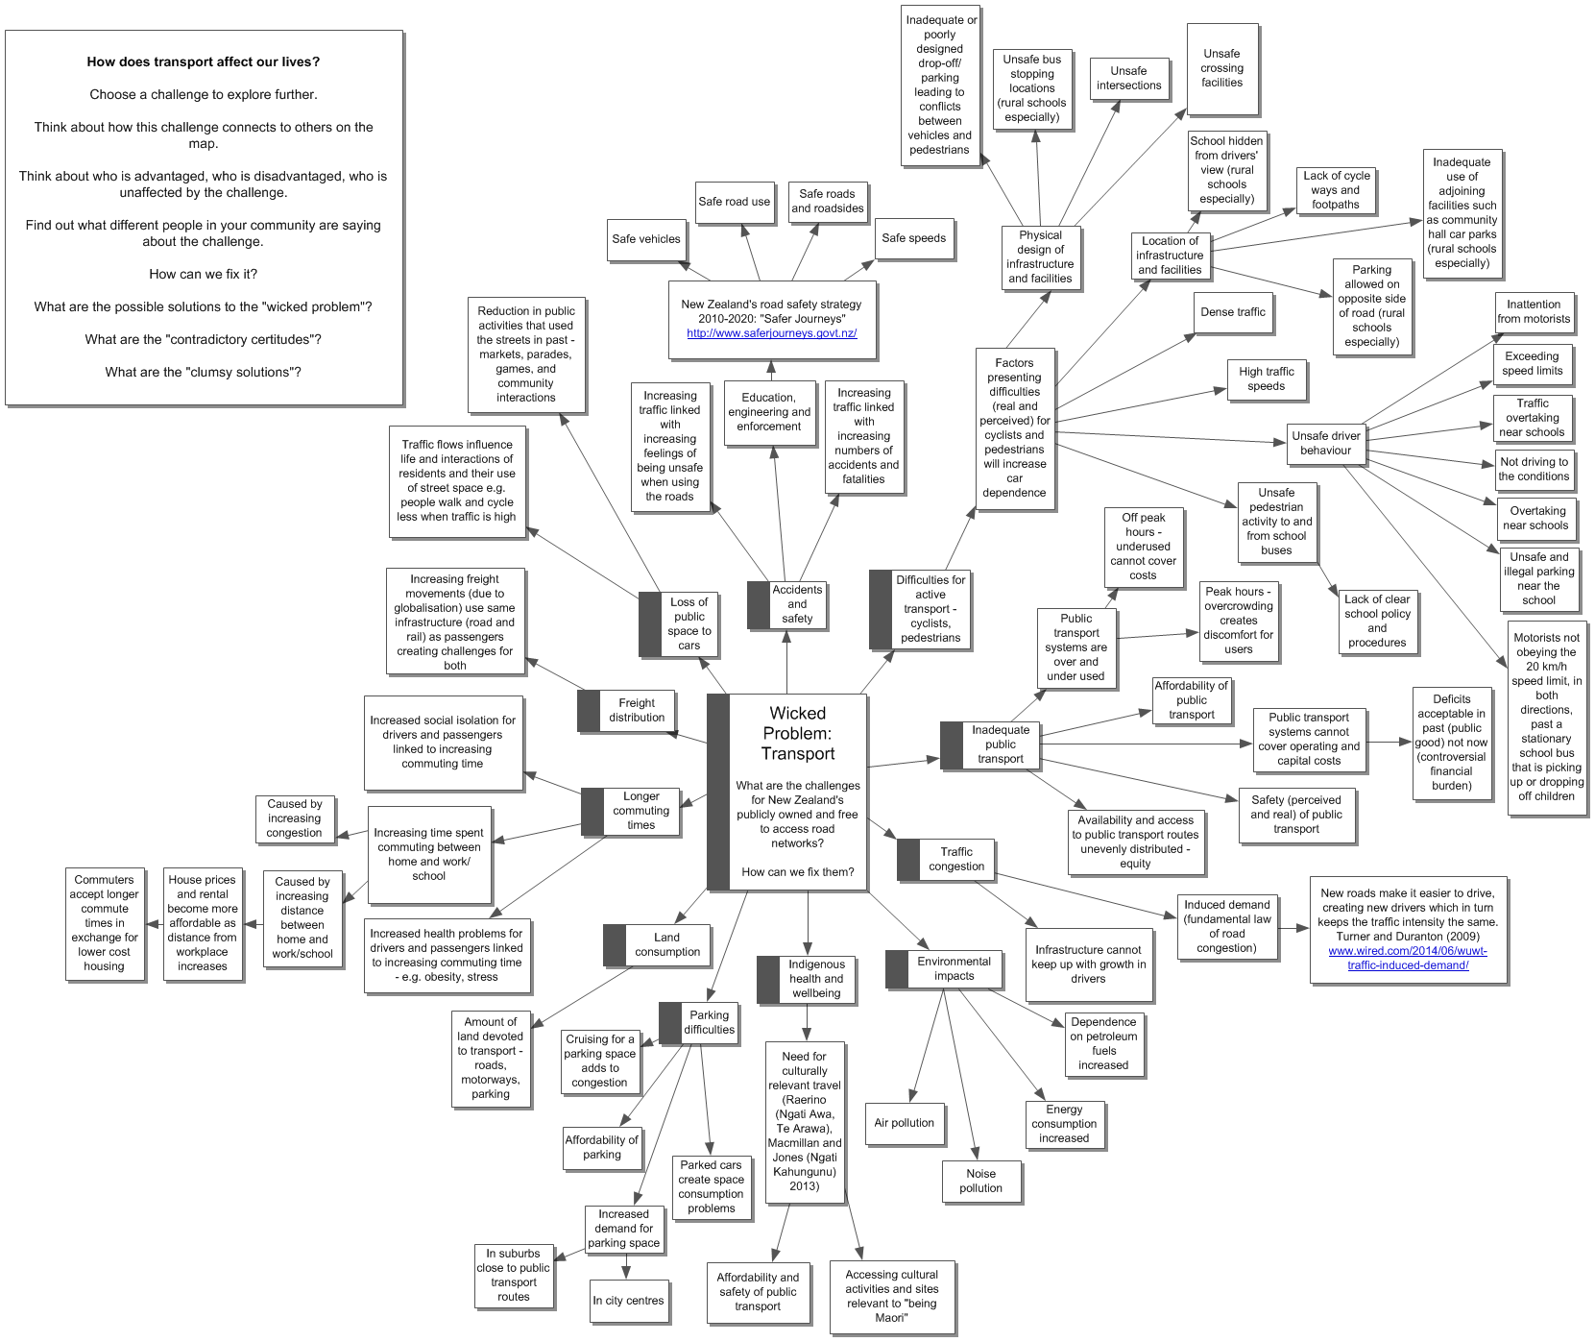

“Wicked problem” investigation

Refer to the transport overview concept map above, or use the transport hexagons activity in appendix 3. Identify possible influences on the experience of young people using the roads in your local community.
Use some of the maths, science and English activities in the resource to build a better understanding of the wicked problems for road users on local roads. Choose the activities that best meet the interests and needs of your students in their local community.
Ask students to:
Conduct your own research into the factors that influence young people’s experience of safer travel on local roads in your community.
The Official New Zealand Road Code has a list of facts that are worth thinking about before starting the activities exploring safer journeys on local roads.
Sharing the road with pedestrians
Choose a fact that interests you and make a visual image to communicate the same message. Look for connections between your images and other’s images.

Things to know about children
- Children aren't little adults, so don’t expect them to act like adults.
- Children, especially those under the age of 9, may not have the skills and abilities needed to be safe in traffic. Be very careful when driving near them.
- Young children have narrow vision and may not see vehicles as easily as adults do.
- Children have trouble judging the speed of moving vehicles. They may let a slow vehicle pass and try to cross in front of a fast one.
- Children often don’t understand that it takes time for a vehicle to stop.
- Children may have difficulty working out where sounds are coming from.
- Because children are small, they often can’t see over bushes and parked vehicles. This also means they can’t be seen easily by drivers.
- Children may have trouble stopping at a kerb and could dart out into traffic.
- Children can freeze when they find themselves in danger, instead of taking quick action as an adult might.
Keep a lookout for children at all times. Take special care when driving during 8–9am and 3–4pm, when children are travelling to and from school.

Find an issue that is important to safer journeys for young people in your local community.
- Explain how this issue is related to other issues on the concept map.
- List all the ways this issue affects people in your local community.
- Ask: Who is advantaged, who is disadvantaged and who is unaffected by this issue in your local community?
- Find out what different people in your community have to say about the issue.
Use these different perspectives to frame the issue as a “wicked problem” for your community to solve.
- Identify one important way in which this issue can affect young people’s safety on the roads as passengers, pedestrians or cyclists.
- List several reasons why this factor may put young road users at risk.
- Generate some ideas about how we could change this factor.
- Find out how different people in your community think the factor should or could be solved.
- Make a list of all the suggested solutions (“contradictory certitudes”).
- Review all the solutions with the wider community and select the “best idea/s” to meet the needs of your local community using a decision-making grid like the one described in Activity 1.3.
Elaborate this idea into a “clumsy solution” to the “wicked problem”.
Find the story to tell people about the “wicked transport problem” in your local community and its “clumsy solution”.
Plan a multimedia campaign to tell a story about your local road and the “clumsy solution” that will help keep road users safe.
Tell your stories (written, oral and visual text) to persuade people in your local community to take action to make local roads safer for pedestrians, passengers and cyclists. Your stories should include:
powerful images and infographics
compelling statistics and data
poetic language to persuade the pessimists
scientific terms and technical language.
- Generate ideas about the organisations and businesses that might be able to help you implement your “clumsy solution”.
- Write an information report on your findings to share with others. Your report should have an opening statement, paragraphs outlining different aspects of the issue and a conclusion summarising the information presented. It should be written in the present tense, use technical vocabulary and avoid giving personal information.
- Use your report to lobby and raise awareness in your local community and with agencies that might help you fix the issues you identify.

Young people can and do make a difference to the wicked problems in their community.

Curriculum plan: Everyone is a road user
NZC Principles: High Expectations, Treaty of Waitangi, Cultural Diversity, Inclusion, Learning to Learn, Community Engagement, Coherence, Future Focus

Concept | Key Understanding | Driving Questions | Subsidiary Tasks | NZC Key Competencies | NZC Values | Context  Junior|Middle|Senior
What is the big idea?  Citizenship  Safer Journeys | What must the student take away from the learning experiences?  Citizens are road users  Everyone uses the roads.  We should use the roads in ways that help keep ourselves and others safe.  Education, engineering and enforcement work together to make safer journeys.  Pedestrians and cyclists are much more vulnerable in a crash than other road users.  Improving safety for pedestrians and cyclists can also encourage others to walk and cycle on local roads. | What are the “wicked problems” (challenges – problems and opportunities) for safer journeys on local roads?  What problems do cyclists, pedestrians and passengers face when keeping safe on and around local roads?  How could we fix these problems so every local road user experiences safer journeys? (clumsy solutions)  How could we take advantage of these opportunities so every local road user experiences safer journeys? (clumsy solutions) | 1. Describe a problem that road users experience when using local roads in your community.  2. Explain why this is a problem that road users experience when using local roads in your community.  3. Create a fix/clumsy solution for a problem that road users experience when using local roads in your community.  Example: An education, engineering or enforcement action or resources to help [a given group of road users] have safer journeys on roads in your local community. | Create self-assessment SOLO functioning knowledge rubrics for KC where appropriate. Refer to Appendix 1.  Thinking – critically analyse the factors influencing safer journeys for [a given group of road users] Managing self – act responsibly when using a local road. (Demonstrate situational awareness when using the local road.)  Participating and contributing – contribute to the responsible actions and/or situational awareness of other road users.  Relating to others – interact with other road users to fix local issues around safer journeys on local roads.  Making meaning from language, symbols and text – interpret and use language, symbols and text to communicate with other road users for safer journeys on local roads. | Create self-assessment SOLO functioning knowledge rubrics for values where appropriate.  Excellence  Innovation, inquiry, and curiosity  Diversity  Equity  Community and participation  Ecological sustainability  Integrity  Respect | Local community road users: pedestrians, passengers and cyclists  People: How can [a given group of road users] keep safe around roads?  Places: How can we improve roads to reduce the risk to [a given group of road users]?  Planet: How can [a given group of road users] affect the planet?  Beyond: How can current [given group of road users] help future road users have safer journeys?

Key competency self-assessment rubrics

Thinking | Managing self | Participating and contributing | Relating to others | Using language, symbols and text
Critically analyse the factors influencing safer journeys for [a given group of road users] on local roads.  Example – describe, explain and justify ways to stay safe when using the road as a pedestrian, cyclist or passenger. | Act responsibly when using the road.  (Demonstrate situational awareness when using the road.)  Example – adopt a “sort it and report it” approach to unsafe road user behaviour or conditions. | Contribute to the responsible actions and/or situational awareness of other road users.  Example – listen, respond and act together to make the roads free of death and serious injury. | Interact with other road users to fix local issues around safer journeys on the roads.  Example – demonstrate a commitment to safer journeys for yourself and other road users. | Interpret and use language, symbols and text to communicate with other road users for safer journeys.  Example – share safe rules and behaviours for places on and around the roads.

Learning intentions (LI)

Learning intention generator (Pam Hook)

Bringing in ideas
LI: Define a safer/unsafe journey for [road users]. (What is it?)
LI: Describe a safer/unsafe journey for a [road user]. (What is it like?)
LI: List the challenges (problems and opportunities) for road users during their travel. (What are the parts of this thing?)
Relating ideas
LI: Sequence the steps to achieving safer travel for a [road user]. (What steps or set process helps me use or experience this thing?)
LI: Classify the challenges (problems and opportunities) to safer travel. (How can I relate this to other things I know? Can I group these together?)
LI: Compare and contrast safer travel for [road users]. (How are they the same? How are they different?)
LI: Explain causes of safer travel. (What led to this? Why did this happen?)
LI: Explain the consequences of safer travel. (What was the result? Why was that an outcome of the event?)
LI: Make an analogy for “safer travel”. (What metaphor can I use to understand how this thing works?)
LI: Analyse safer travel. (What are the parts and how do they work together?)
Extending ideas
LI: Make a generalisation about safer travel. (If something is true of this thing, is it true of other similar things? Why might this be so?)
LI: Make a prediction about safer travel. (If something is true of this thing in one circumstance, how likely is it to be true in other circumstances?)
LI: Evaluate safer travel. (What is the overall impact of this thing? Does it succeed? Why? Could it be improved? How?)
LI: Create an action that leads to safer travel. (Can I create an action that leads to a similar thing but differs in original and significant ways from what has been created previously?)

Table of learning activities

Section 1  Bringing in ideas about “wicked problems” for road users | Section 2  Relating ideas about “wicked problems” for road users | Section 3  Extending ideas about “wicked problems” for road users
Activity 1.1. Wonder about a local road in the real world and in poetry.  eLearning: Digital photography, Google Earth, Google Maps, video, VoiceThread, podcasting  [NZC: English – Making and Creating Meaning] | Activity 2.1. Compare road users: using local roads and as represented in poetry.  eLearning: InstaGrok, Google Earth, digital photography  [NZC: English- Making and Creating Meaning] | Activity 3.1. Write to an author/poet about safer journeys for road users.  eLearning: Blogs  [NZC: English – Making and Creating Meaning]
Activity 1.2. Describe the use of visual text to tell stories about the roads and road users.  eLearning: Graphics programs, e.g. Tux Paint  [NZC: English – Making and Creating Meaning – Visual Texts] | Activity 2.2. Compare road users: using visual text.  eLearning: Image editing software  [NZC: English – Making and Creating Meaning] | Activity 3.2. Create a visual text for road engineers, architects and builders.  eLearning: SketchUp/Minecraft  [NZC: English | Maths and Statistics – Measurement and Shape]
Activity 1.3. Calculate the area that parked cars cover.  eLearning: Google Maps  [NZC: Maths and Statistics – Measurement and Shape] | Activity 2.3. Compare the area covered by a parked vehicle with the total area needed to park.  [NZC: Maths and Statistics – Measurement and Shape] | Activity 3.3. Is parking an issue?  eLearning: Google Maps, SketchUp/Minecraft  [NZC: Maths and Statistics – Measurement and Shape]
Activity 1.4. What do road users ask about a local road?  eLearning: Online survey makers, e.g. Google Forms, SurveyMonkey; collaborative online software  [NZC: Maths and Statistics – Statistics – Statistical Investigation] | Activity 2.4. Connect the questions that road users ask about a local road.  eLearning: word cloud generator  [NZC: Maths and Statistics – Statistics] | Activity 3.4. What are the challenges (problems and opportunities) for road users on a local road?  eLearning: Google Maps; slideshow programs; graphics programs or alternative e.g.  VoiceThread  [NZC: Maths and Statistics – Statistics | English]
Activity 1.5. How do road users move?  eLearning: Comic Life or other comic strip creators  [NZC: Science – Physical World | Nature of Science] | Activity 2.5: What types of forces do road users experience?  [NZC: Science – Physical World] | Activity 3.5: Consider road users and local roads as wildlife and waterholes.  eLearning: Video making/editing software  [NZC: Science – Physical World]
Activity 1.6. What do road users see?  eLearning: Light meters/data loggers, GarageBand/Audacity  [NZC: Science – Living World] | Activity 2.6: Explain how road users see other road users.  eLearning: Virtual dissection  [NZC: Science – Living World] | Activity 3.6: Does “I can see you” mean “you can see me”?  eLearning: Animation software, Minecraft  [NZC: Science – Living World]

Determining prior knowledge

Finding out what students know about the challenges (problems and opportunities) for road users on local roads before we start.
Ask students to:
- Pause – clear your mind and then think deeply about challenges (problems and opportunities) and keeping safe on local roads. What is dangerous and what is wonderful about local roads?
- Discuss the following question prompts in turn.
  - What are the dangerous things you know to watch out for on local roads?
  - What are the wonderful things provided by local roads?
  - What have you done that was potentially dangerous on a local road?
  - Why do you think you did this?
  - What have you done that was wonderful when using a local road?
  - Why do you think you did this?
  - What have you seen other people do that was dangerous on a local road?
  - Why do you think people do things that are dangerous on local roads?
  - How do you feel when you see people doing things that are dangerous on local roads?
  - What do you do when you see people doing things that are dangerous on local roads?
  - What have you seen other people do that was wonderful when using a local road?
  - Why do you think people use local roads to do things that are wonderful?
  - How do you feel when you see people using local roads to do things that are wonderful?
  - What do you do when you see people using local roads to do things that are wonderful?
  - What do kids need to know about keeping safe on local roads?
  - What do grown-ups need to know about keeping safe on local roads?
  - How should we help kids to keep safe on local roads?
  - How should we help grown-ups to keep safe on local roads?

- Record your answers to each question on a collaborative online document (e.g. Google Forms) or using Post-it notes and large sheets of newsprint.
- Discuss each question in a small group and then with the class.
- At the end of the discussion on each question, collate your individual and group responses for future reference.

