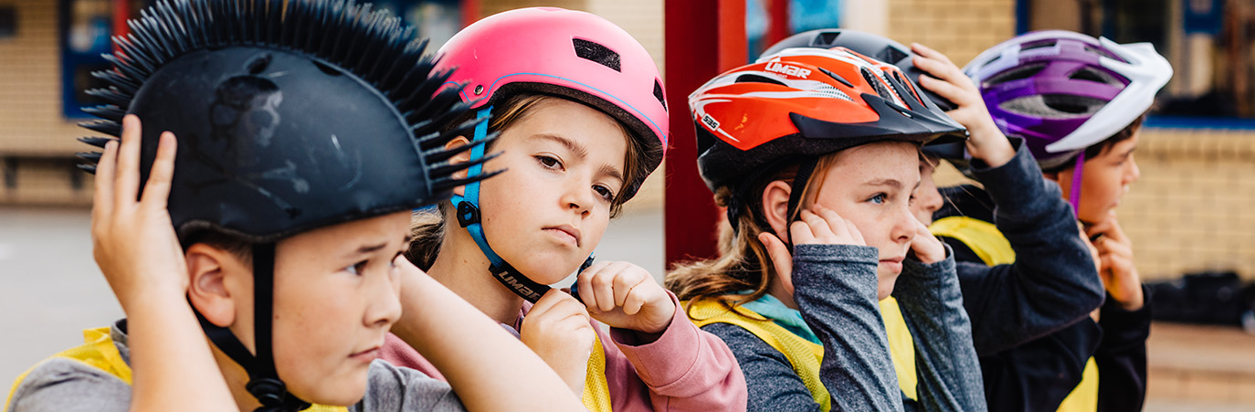

BikeReady introduction
Curriculum-based lesson plans developed to support learning experiences in the BikeReady cycle skills training sessions. Updated 2022.

This resource provides classroom teachers with learning activities that encourage students to solve problems, discuss, experiment and create resources to develop a deep understanding of safe riding and having fun when riding.
Students learn the causes and consequences of safe and fun cycling as well as risk management strategies to keep cyclists safe.
The resource is designed for classroom use alongside student participation in BikeReady Grade 1 cycle skills training courses.

Big ideas
This resource activates learning through notions of:

Cycling and citizenship
People who use bicycles when using the road for transport are called cyclists.
- Cyclists have special knowledge, skills, attitudes and behaviours.
- Cyclists are citizens – they look out for other road users when sharing the road – so that all road users enjoy safer journeys.
- Rules and laws help cyclists have safer journeys.
- There are rules and laws for cycling behaviour and cycling equipment.

Cycling and well-being
Cycling creates many opportunities for well-being (hauora):
- Taha tinana – Physical well-being
- Taha hinengaro – Mental and emotional well-being
- Taha whānau – Social well-being
- Taha wairua – Spiritual well-being
Cycling, design thinking and STEM
Cycling creates many contexts for learning through STEM, integrating design thinking with:
- Science
- Technology
- Engineering
- Maths
For example, critical and creative thinking about:
- Construction – building new bicycles and improving the performance of existing bicycles. Design history of bicycles
- Machines – technology, cogs, wheels, gears, chains, pedals, brakes
- Movement – forces, distance, speed, direction, acceleration, deceleration, stationary, friction, air resistance
- Mapping and position – roads and cycling routes, maps, pathways, bike lanes, designing and creating new routes
- Designing an opportunity for cyclists to regularly maintain their cycles – pop up workshops
- Ethics of professional practice – design implications of sharing the roads with other road users (pedestrians, motorcyclists, drivers, truck drivers), cycle ways.

Cycling and literacy and numeracy
Making meaning of language, symbols and text in the road code, fiction, non-fiction, poetry, multiliteracies, oral texts, visual texts including safety posters and so forth.

Cycling and future focus
Use critical and creative thinking to think about the role of cycling in the past, present and future of transport.

Connections
Many people, groups, government agencies and non-government organisations can support the teaching and learning activities outlined in the resource.

Note: Be aware that these plans may involve the discussion of unsafe situations that cause serious injury. It’s likely some students have first-hand experience of such issues. Discretion is advised

How teachers can use this BikeReady curriculum resource

All activities are designed for use by classroom teachers to deepen learning alongside student experiences in BikeReady Grade 1 cycle skills courses.
Cycle skills courses are run by professional instructors who visit your school.
This curriculum resource is not prescriptive. Use it flexibly to support the school’s curriculum planning. You can select as many or as few learning activities as suitable to match student interests, knowledge and learning needs.
The curriculum resource has 4 sections.

Prior Knowledge – What do you know about having fun and safe riding on a bike?
Classroom activities to determine students’ prior knowledge.
These activities can be used by the classroom teacher before cycle skills courses take place in the school. Optionally, teachers could share the results of classroom discussions with the instructors.

Lesson plans 1 to 6 – to support Grade 1 skills courses
Six NZ Curriculum aligned lessons that support and expand on the key skills students learn during a BikeReady Grade 1 cycle skills course. Classroom lessons would typically take place after professional instructors have taken students through the cycle skills course.

Transfer – Student inquiry into challenges and opportunities for cyclists in the local community
Extension activities for students to think critically and creatively about cyclists in the community.

Appendices
Self-assessment rubrics and example curriculum planning tables.

Structure of lesson plans
Each lesson includes the following components.

Planning

Skills focus
Identify focus of the lesson

Reflection on skills training session
Class reflection on new learning in skills training session

Opportunities for community engagement
People in the local community who could be approached to support the new learning

Alignment to NZC learning areas
Refer to NZC Learning Areas Overview. Refer to the resource for Achievement Objectives and Learning Intentions (L1 to 4).
English | Listening, Reading and Viewing |  |  |  |  |  |  | Speaking, Writing and Presenting
The Arts – Drama | Understanding the Arts in contexts |  | Developing Practical Knowledge |  |  |  |  | Developing Ideas |  |  |  | Communicating and Interpreting
Health and Physical Education | Personal Health and Physical Development A – A3 Safety Management |  |  |  |  |  | Healthy Communities and Environments S – D2 Community Resources
Mathematics and Statistics | Geometry and Measurement
 | Measurement |  |  | Shape |  |  |  |  |  |  | Position and orientation
Science | Nature of Science |  |  |  |  |  |  |  |  |  |  |  | Physical World
 | Understanding about science | Investigating science |  |  |  | Communicating in science |  |  | Participating and contributing |  |  |  | Physical inquiry and physics concepts
Social Sciences | Identity, Culture and Organisation |  | Place and Environment |  |  |  |  | Continuity and Change |  |  |  | The Economic World
Technology | Technological Practice |  |  |  | Technological Knowledge |  |  |  |  | Nature of Technology

Classroom activities
Learning activities are designed to support surface to deep understanding associated with each cycle skills lesson. Each is aligned to different NZC Learning Areas – see above.

Wrap Up

Session reflection

Key competency self-assessment rubric

