BikeReady Lesson 5

Demonstrate skills for signalling right/left/stop without losing control.

Planning for lesson 5

Skills focus

Signalling right/left/stop without losing control – consider:
- how long to signal for
- who you need to signal to
- which hand to use for each signal
- which signal to use and when to use it.

Reflection on skills training session

Share new learning with classroom teacher
Identify experiences students enjoyed when taking part in cycle skills training on signalling. Record your findings on a SOLO Strip.
Draw pictures (take photographs or video) in response to the following prompts.
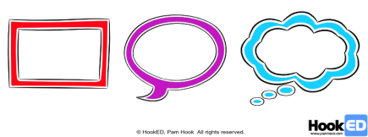
- What did you enjoy when you were taking part in the cycle skills training? [SOLO Multistructural – rectangle]
- Why do you think it was like that? [SOLO Relational – speech bubble]
- What does it make you wonder about cyclists and/or cycling? [SOLO Extended abstract]
Add to the class list of all the enjoyable experiences students encountered during cycle skills training.
Identify any new terms and vocabulary introduced in the cycle skills training session. Highlight new terms and vocabulary.
For example: message, sender, receiver, decode, encode, channel, feedback.
Add the terms and their meanings to the class/group glossary. Identify unfamiliar terms and use them on a Frayer Vocabulary Chart.

Opportunities for community engagement

Make connections with people and organisations in the local community with experience in signalling and communication.
Make connections with people and organisations in your local community who might volunteer to visit or host students wanting to find out more about communication through signalling.
For example, contact people who use signalling for their work or arrange visits from people who rely on communication in their jobs, such as psychologists, dog whisperers or electronic engineers.

Alignment to NZC learning areas

Refer to NZC Learning Areas Overview. Refer to the resource for Achievement Objectives and Learning Intentions (L1 to 4).

English | Listening, Reading and Viewing |  |  |  |  |  |  | Speaking, Writing and Presenting
The Arts – Drama | Understanding the Arts in contexts |  | Developing Practical Knowledge |  |  |  |  | Developing Ideas |  |  |  | Communicating and Interpreting
Health and Physical Education | Personal Health and Physical Development A – A3 Safety Management |  |  |  |  |  | Healthy Communities and Environments S – D2 Community Resources
Mathematics and Statistics | Geometry and Measurement
 | Measurement |  |  | Shape |  |  |  |  |  |  | Position and orientation
Science | Nature of Science |  |  |  |  |  |  |  |  |  |  |  | Physical World
 | Understanding about science | Investigating science |  |  |  | Communicating in science |  |  | Participating and contributing |  |  |  | Physical inquiry and physics concepts
Social Sciences | Identity, Culture and Organisation |  | Place and Environment |  |  |  |  | Continuity and Change |  |  |  | The Economic World
Technology | Technological Practice |  |  |  | Technological Knowledge |  |  |  |  | Nature of Technology

Classroom activities

Acquire surface and deep understanding needed to support the cycle skills sessions.

Building student understanding about communication through signalling when cycling

What is a hand signal?
Cyclists use hand signals to show other road users what they are doing.
Signalling (New Zealand code for cycling)
What is being communicated in the hand signal? What is the message?

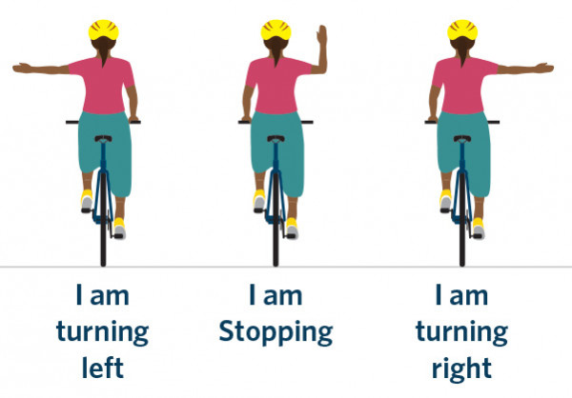
Images from The New Zealand code for cycling.

When should hand signals be used?
Hand signals must be used at least 3 seconds before:
- moving into traffic
- stopping
- turning left
- turning right
- moving from a lane.

5.1. What is communication? Define communication

[Bringing in ideas]
[Links to NZC Learning Areas: Health and Physical Education, Social Sciences]

Communication occurs when a sender transfers a message containing information to a receiver. People have been sending messages to each other since ancient human history.
Ask students to work in small groups to list all the different ways a [insert common domestic animal e.g. school cat, seagull] communicates.
For example: sound, symbolic gestures, repetitive behaviours.
List all the ways that people use to communicate a message.
For example: grunting, gestures, vocalisation, symbols (rocks, bending branches), dead animals, town criers, parchment scrolls, personal objects (rings, trinkets), fires (smoke signals), signs on doors, letters, sea, horse, foot, rail, road, semaphores (flags), sign language, Morse code, atmosphere (electricity, telegraph, Bluetooth, wireless, infrared), phones, faxes, emails, SMS, videos, digital photographs.
Cyclists use hand signals to communicate to other road users what they are doing.
Identify how people communicated before we had electricity.
Sort a collection of images or objects into those that are useful for communication and those that are not useful for communication.
Find out the appropriate body language for greeting others in different cultures (hello, goodbye).

Sending and receiving messages through the ages

Ask students to:
Brainstorm everything they know about sending and receiving messages. Refer to the previous lists of methods of communication and new ideas from the bike skills training lesson on hand signals.
Record each idea or thought on a separate blank hexagon.
Use the prompts below to further unpack student ideas about hand signals and other messages for having fun and keeping safe on bicycles. Think about messages:
- about keeping safe
- about starting and stopping (speeding up and slowing down)
- about changing direction
- about potential hazards – taking care
- saying yes or no
- that use technology to send or receive
- for greeting others
- for belonging or identity.
Working in groups, cut each hexagon from the templates and then tessellate them as shown below.
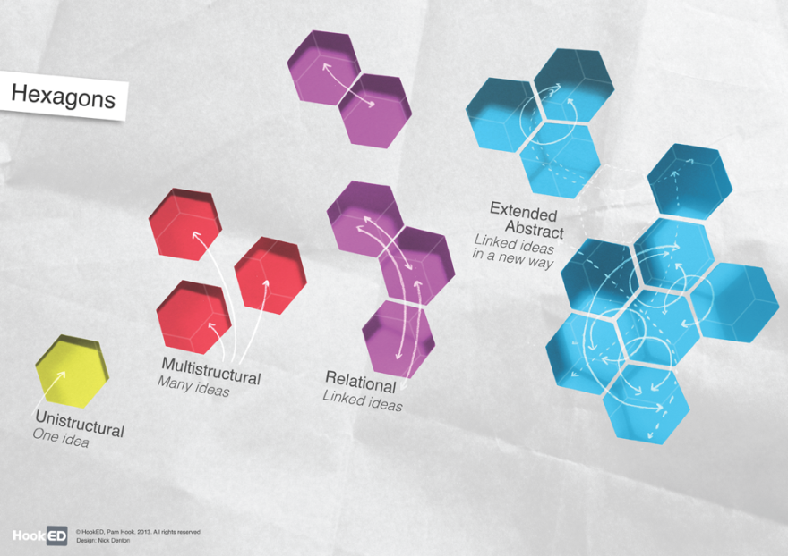

Explain why they have made straight-edged connections between individual hexagons (using connectives like ‘because …’ and ‘so that …’).
When they have finished organising the hexagons, step back and look at the cluster of hexagons (or the vertex where three hexagons come together).
Make a generalisation about the nature of the relationship between the ideas (‘Overall we think messages/ communicating with others is all about … because … because …’).
Share these generalisations about messages and communicating with others.
Use the ideas from the discussion around the hexagons activity to decide on a message about hand signals to help students keep safe when they are cycling. For example, ‘Our important safety message to cyclists is …’
Write safety messages on large sheets of paper and display them around the room.
Hold a class vote on the ‘best message’ to keep us safe when cycling.

Hexagon templates
Use the HookED SOLO iPad app to generate and organise hexagons
SOLO Hexagons (App Store)
HookED SOLO Hexagon generator
SOLO Hexagon templates primary
SOLO Hexagon templates secondary

Hand signal messages used when cycling

Ask students to:
Observe a cyclist using hand signals to communicate a message.
Select one method of communication from the list above and describe it in detail. For example, turning left.
Describe the hand signal message sent by a cyclist. Use a HookED Describe ++ Map and Self-assessment Rubric to draft your thinking. (Refer below.)
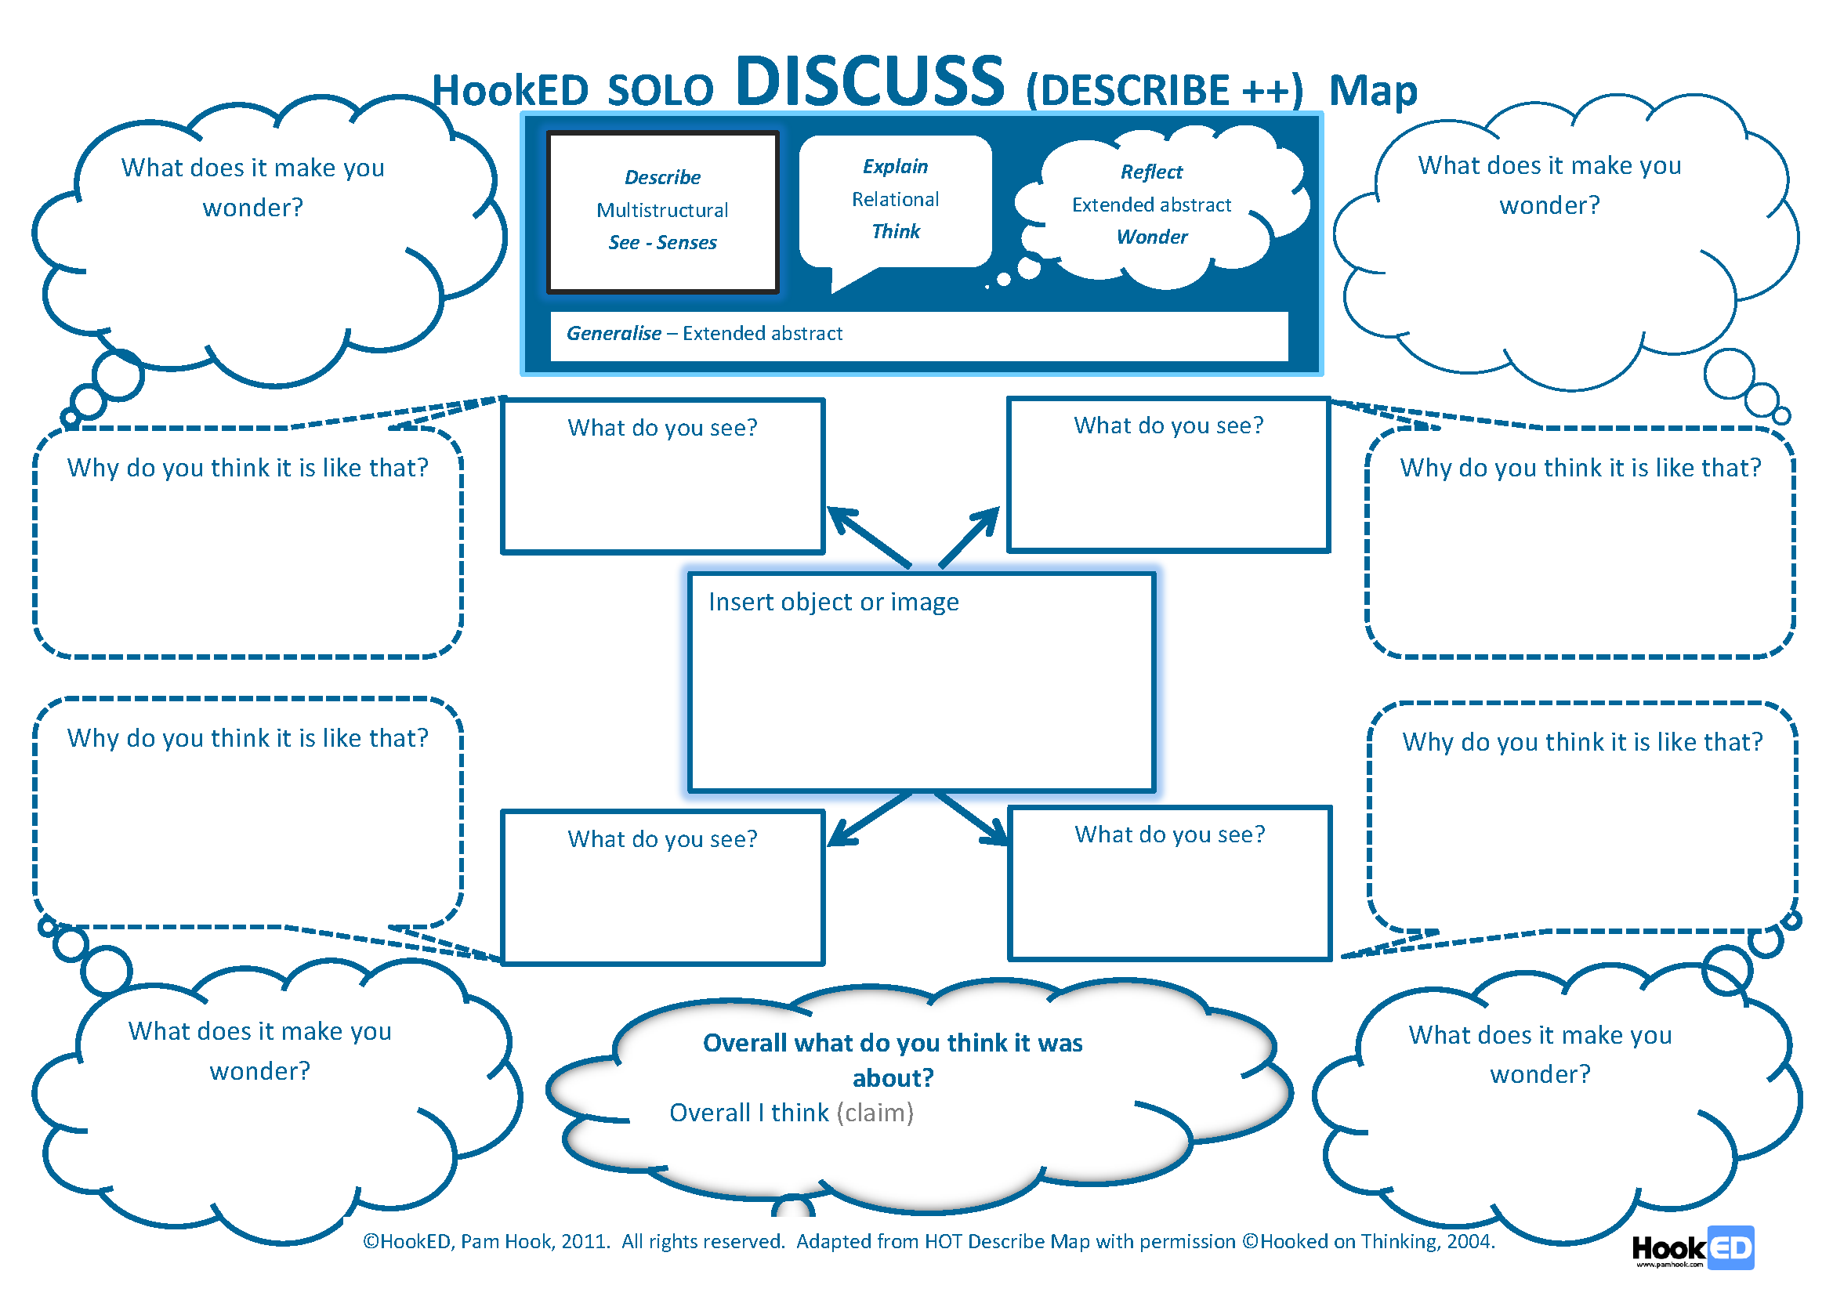
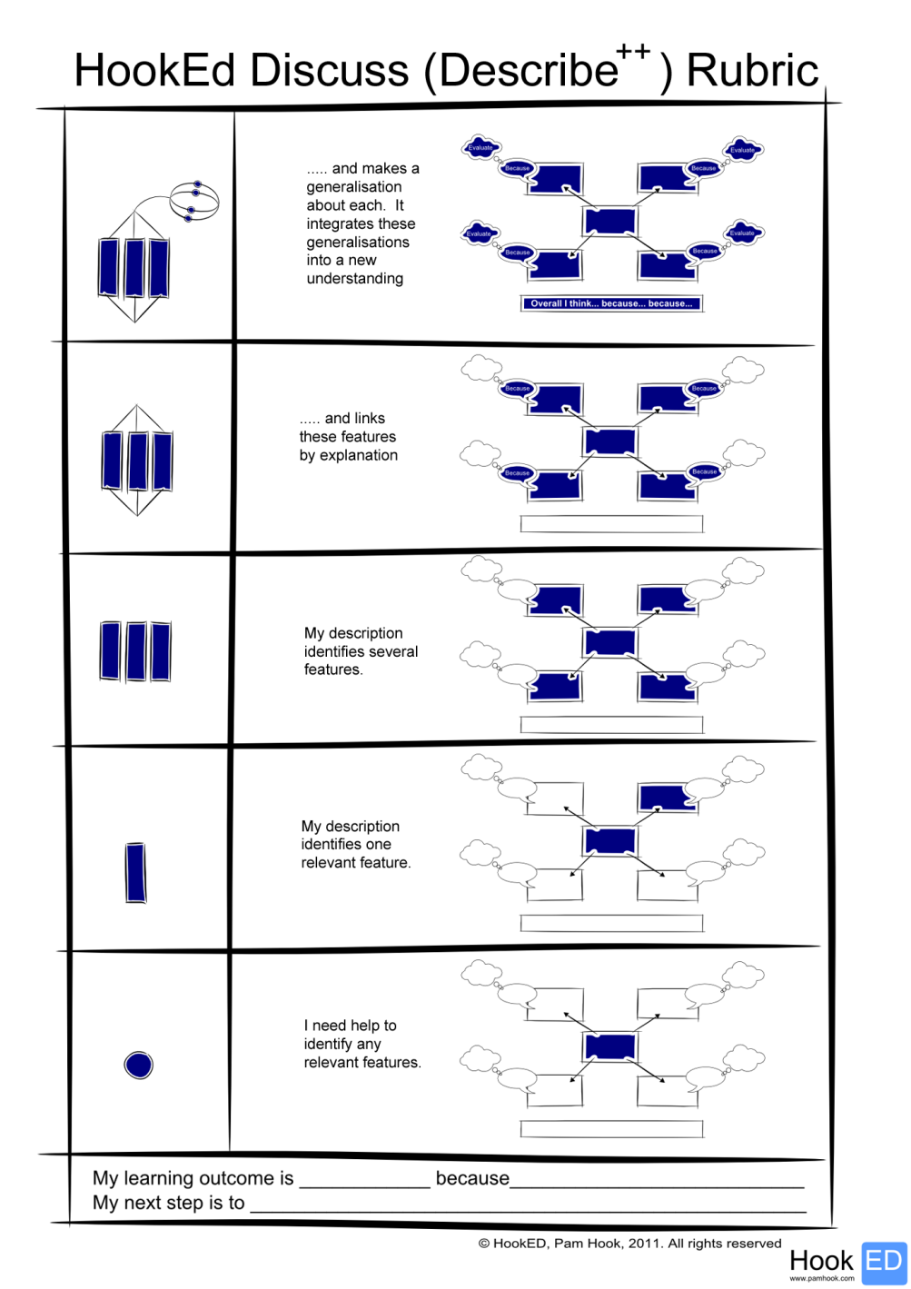

How to Discuss (using a HookED SOLO Taxonomy Discuss Map (YouTube)
Imagine you are riding a bike around the school.
Choose one of the hand signal messages above and model this message to other students. How do we know if your message has been successfully communicated – seen and understood?

5.2. Making meaning of messages

[Relating ideas]
[Links to NZC Learning Areas: English Creating Meaning; Technology; Social Sciences]

Sequencing a message using the senses
What senses are involved in sending and receiving messages?
List all the senses that are involved in communicating with hand signals.
Sequence the path of a message (from encoding to decoding).
Make a wall display showing the sequence of senses involved when a cyclist successfully sends a message that is received by others.

Explaining the causes and consequences of messages
Interview book lovers and visit the school library to identify children’s picture books, graphic novels and comic books about messages.
Make a list of titles that explain:
- the causes for sending a message
- the consequences of receiving a message
- the consequences of not receiving a message
- the causes for the failure of a message because of a transmission failure
- the causes for the failure of a message because of a decoding failure.
Share your book list with others wanting resources for working with young people on the importance of communicating messages in everyday life.

Classifying messages
Technology changes the ways in which we can communicate.
Survey parents (or grandparents) about communication today and in the past.
Identify some significant similarities and differences in the methods used.
Classify a selection of communication methods by the following descriptors: the number of people who can receive the message, the distance the message travels, the time the message can be sent, the raw materials required etc.
Refer to the example grid below:

 | Grunting | Smoke signals | Symbols | Letters | Voice | Text
Number of people | a few around you | greater number of people | those who pass by | a few people | usually between one and a few people | large number of people
Distance away | close | much further (km) | huge distances | huge distances, time dependent | huge distance, immediate | huge distance, immediate
Time available | day and night | only day | only day | day and night | any time, any place | any time, any place
Raw materials | people | fire | objects around us | paper  ink | phone | phone

Compare and contrast the cyclist’s use of hand signals with another method of communication.
Use the HookED SOLO Compare and contrast map and self-assessment rubric below to draft your thinking.
Refer to:
How to compare and contrast using a HookED SOLO Taxonomy Map (YouTube)
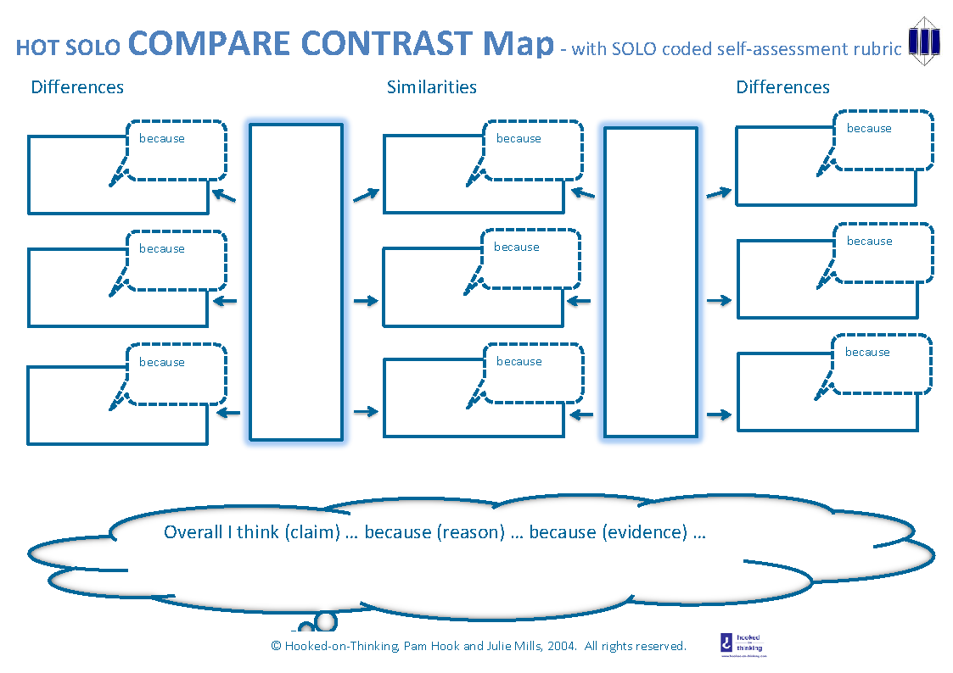

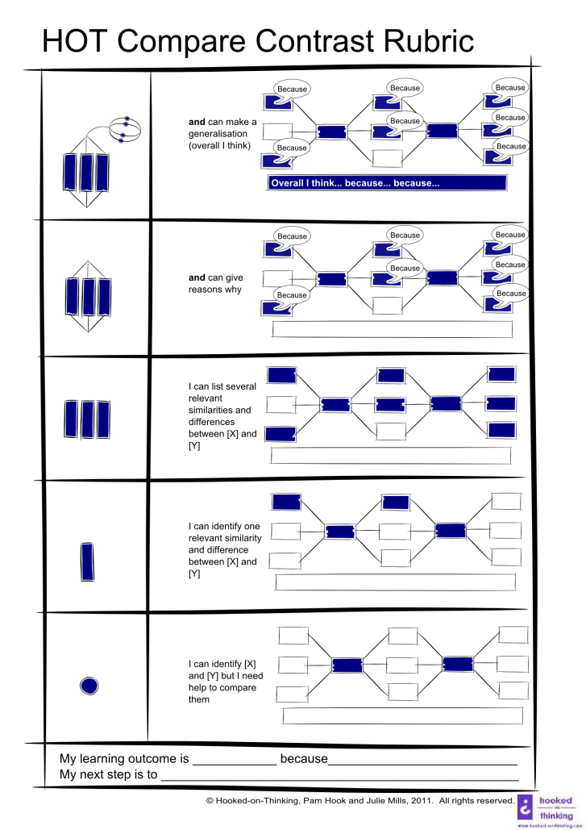

5.3. Creating a draft comic book about cyclists’ use of hand signals – include a message about effective communication

[Extending ideas]
[Links to NZC Learning Areas: English Creating Meaning]

Just how effective are cyclists’ hand signals for letting other road users know what a cyclist intends to do next?
Ask students to work in groups of 2-3.
Prepare a cartoon strip or a series of comic strip cells that develop a persuasive argument for using hand signals when cycling.
Use the grid below to draft two arguments.

In this first template, the cyclist promotes the use of hand signals by cyclists.

Claim  Hand signals are very effective | Reason 1 | Example 1
 |  | Example 2
 |  | Example 3
 | Reason 2 | Example 1
 |  | Example 2
 |  | Example 3
 | Reason 3 | Example 1
 |  | Example 2
 |  | Example 3

In this second template, another cyclist presents the argument against the use of hand signals by cyclists.

Counter claim | Reason 1 | Example 1
 |  | Example 2
 |  | Example 3
 | Reason 2 | Example 1
 |  | Example 2
 |  | Example 3
 | Reason 3 | Example 1
 |  | Example 2
 |  | Example 3
Conclusion

Develop this thinking into a persuasive argument between two cyclists written in comic strip form.
Ask students to:
- Describe the pro-hand signal cyclist and explain how they were persuaded about the usefulness of hand signals.
- Describe the anti-hand signal cyclist. What motivated them to reject hand signals when cycling? Brainstorm ideas for a plot line. For example:
Part 1. Your cyclist’s everyday life before the event that makes them take action and champion the use of hand signals.
Part 2. The difficulties your cyclist faces while trying to persuade others to use hand signals when cycling.
Part 3. The turning point in the story – where your cyclist triumphs (or not) in their efforts to persuade others to use hand signals to stay safe.
Plan your frames before you start.

Using hand signals
Frame | What happens | Cyclists | Setting and props | Caption
Part 1
Part 2
Part 3

Use large sheets of newsprint to hand-draw the cells in your comic page template, or make up a template using Microsoft Word.
If online resources are available, students can also refer to the many downloadable comic book templates online:
Comic Strip Template Resources TES
How to make a comic book on Microsoft Word
The following interactive comic book creators and story book writers are also fun.
Read Write Think: Online Comic Creator
Storybird
Ask for and give feedback on how you could improve the draft comic book story board. Use the success criteria and feedback prompts to give explicit feedback.
Feedback prompts for students
  - I liked …
  - I learnt …. from this.
  - One thing you could work on improving is …
  - Next time you could try …

Wrap Up

Session Reflection

What do you know you don’t know about communicating using hand signals when cycling?
What have you learnt that is new to you about communicating using hand signals when cycling?
What do you wonder about communicating using hand signals when cycling?
Use the student responses to make decisions about follow-up sessions.

Key competency self-assessment rubric

Thinking | Managing self | Participating and contributing | Relating to others | Using language symbols and text
Develop a critical eye (situational awareness) for unsafe environments and unsafe actions when out on your bike. | Act appropriately when on and around bikes.  Act in ways that create and maintain ‘bike fun and safe environments’. | Display an awareness of local issues around riding bikes.  Be actively involved in community issues around having fun and keeping safe when riding bikes  Contribute to physical environments and local events to make them ‘bike fun and safe’. | Interact with others to create ‘fun and safe’ biking environments at school and in the local community. | Interpret messages in communications about ‘bike fun and safe environments’.  Use language symbols and text to communicate messages about ‘bike fun and safe environments’.

For more about key competency self-assessment rubrics, see Appendix B.

