BikeReady Lesson 4

Developing skills for looking all around to identify hazards

Planning for Lesson 4

Skills focus

Looking all around including behind
- Need to look, and also need to gather information (speed, distance etc).
- Last look (lifesaver) over the left shoulder.
- Pedalling while looking may help with balance.

Reflection on cycle skills training session

Share new learning with classroom teacher
Identify experiences students enjoyed when taking part in cycle skills training on situational awareness. Record your findings on a SOLO Strip.
Draw pictures (take photographs or video) in response to the following prompts.
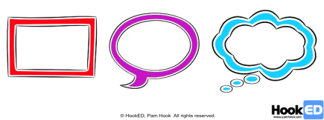
- What did you enjoy when you were taking part in the cycle skills lesson? [SOLO Multistructural – rectangle]
- Why do you think it was like that? [SOLO Relational – speech bubble]
- What does it make you wonder about cyclists and/or cycling? [SOLO Extended abstract]

Add to the class list of all the enjoyable experiences students encountered during cycle skills training.
Identify any new terms and vocabulary introduced into the training session. Highlight new terms and vocabulary.
E.g. see, notice, measure, present, comprehend, make meaning, interpret, infer, project, predict, future events, make decision, perform actions, distraction, risk, focus.
Add the terms and their meanings to the class/group glossary. Identify unfamiliar terms and use them in a Frayer Vocabulary Chart.

Opportunities for community engagement

Make connections with people and organisations in the local community with experience in situational awareness, and estimating speed and distance travelled by bikes.
Make connections with people and organisations in your local community who might volunteer to visit or host students wanting to find out more about situational awareness and the effects of distraction.
For example, contact people who make complex decisions based on the environment around them, such as aviation workers, air traffic controllers, yacht racers, ship navigators, emergency service workers (firefighters, ambulance drivers, emergency room workers and police officers), car drivers and bicycle riders.
Sometimes knowing how our attention can be distracted helps retain a focus on the wider environment. Professional magicians make their livelihood by distracting the attention of their audience.

Alignment to NZC learning areas

Refer to NZC Learning Areas Overview. Refer to the resource for Achievement Objectives and Learning Intentions (L1 to 4).

English | Listening, Reading and Viewing |  |  |  |  |  | Speaking, Writing and Presenting
The Arts – Drama | Understanding the Arts in Contexts |  | Developing Practical Knowledge |  |  |  | Developing Ideas |  |  | Communicating and Interpreting
Health and Physical Education | Personal Health and Physical Development A – A3 Safety Management |  |  |  |  | Healthy Communities and Environments S – D2 Community Resources
Mathematics and Statistics | Number and Algebra
 | Number strategies and knowledge |  |  | Equations and expressions |  |  |  |  | Patterns and relationships
Science | Nature of Science |  |  |  |  |  |  |  |  |  | Physical World
 | Understanding about science | Investigating science |  |  | Communicating in science |  |  | Participating and contributing |  |  | Physical inquiry and physics concepts
Social Sciences | Identity, Culture and Organisation |  | Place and Environment |  |  |  | Continuity and Change |  |  | The Economic World
Technology | Technological Practice |  |  | Technological Knowledge |  |  |  |  | Nature of Technology

Classroom activities

Acquire surface and deep understanding needed to support Cycle Skills Lesson 4.

Building student understanding about situational awareness when cycling

A key aspect of situational awareness is paying attention. Cyclists need to notice any threats or risks en route, using this awareness to manage and choose the safest behaviours in different local cycle environments.
Think about the hazardous road features that:
- can stop a cycle rapidly: immovable features that will put huge forces on cyclists’ bodies in a collision
- create poor visibility on a road: winding roads, sharp corners and steep gradients
- are caused by road surfaces, inclines and bends: sharp corners, steep gradients, pot holes and gravel surfaces
- are caused by other vehicles: heavy traffic flow and large trucks
- are due to the physical health issues of the people using the road: road users suffering from dizziness, nausea, a heart attack or exhaustion
- are due to unsafe use of equipment by road users: road racers, unsafe use of skateboards or baby strollers
- are due to livestock: farmers moving cows for milking
- are due to young children on and around the road: roads around schools at the beginning or end of the school day, or roads that include school bus stops
- are due to elderly people: roads passing retirement villages or nursing homes
- are due to medication, alcohol or other drug use by people using the road: roads near pubs or party venues
- are due to the emotional state of road users: roads near hospitals, schools or sporting venues
- can distract cyclists: accidents, road works or roadside advertising
- are due to the weather: rain, ice, wind gusts, sun strike, glare, fog, slips, and fallen trees.
If we know what is going on, we can figure out ways to deal with or manage hazards that lead to safer outcomes.

4.1. Paying attention

[Bringing in ideas, relating ideas and extending ideas]
[Links to NZC Learning Areas: Health and Physical Education]

In school we sometimes talk about learning to listen. By this we mean listening with empathy so that we understand what we are being told, rather than listening for a gap in the conversation when we can talk.
In a similar way, demonstrating situational awareness requires cyclists to pay attention and to be alert to everything happening around them.

Cyclists can observe hazards on the left, on the right, ahead, behind and coming towards them. When reacting to hazards, road users should be continually scanning the road ahead (12 seconds ahead), behind and to the sides, including blind spots.
Ask groups of 3-5 students to build a diorama or model or to annotate a photograph of a local road.
Encourage students to scan ahead, behind and to the sides as they observe their model route.
How many threats or risks can they introduce?

Environmental situation or potential hazard

List all the features in the environment that could represent a potential hazard to a cyclist.
For example: elderly pedestrians, poor lighting, pre-schoolers on scooters, groups of teenagers walking and laughing together, hospital carpark exits, rental car depots, trees, ditches, undivided road, high traffic flow, narrow road, steep road, high number of connecting intersections, give way signs, stop signs, pedestrian crossings, level crossings, flush medians, primary schools, road works, cyclist training squads, loose dogs.

4.2. Making meaning of the situation

[Bringing in ideas, relating ideas and extending ideas]
[Links to NZC Learning Areas: Health and Physical Education]
Collate all the hazards to create a class resource of potential situational awareness hazards for cyclists.

Sort the hazards into categories. Students may invent their own categories such as people, places, road conditions, other vehicles, weather and environment factors.
Ask students to:
Draw up a table with 3 columns.
In the left-hand column, list 5 potentially hazardous road features that a cyclist might identify when scanning a road.
In the middle column, explain why these 5 might represent hazards to a cyclist. Talk with other experienced cyclists to find out other ways of countering or managing these hazards.
In the right-hand column, explain how the hazard can be managed. What action could or should the cyclist take? Sometimes the best way to manage a hazard is to avoid it.

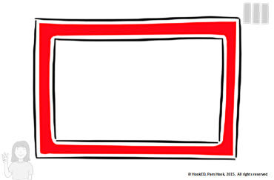 | 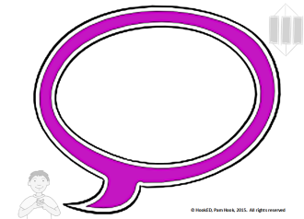 | 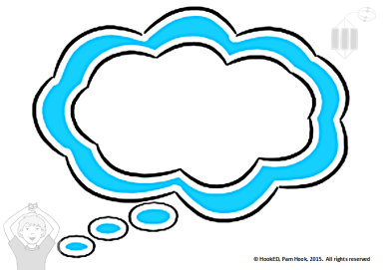
Environmental situation/potential hazard | Cause of hazard/risk  This is a hazard because … | How to manage the hazard  This can be managed by …

4.3. Making decisions on next steps

[Bringing in ideas, relating ideas and extending ideas]
[Links to NZC Learning Areas: Health and Physical Education]

Ask students to:
Plan a bike route for a safe journey, making decisions to reduce road hazards on the route.
A key skill for cyclists is to be able to plan a route for a safer journey, keeping road hazards in mind. When you first bike to school you choose a route you are familiar with. This may be a safe route for a car or a pedestrian but it may not be the safest route for a cyclist.
In this activity you will research the safest route from your school to your house for a cyclist.
Walk the route a cyclist would take to travel safely from their home to a named location.
Use situational awareness to identify any potential hazards for cyclists. (Refer above.)
Use Google Maps or a hand-drawn map to mark up any potential hazards on the ‘safest route’ from home to school.
Share these maps with the school community.

Wrap up

Session reflection

What do you know you don’t know about situational awareness when cycling?
What have you learnt that is new to you about situational awareness when cycling?
What do you wonder about situational awareness when cycling?
Use the student responses to make decisions about follow-up sessions.

Key competency self-assessment rubric

Thinking | Managing self | Participating and contributing | Relating to others | Using language symbols and text
Develop a critical eye (situational awareness) for unsafe environments and unsafe actions when out on your bike. | Act appropriately when on and around bikes.  Act in ways that create and maintain ‘bike fun and safe environments’. | Display an awareness of local issues around riding bikes.  Be actively involved in community issues around having fun and keeping safe when riding bikes  Contribute to physical environments and local events to make them ‘bike fun and safe’. | Interact with others to create ‘fun and safe’ biking environments at school and in the local community. | Interpret messages in communications about ‘bike fun and safe environments’.  Use language symbols and text to communicate messages about ‘bike fun and safe environments’.

For more about key competency self-assessment rubrics, see Appendix B.

