Literacy and numeracy using the road code

Introduction
This transition resource includes learning experiences that use The official New Zealand road code (2023 and online) to integrate learning for citizenship within broad contemporary social issues for safer travel in New Zealand.
The official New Zealand road code
Lessons support NCEA in its current format, helping students meet literacy and numeracy requirements. Learning is designed to generate evidence for the criteria in the following unit and achievement standards:
Unit standards | Achievement standards
26622: Write to communicate ideas for a purpose and audience  26624: Read texts with understanding  26625: Actively participate in spoken interactions  26623: Use numbers to solve problems  26626: Interpret statistical information for a purpose  26627: Use measurement to solve problems | AS 90052: English 1.4 Produce creative writing  AS 90053: English 1.5 Produce formal writing  AS 90857: English 1.6 Construct and deliver an oral text  AS 90855: English 1.7 Create a visual text  AS 90853 English 1.9 Use information literacy skills to form conclusion(s)

Varied learning experiences do this at three levels of understanding. Learning experiences for:
- bringing in ideas (35 activities, see Part 1)
- relating ideas (15 activities, see Part 2)
- extending ideas (12 activities, see Part 3).

Links to the road code
Activities are aligned to the relevant section of The official NZ road code and to lessons in Drive Road Code – the official way to learn the road rules and get the information needed to pass the learner licence theory test.
Drive Road Code
They can also be aligned with the road code modules at Pathways Awarua, the online literacy and numeracy tool.
Road code (Pathways Awarua)
Consider the interests, abilities and future needs of your students when selecting the most suitable activities (in terms of prior knowledge and cognitive complexity) and the order of activities to include in your teaching programme.
The official New Zealand road code explains the legal responsibilities of vehicle owners and the legal requirements for your vehicle.

Overview

Learning contexts for bringing in ideas (35)

Learning contexts for relating ideas (15)

Learning contexts for extending ideas (12)

Possible learning pathways
The number, complexity and sequence of pathways will vary according to the different learning needs of students.
Each learning activity comes with suggested links to Drive, Pathways Awarua modules, the Official New Zealand Road Code and further learning activities to deepen understanding.
Learning experiences to bring in ideas | Learning experiences to relate ideas | Learning experiences to extend ideas

Responsible driving

Safe vehicles

Driver licence

Driving on different types of roads

Stopping distances

Big ideas behind the resource
Note: this unit may involve the discussion of road crashes. It is likely there will be students in your class with first-hand experience and it is recommended that you exercise discretion.
What is the big idea?
The big idea is that people using our roads are precious. We need to work together so everyone, whether they’re walking, cycling, driving, motorcycling or taking public transport, can get to where they’re going safely.
The Official New Zealand Road Code is a guide on how to be active citizens in working together for this outcome. Everyone is connected. What we do affects others. What others do affects us.
Our vision
Our vision is a New Zealand where no one is killed or seriously injured in road crashes. This means that no death or serious injury while travelling on our roads is acceptable.
How do we get there?
Road to Zero is New Zealand’s Road Safety Strategy to 2030. It outlines the national approach to achieving this vision.
Road to Zero (Waka Kotahi)
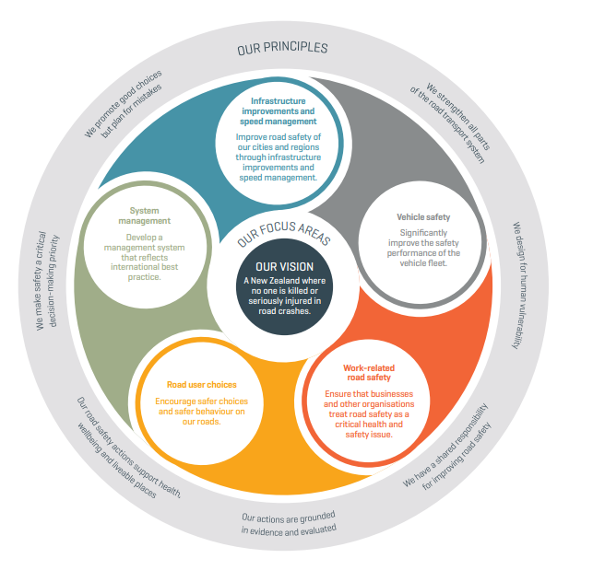

How we work together
When we share something with others, what we do affects what they can do. We need to share the roads in ways that are fair – in ways that don’t create unnecessary risk for others.
We need to work together to keep everyone safe when they use the roads.
How young people can measure their progress
The activities in this curriculum resource encourage students to consider their part in a safer road system in 3 ways:
Actions – no compromises – demonstrate a commitment to safer travel for self, friends, family and whānau. Adopt a “sort it and report it” approach to unsafe road use. Take responsibility for past actions and make efforts to improve. Seek out and correct unsafe road use.
Collaboration – listen, respond and act together to make the roads a system free of death and serious injury.
Communication – describe, explain and justify ways to share the road safely with others – share safe speed rules, safe road use rules, safe vehicles rules and other rules.
For more on this, see SOLO self-assessment rubrics for actions, collaboration and communication.

Values, key competencies and key understanding
Values | Key competencies – to be exercised and strengthened. | Key understanding
Excellence  Innovation  Diversity  Equity  Community and Participation  Ecological Sustainability  Integrity  Respect | Thinking – Critically analyse the factors contributing to safe roads for all citizen road users.  Managing self – Act responsibly when using the road as a pedestrian, passenger or driver to ensure all road users travel safely.  Participating and contributing – Display an awareness of the local issues around creating and maintain safe roads. Be actively involved in community issues around safe roads. Contribute to ensure every road user travels safely.  Relating to others – Interact with others to create safe roads.  Making meaning from language, symbols and text – Interpret and use language, symbols and text to communicate messages about citizenship through contexts of road users and safe roads. | Everyone belongs, matters and makes a difference when using the road.  Everyone has the right to safe travel on the roads.  Everyone is responsible for making sure other road users travel safely.

