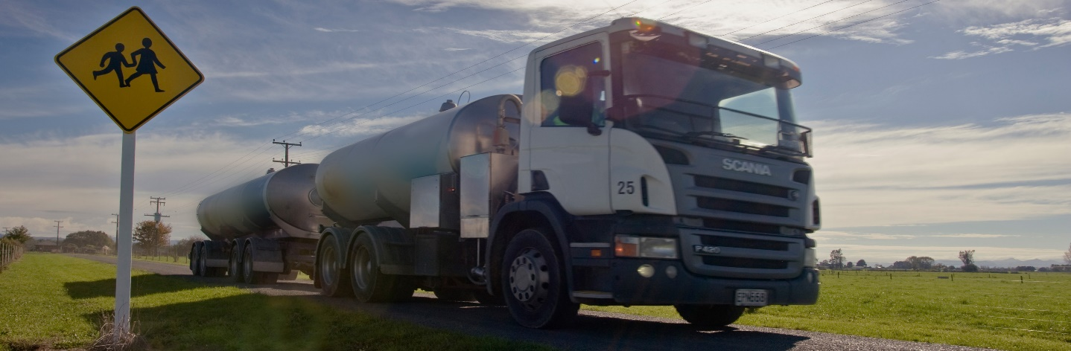
Keeping safe around trucks

Curriculum resource, updated 2023

Section 2: Bringing in ideas

2.1. What are the hazards that children face when they share the road?
Learning area: Health and PE
Health and Physical Education | Personal Health and Physical Development A – A3 Safety management |  |  |  |  | Healthy Communities and Environments S – D2 Community resources
Mathematics and Statistics | Geometry and Measurement
 | Measurement |  |  | Shape |  |  |  |  | Position and orientation
Science | Nature of Science |  |  |  |  |  |  |  |  |  | Physical World
 | Understanding about science | Investigating science |  |  | Communicating in science |  |  | Participating and contributing |  |  | Physical inquiry and physics concepts
Social Sciences | Identity, Culture and Organisation |  | Place and Environment |  |  |  | Continuity and Change |  |  | The Economic World

Share “Things to know about children” from the official New Zealand Road Code.
Sharing the road with pedestrians

Things to know about children
Children aren't little adults, so don’t expect them to act like adults.
Children, especially those under the age of 9, may not have the skills and abilities needed to be safe in traffic. Be very careful when driving near them.
Young children have narrow vision and may not see vehicles as easily as adults do.
Children have trouble judging the speed of moving vehicles. They may let a slow vehicle pass and try to cross in front of a fast one.
Children often don’t understand that it takes time for a vehicle to stop.
Children may have difficulty working out where sounds are coming from.
Because children are small, they often can’t see over bushes and parked vehicles. This also means they can’t be seen easily by drivers.
Children may have trouble stopping at a kerb and could dart out into traffic.
Children can freeze when they find themselves in danger, instead of taking quick action as an adult might.
Keep a lookout for children at all times. Take special care when driving during 8–9am and 3–4pm, when children are travelling to and from school.

Ask students to work in pairs to:
- Complete a HookED SOLO “See Think Wonder” strip about one bullet point in the list above.
- Share your thinking with other pairs in the class.
- Revise your strips to reflect the feedback from other students.
Use the final version of SOLO strips from each pair to make a wondering wall about the special hazards students face when they share the road network.
Invite students from other classes to visit your wall and add their own wonderings.

HookED SOLO “See Think Wonder” strip
What is claimed? | Why do you think this is a hazard? | What does it make you wonder about keeping children safe when they share the road network?
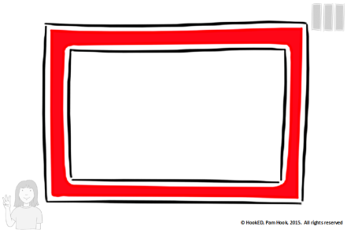 | 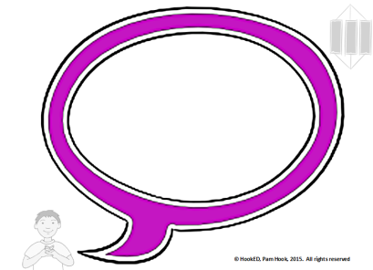 | 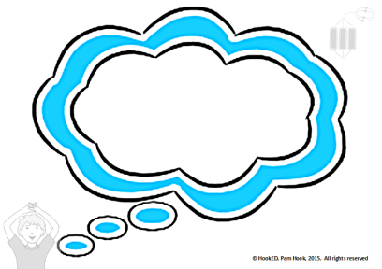

2.2. Trucks and truck drivers keep our country going
Learning areas: Health and PE, Social Sciences
Health and Physical Education | Personal Health and Physical Development A – A3 Safety management |  |  |  |  | Healthy Communities and Environments S – D2 Community resources
Mathematics and Statistics | Geometry and Measurement
 | Measurement |  |  | Shape |  |  |  |  | Position and orientation
Science | Nature of Science |  |  |  |  |  |  |  |  |  | Physical World
 | Understanding about science | Investigating science |  |  | Communicating in science |  |  | Participating and contributing |  |  | Physical inquiry and physics concepts
Social Sciences | Identity, Culture and Organisation |  | Place and Environment |  |  |  | Continuity and Change |  |  | The Economic World

Use the information below (text and video) to bring in information about trucks and truck drivers.

Keeping New Zealand going
Truck drivers are an essential part of the transport system. When you drive a truck, you belong and you matter to our community, and you make a difference for all New Zealanders. Trucks help keep our economy functioning.
Trucks carry over 90 percent of New Zealand’s total freight by weight. Trucks carry 75 percent of our total freight by weight and distance (measured in tonne-kms) – as trains and coastal shipping tend to carry goods for longer distances than the average truck journey.
Look ahead to the future. The total amount of freight moved in 2042 is forecasted to be 30 percent higher than it was in 2017, suggesting the importance of trucks will not be changing any time soon. If you want to help the New Zealand economy by exporting products overseas, you will in many cases need trucks to help transport your products to a port.
A reliable and affordable transport system is important to everyone. The transport system helps us to access the goods and services and the physical structures and systems that support the New Zealand economy. Additionally, 1 in 25 New Zealanders works in the transport industry.
For more information:
National Freight Demand Study 2017/18 (Ministry of Transport)

What is a truck?
Trucks are big, heavy road vehicles, many of which tow trailers or semi-trailers. In New Zealand, our largest trucks can weigh more than 60 tonnes (eight times as heavy as an African elephant) and be up to 25 metres long (one quarter the length of a rugby playing field).
The different types of heavy motor vehicles are described on the Waka Kotahi website:
Vehicle types
Trucks in New Zealand come in different shapes and sizes depending on the load they are designed to carry. Types include tipper truck, heavy haulage truck, container truck, flat deck truck, line-haul truck, logging truck, livestock truck, fuel tanker, recovery truck, crane truck, army truck and refrigerator truck.
Types of trucks, trailers and loads

What do trucks do?
Trucks transport (carry) goods and materials from one place to another. In New Zealand, these goods and materials include logs, livestock, crops, milk, petroleum and fuel, as well as perishable, refrigerated, life-saving and life-endangering items.
Trucks carry the food we eat, the materials we use for shelter, the fuel we need to power our vehicles and heat our homes and the waste we create.
They collect, transport and distribute the goods and materials we import and export at our sea ports, airports and container terminals.
Where do trucks go?
Trucks travel on all New Zealand roads, private and public. Most truck trips in New Zealand are short distances, less than 100 kilometres at a time.
What do trucks provide?
Trucks can provide a “just in time - any place – any time” service across New Zealand’s 11,000 kilometres of state highways and 83,000 kilometres of local roads. Such “just in time” services reduce holding too much stocking in local warehouses. However, having “just in time” services also means that when truck deliveries are disrupted, local communities are quickly cut off from the goods they need to eat, to shop, to play, to get to work and to access medical care. When earthquakes, slips, snow, extreme weather or other disruptions stop the trucks from getting through, everyone is affected.

Who drives the trucks?
Truck drivers have to drive in ways that keep themselves and others safe on the roads and also get the job done. Driving a large, heavy truck is skilled and specialised work. It is challenging to drive a truck on New Zealand highways, urban roads and rural roads while other vehicles, cyclists and pedestrians are using these same roads.
A trucker’s job matters. A truck driver must keep to timetables so that supply chains are not interrupted and it is especially important to deliver certain goods on time.
Truck drivers are often happy with their own company – individuals who like to be their own boss. They meet other truck drivers (co-workers) briefly and often only by chance – at a truck stop or when passing an oncoming truck on the road.
Worker surveys show the independence is what attracts many truck drivers to the job. They like the promise of driving through new territory as “explorers of the highway” and resolving unexpected challenges each day. Truck drivers have to carefully monitor their levels of driver fatigue and physical health when they take on the responsibilities of driving a big, heavy and powerful truck on the road network.
Driving a truck has spawned a whole genre of truck movies and reality TV series, where some truck drivers have become media celebrities.
Truck drivers need special qualifications to drive these heavy vehicles. Only the very safest and most skilled drivers ever qualify to drive the biggest rigs with the heaviest loads. In New Zealand, you have to be determined and work hard to get a Class 5 driving licence for driving the big rigs. It can take three years for drivers to work through the qualification process for a Class 5 driving licence.
Truck driving is a rewarding career. However, New Zealand currently has a shortage of qualified big rig drivers. Trucking firms are struggling to find drivers and are looking for qualified drivers from overseas.
Heavy truck driver (Careers.govt.nz)

How can we keep trucks and truck drivers safe?
Technology is improving the safety and efficiency of transport systems across the world. For example, vehicles have devices that monitor safe driving distances, detect hazards, warn drivers when they drift out of their lane, control safe braking, monitor blind spots, minimise roll when cornering, help you park and detect driver fatigue.
Self-drive vehicles, trucks and cars are used or trialled in a few locations.
Recently companies in New Zealand have started to introduce performance monitoring technology into their trucking fleets to increase safety and driving efficiency. This means companies can access details of an individual’s driving location and driving behaviour. They share and aggregate these details to create new metrics to evaluate job performance. However, the technology can also reduce truck drivers’ sense of independence when driving. Refer to:
The contexts of control: information, power and truck-driving work
For example, Fonterra’s fleet of about 500 tankers, one of the largest transport fleets on New Zealand roads, uses surveillance software to improve safety and performance. The software keeps a daily record of total driving hours, any fast cornering, heavy braking and any travel at speeds above 90 kilometres per hour. The record is reviewed daily and is used to create metrics for driver assessment (Barry McColl, Fonterra General Manager of Transport and Logistics - cited in Sunday Star Times, 1 January 2017, News A5).

Videos
Trucks NZ, Christchurch Footage from a truck show, many types of trucks displayed.
Big Rigs on Mt Messenger Footage of trucks on a New Zealand highway.
Kaingaroa 200-tonne-plus triple off-highway On the private roads of the North Island’s pine forests, you’ll find trucks bigger than any on the highway.
Fonterra: Tanker driver careers
Fonterra Driver Fatigue Programme
24 Hours of Fonterra tankers Movements shown on a map over 20 seconds.

Tasks
Use the text and videos above and any other relevant resources to find the best answers to the following tasks.
1. Define a truck.
What is a truck? Use text or annotated 2-D drawings and 3-D models to show what a truck is.
2. Describe a truck driver’s job.
What does a truck driver do? Describe the roles and responsibilities of a truck driver’s job. How is this similar or different to the roles and responsibilities of being a pedestrian on the road network? Compare a truck driver’s job with the role of being a pedestrian.
3. Explain why truck driving is important.
Why is truck driving an important job?
4. Explain why it takes a long time to get a heavy truck driving licence.
Why does it take so long to get a heavy truck driving licence?
5. Reflect on the use of monitoring technology in the trucking industry.
Create a persuasive argument for or against using monitoring technology in the trucking industry.
Use a HookED SOLO Argument Writing Plan to plan your argument.
6. Create a glossary of new vocabulary and science terms that will help students describe trucks and explain how they use the road network for safer journeys.

2.3. How can we keep safe around trucks? – Making the TruckED Video Talks Series
Learning Areas: English – Creating Meaning, Health and Physical Education, Science – Physical World, Mathematics and Statistics
Health and Physical Education | Personal Health and Physical Development A – A3 Safety management |  |  |  |  | Healthy Communities and Environments S – D2 Community resources
Mathematics and Statistics | Geometry and Measurement
 | Measurement |  |  | Shape |  |  |  |  | Position and orientation
Science | Nature of Science |  |  |  |  |  |  |  |  |  | Physical World
 | Understanding about science | Investigating science |  |  | Communicating in science |  |  | Participating and contributing |  |  | Physical inquiry and physics concepts
Social Sciences | Identity, Culture and Organisation |  | Place and Environment |  |  |  | Continuity and Change |  |  | The Economic World

Ask students to work in groups to:
Choose 1 thing that truck drivers would really like students to know about keeping safe around trucks from the “Truck drivers would like …” Resource below.
Investigate this fact using the HookED SOLO “See Think Wonder” strip.
Mock up a set of a trucker’s cab, using found materials in the classroom.
Write a script for a 90-second video of an interview with a “trucker” designed to capture one idea the trucker wishes they could share with students across New Zealand.
Draft your question ideas using the HookED SOLO “See Think Wonder” strip (refer to 2.1. above). Be sure to ask the “truck driver” why this idea is important and what it makes them wonder.
Allocate roles and make the video.
Share the series of TruckED Video Talks with an audience.

“Truck drivers would like …”
Truck drivers would like all students (walking, cycling or on scooters) to know that:
Trucks are big. Trucks are tall and long and heavy.
When we share the roads with big and heavy vehicles like trucks, we need extra strategies to keep ourselves safe.
Trucks cannot stop quickly because they are very big and heavy.
Trucks can take up to 50m to stop in a city area and 200m or more in a rural area. Never chase after atruck or run to get in front of a moving truck. Don't step out (or pull out on your cycle or scooter) in front of a truck.
Take extra care at pedestrian crossings and intersections. At an intersection or pedestrian crossing, the space between you and an oncoming truck may look larger than it really is.
Talking Trucks by NZ Trucking Association
Trucks have large blind zones because they are big (tall and long).
Truck drivers often cannot see pedestrians, cyclists or other vehicles on either side, directly in front of or behind the cab. A truck’s blind zone on the left of the cab may run the length of the trailer and extend out three lanes.
You can disappear from view when you walk or cycle close to a truck. Truck drivers use mirrors to see pedestrians, cyclists or other vehicles. If you are in a blind zone, they might not see you.
Don’t stand, play, ride your bike or skateboard behind, beside or in front of a truck. Never linger around a truck. Remember if you cannot see the driver in the mirrors, the driver cannot see you.
Share the road safely with big trucks by NZ Trucking Association
Trucks take up more space when turning because they are big (tall and long).
When a truck starts its turn, it may have to pull into another lane to do so. Give turning trucks lots of space to manoeuvre. When a truck driver indicates a turn: Keep away from the truck – stand back and be aware of all parts of the truck and trailer unit and where they might go.
It's safer not to undertake or overtake a turning truck until the truck has completed its turn.
Truck drivers cannot always see marked cycle lanes because trucks are big (tall and long).
A marked cycle lane is not safe if the driver can't see you. A cycle lane can be a blind zone. If you and the truck are both turning left, don't take a risk, sit back a bit and let the truck go first.
Sharing the road safely with big trucks and cyclists – Cyclists Blind Zones by NZ Trucking Association
Trucks can create unexpected air turbulence because they are big and heavy.
Trucks are big and create a lot of air turbulence around them. This air turbulence can affect students who are walking or cycling when the truck passes. It might cause you to lose your balance and wobble, trip or fall in the path of the truck or another vehicle.
Air Turbulence around Trucks by NZ Trucking Association
Trucks can create unexpected splash or spray because they are big and heavy.
Watch out for splash and spray when you are being passed by or following a truck on a wet road. Splash and spray can make it difficult for you to see and the surprise may make you lose your balance and stumble into the road.
Keep a safe distance from trucks at all times.
Do not play on or around trucks. Make sure you are visible around trucks.

Reflection on Bringing in Ideas Sessions
What do you know you don’t know about keeping safe around trucks?
What have you learnt that is new to you about keeping safe around trucks?
What do you wonder about keeping safe around trucks?
Use the student responses to make decisions about follow-up work.

