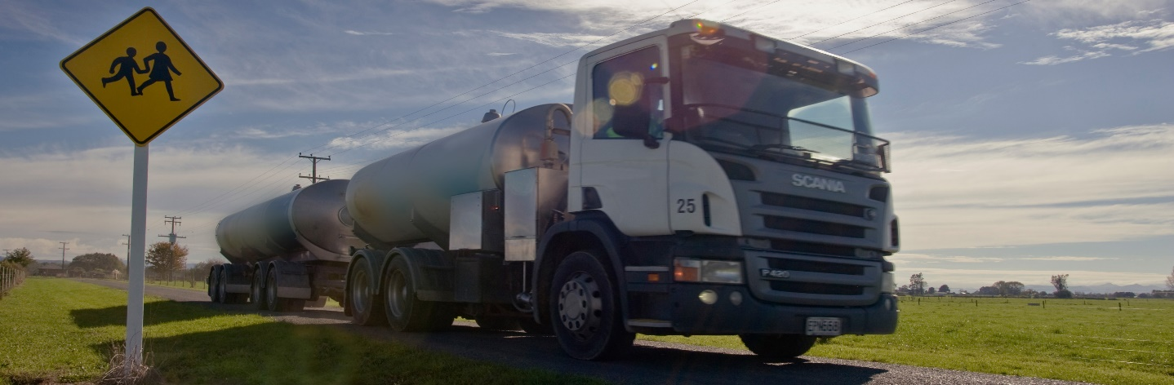

Keeping safe around trucks

Curriculum resource, updated 2023
Note: Be aware these resources may involve the discussion of incidents on the roads that cause serious injury or death. It’s likely some students have first-hand experience of such issues. Discretion is advised.

Section 1: Prior knowledge

1.1. What do children identify as hazards when they share the road with others?
Learning area: Health and PE
Ask students to:
Pause – clear your mind and then think deeply about how you share the road network – as a pedestrian, cyclist, scooter rider or passenger.
Discuss the following questions in turn.
- Have you (or anyone you know) found yourself in a dangerous situation (been frightened) when using the road network?
- What was it like?
- What caused it to happen?
- What happened afterwards?
- What are the dangerous things you know to watch out for when using the roads?
- What have you done that could put other children in danger on the road network?
- Why do you think you did this?
- What have you seen other children do that could put others in danger on the road network?
- Why do you think children do things that could put other children in danger?
- How do you feel when you see children doing things that could put other children in danger?
- What do you do when you see children doing things that could put other children in danger on the road network?
- What do children need to know about keeping safe on the road network?
- How should we teach children about keeping safe on the road network?

For each question, record (write or draw) each of your answers on a separate sticky note.
Date the sticky notes.
At the end of the discussion on each question, stick your answers onto a large sheet of newsprint paper headed with the question.
Photograph or photocopy the newsprint sheets as a record of the group’s start-up responses and ideas.

1.2. Finding out student ideas about safety around trucks before we start
Learning area: Social Sciences, Health and PE

What do you know about trucks?
What do you know about keeping safe around trucks?
Ask students to:
Brainstorm everything you know about trucks. Record each idea or thought onto a separate blank hexagon.
Brainstorm everything you know about keeping children safe around trucks. Record each idea or thought onto a separate blank hexagon printed on paper of a different colour.
Use the prompts below to further unpack student start-up ideas for keeping safe around trucks. Note – students may not know about any of these hazards.
Think about hazards due to:
- the size of trucks
- the heaviness of trucks
- the truck drivers’ blind spots
- the turning space needed by large, long vehicles
- air turbulence when a truck passes
- splash and spray when a truck passes.
Working in groups, cut each hexagon from the templates and then tessellate them as shown below.
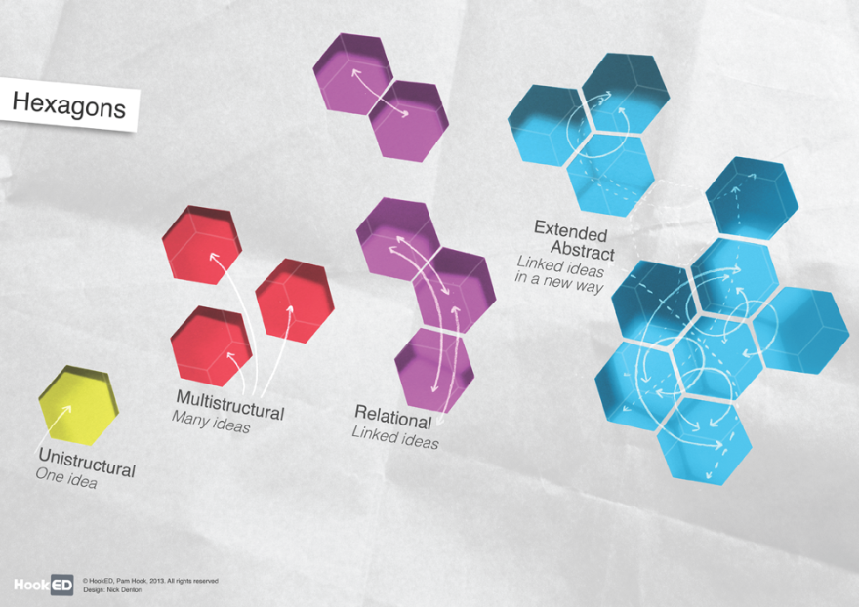
Explain why you have made straight-edged connections between individual hexagons (using connectives like “because …” and “so that …”).
When you have finished organising the hexagons, step back and look at the cluster of hexagons (or the vertex where three hexagons come together). Make a generalisation about the nature of the relationship between the ideas (“Overall we think keeping safe around trucks is all about … because … because …”).
Share your generalisations about keeping safe around trucks.
Use the ideas from the discussion around the Hexagons activity to decide on a message to help students keep safe when they are around trucks. For example, “Our important safety message is …”
Write safety messages on large sheets of paper and display them around the room.
Hold a class vote on the “best message” to keep us safe around trucks.

For hexagon templates, add content to hexagons using the online generator:
HookED SOLO Hexagon Generator
Download blank SOLO Hexagon templates:
HookED SOLO Hexagons template primary Y 0-12
HookED SOLO Hexagons template secondary
Keep a record of the student start-up messages on keeping children safe around trucks.
Add any new ideas that develop during the activities to the “before we start” truck safety messages on display around the room.
Use the student responses to guide your choice of the next activities for teaching and learning.

Reflection on Prior Knowledge Sessions
What do you know you don’t know about keeping safe around trucks?
What have you learnt that is new to you about keeping safe around trucks?
What do you wonder about keeping safe around trucks?
Use the student responses to make decisions about follow-up work.

